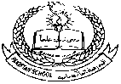 **Pakistan School , Kingdom of Bahrain**

**E- Support and Learning Material / Session 2020-2021**

**Subject:Social Studies Grade : 3**

**Book: New Oxford Social Studies**

**Lesson no 2: Maps Pg. No: 8**

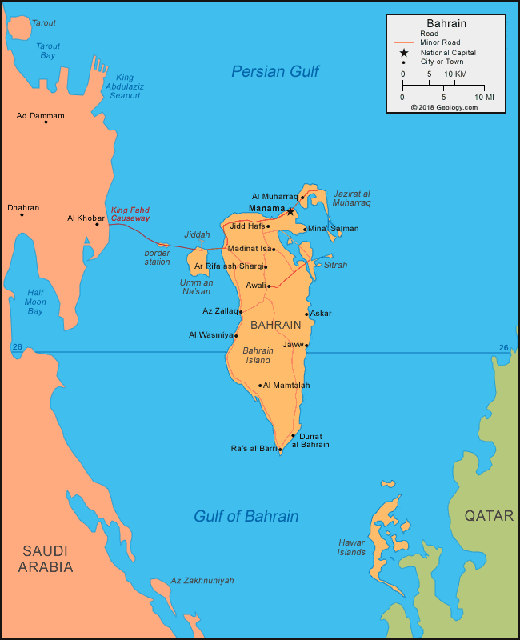

**Reading of the lesson ‘’Maps’’**

**Difficult words:**

* Surface
* Position
* Centimeter
* Symbols
* Directions
* Compass
* Continents
* Scale
* Wavy
* Atlas

**Answer the following questions:**

**Q.1: What would you find in an atlas?**

Ans: We can find different kinds of maps in an atlas.

**Q.2: What three things a map must have?**

Ans: A map must have key, directions and scale.

**Q.3: What does a map show?**

Ans: A map shows where places and land are located. It also shows the shape of the land and the sea.

**Q.4: What is the large area of the land on the earth called?**

Ans: These are called continents.

**Write suitable words to fill in the blanks:**

1. Maps cannot show us the actual size of a place.

2. Symbols are used to show the feature on the land.

3. A book of maps is called an atlas.

4. We might use a scale of one centimeter on a map.

5. Every map must have a key.

**Complete the following fact sheet about the Earth:**

|  |  |
| --- | --- |
| **Names of Continents** | **Names of Oceans** |
| Europe | Pacific Ocean |
| Asia | Atlantic Ocean |
| Africa | Indian Ocean |
| Antarctica | Arctic Ocean |
| North America | Southern Ocean |
| South America |  |
| Oceania |  |

**WORKSHEET**

**Lesson no 2: Maps**

**Name:_________________________ Grade: 3 Subject: Social Studies**

**Q.1 Encircle the correct answer:**

1. Maps are used to show the surface of (sun, earth).

2. There are seven large areas of (land, moon).

3. Every map must have a (scale and key, scale and light).

4. Book of maps is called an (oxford book, atlas).

**Q.2 State whether the statements are True or False:**

1. A map shows where the land and places are located. _________
2. A book of maps is called atlas. ________
3. Maps can show us the actual size of a place. __________
4. Every map must have a key. __________

**Q.3 Draw and colour or stick the map of Bahrain or Pakistan :**

|  |
| --- |
|  |

|  |  |  |  |  |  |  |  |  |  |  |  |  |  |  |  |  |
| --- | --- | --- | --- | --- | --- | --- | --- | --- | --- | --- | --- | --- | --- | --- | --- | --- |
| **Content Accuracy** | | | | **Creativity** | | | | **Completeness** | | | | **Neatness** | | | | **Total Points** |
| **1** | **2** | **3** | **4** | **1** | **2** | **3** | **4** | **1** | **2** | **3** | **4** | **1** | **2** | **3** | **4** |  |
| **1- Excellent 2 – Good 3- Satisfactory 4- Needs Improvement** | | | | | | | | | | | | | | | | |

**Rubric:**