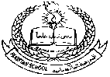**Pakistan School , Kingdom of Bahrain**

**E- Support and Learning Material / Session 2020-2021**

**Subject: Social studies Grade : 1**

**Book: New Oxford Social studies for Pakistan-1 FIRST TERM**

**Unit 1: About Myself Pg. No: 2-5**

**Lesson 1 : Me and My family**

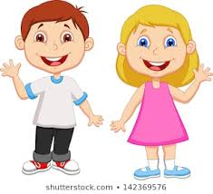 

This is Yasir. This is Anum.

He is a boy. She is a girl.

**Q1: Write answers of the following questions.**

Q1: What is your name ?

Ans : My name is _________.

Q2: Are you a girl or a boy?

Ans: I am a _______

Q3: How old are you?

Ans: I am ____ years old .

**Q2 : Fill in the blanks with suitable words.**

|  |  |  |  |
| --- | --- | --- | --- |
| girl | boy | six | seven |

1. Anum is six years old.
2. Yasir is a boy.
3. Yasir is seven years old.
4. Anum is a girl .

**About me**  Paste your picture

|  |
| --- |
|  |

1. My name is _________.
2. I am a ________ ( boy / girl )
3. I am _________ years old.
4. I live in __________.
5. I love my country.