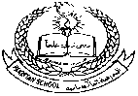**Pakistan School , Kingdom of Bahrain**

**E- Support and Learning Material / Session 2020-2020**

**Subject: Social studies Grade : 1**

**Book: New Oxford Social studies for Pakistan-1 FIRST TERM**

**Unit 1: About Myself Pg. No: 1-2**

**Lesson 1: Akbar and Mumtaz**

**Worksheet:**

