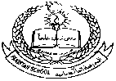 **PAKISTAN SCHOOL, KINGDOM OF BAHRIAN**

**E- Support and Learning Material / Session 2020-2021**

**Subject: Social Studies Grade: 2**

**Book: New Oxford Social Studies FIRST TERM**

**Unit 1: My self and my family Pg. No: 3 ( Notes)**

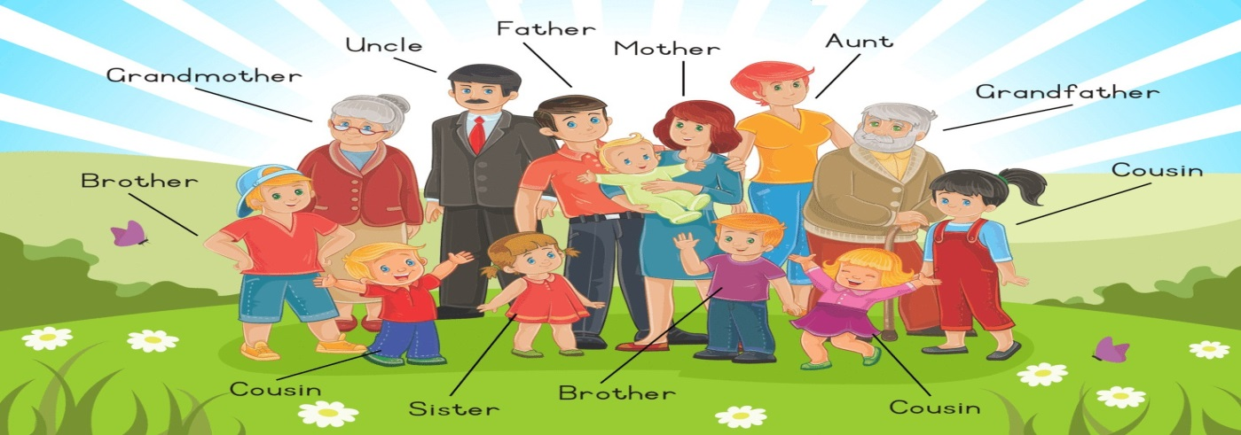

**grandfather , grandmother , brother , sister, mother ,sister,uncle, aunt.**

**Difficult Words:**

**Q1: Who is the youngest person in the Ali family?**

Ans:Yasir is the youngest person in the Ali family.

**Q2: How many cousins does Mahmood have?**

Ans:Mahmood has two cousins.

**Q3:How many aunts and uncles does Anum have?**

Ans:Mumtaz has one uncle and aunt.

**Q4:What are their names?**

Ans:Tehmina and Imran.

**1 Mr Raza Ali’s father:** Mr. Habib Ali

**2. Anum’s mother:** Zainab Ali

**3. Yasir’s grandmother:** Mrs Habib Ali

**4. Yasir’s uncle:**  Imran

**5. Ahmed’s brother:** Mahmood

**Re-arrange the jumbled letters to form correct words:**

**1:remoth:** mother  **4.freath:**  father

**2:sicoun:** cousin  **5.trises:** sister

**3:trobher:** brother  **6.cluen:** uncle