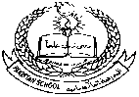

**Pakistan School, Kingdom of Bahrain**

**E- Support and Learning Material / Session 2020-2021**

**Subject: Social Studies Grade: 2**

**Unit 1: Lsn: 1: About Myself ( Pg. No: 2 ) Activity Sheet**

**Student’s Name:___________________________ Grade 2 Sec: _____ Isa Town / Manama**

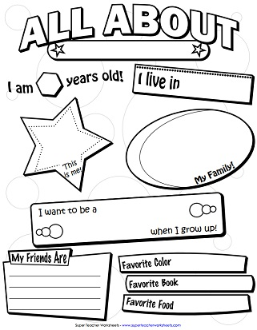

**Answer these questions:**

**Q1: What is your family name?**

**Ans:__________________________**

**Q2: What is your mother’s name?**

**Ans:____________________________**

**Q3:How many cousins do you have?**

**Ans:______________________________**

**Q4:What is your mother’s daughter called?**

**Ans:________________________________**

**Q5: What is your father ‘s name?**

**Ans:_________________________________**

**Q6:How many sisters do you have?**

**Ans:_________________________________________**

**Q7.How many brothers do you have?**

**Ans:_______________________________________**

**Q8:How many members are there in your family?**

**Ans:_______________________________________**

**Home Work:**

**Do Exercises on Pg 2 and 5 on the textbook itself.**

**Make a family tree on A4 colour paper . Stick pictures or write names of your family members.**