**Pakistan School , Kingdom of Bahrain**

**E- Support and Learning Material / Session 2020-2021**

**Subject:Social Studies Grade : 3**

**Book: New Oxford Social Studies FIRST TERM**

**Unit 1: The Earth in Space Pg. No: 1**

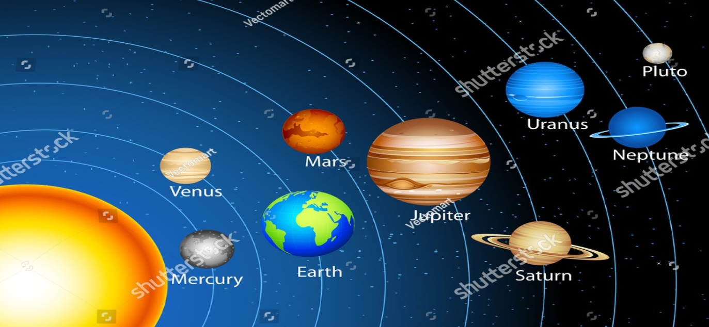

Day 1:

**Q.1 :Difficult Words:**

* 1.Solar System
* 2.Planet
* 3.Atmosphere
* 4.Surrounded
* 5.Directions
* 6.Damage
* 7.Reflection
* 8.Satellite
* 9.Spinning
* 10.Space

**Answer the following questions: ( Book pg no 2)**

**Q.1: What do we find in space?**

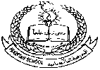**Ans:** We can find million of stars and planets in space.

**Q.2: What is the earth surrounded by?**

**Ans:** The earth is surrounded by atmosphere which is made of layer of air.

Day 2:

**Q.3: Does the earth stay in one place?**

**Ans**: No the earth is not fixed on one place it spins in anticlockwise direction.

**Q.4: What is the sun made of?**

Ans: The sun is made of huge ball of very hot gases.

**Q.5**: **How do night and day take place?**

Ans: Day and night take place by the spinning movement of the earth around the sun.

Day 3:

**Fill in the blanks.**

1: A plateau is high fiat land.

2: The area where the land meets the sea at same level is called the coast.

3: Water surrounded on all sides by land is called lake.

4: A small area of land surrounded by water is called an island.

5: A sandy place without much water is called a desert.

**Match the followings:**

|  |  |  |  |
| --- | --- | --- | --- |
| **S.NO** | **COLUMN A** | **COLUMN B** |  |
| 1 | The planet where we live | Night | 5 |
| 2 | The time that earth takes to go around the sun. | Day | 3 |
| 3 | The part of the time on the side of the earth which is facing the sun | Moon | 4 |
| 4 | A natural satellite of the earth. | One year | 2 |
| 5 | The part of the time on the side of the earth facing away from the sun. | Earth | 1 |

Day 4:

**Draw or stick a picture of different land forms :**

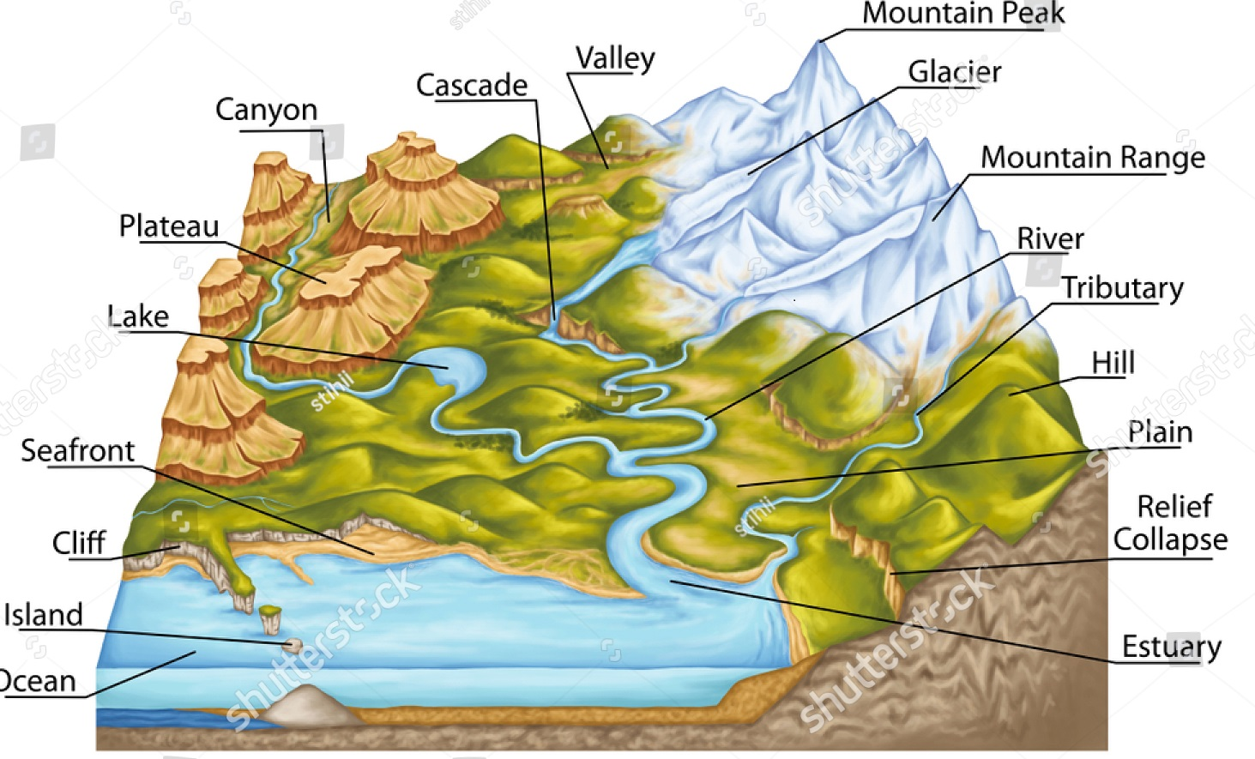

**State whether the statements are true or false:**

1: A plain is low, flat land. (True)

2: Dirty water damages plant and animal life. (True)

3: Rivers flow from the sea to the land. (False)

4: Mountains are higher than hills. (True)