Day 5:

**Day 5**

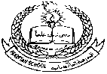**Pakistan School , Kingdom of Bahrain**

**E- Support and Learning Material / Session 2020-2021**

**Subject: Social Studies Grade : 3 Sec: _____ Isa Town / Manama**

**Unit 1: The Earth in Space Worksheet**

**Student’s Name:___________________________________________**

**Read the notes of the lesson** The EARTH IN SPACE **carefully:**

**Write the names of the any five landforms:**

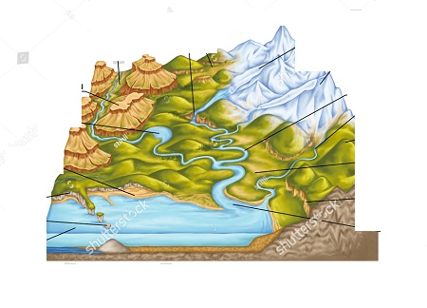

**Write the missing words by learning the vocabulary words carefully:**

1. S__la___ s___st___m**.**
2. D__r__c___io____.
3. ___t__0___ph___r__.
4. S___rr__un____e____.
5. S___i____ ____i___g.

**Choose the right option and circle it:**

1. The earth is surrounded by (moon, atmosphere).

2. The earth is called (star, planet).

3. The sun is made of (electricity, hot gases).

4. In the space we can find (solar system, nothing)

5. The earth spins in (clockwise, anticlockwise) direction