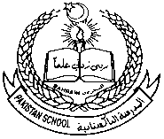 **Pakistan School, Kingdom of Bahrain**

**E_Support and learning Material**

**Class : HKG / sec**

**Subject: Science ( Isa Town / Manama)**

**Student Name: _______________________________________________**

**Lesson:1: People**

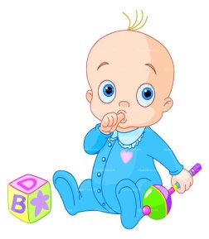**Q1:Match the following with the suitable pictures:**

**Child**

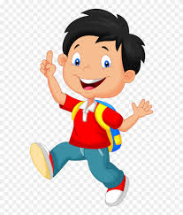

**Baby**

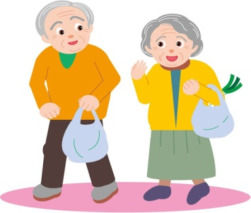

**young**



**old**

**Q1.Do all people have same skin colour?**

**Ans.________________________________________**

**Q2.How many types of people are there?**

**Ans.________________________________________**

**Q3. How do people differ from each other?**

**Ans._______________________________________**

**(Read pg.2 )**