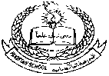 **Pakistan School , Kingdom of Bahrain**

**E- Support and Learning Material / Session 2020-2021**

**Subject: Science Grade : 7th**

**Book: Oxford Secondary Science 2 FIRST TERM**

**Chapter 1:The digestive system Pg. No:2,3,4,5**

**Topic1 : The digestive System,**

**Notes:**

**Part 1: Short Question and answers:**

**Q.1 what is meant by digestion? Where does digestion occur?**

Ans. Digestion is the breakdown of large molecules in food into smaller molecules, which can be absorbed into the blood. Digestion takes place in the digestive system. Acids and chemical (enzymes) breakdown food.

**Q.2 Why do we need to digest our food? What are the two ways in which food is broken down during digestion?**

Ans. We need to digest our food so that it can pass into the blood and be distributed to the muscles to provide enegy.During digestion food is broken down by two processes

1. Mechanical breakdown of food is done by chewing the food

2. Chemical breakdown of food is done by enzymes and acid

**Part 2: Multiple Choice Questions:**

Q.1 There are ___________basic food groups

a.2 b.5 c.7 d.5

Correct answer: 5

Q.2 Faeces are stored temporarily in _________________

a. anus b. large intestine c. small intestine d. rectum

Correct answer: rectum

Q.3 During digestion starch is broken down into __________________.

a. amino acid b. fatty acids c. glycerol d. glucose

Correct answer: glucose

Q.4 There is no role of _________________ in digestion in humans.

a. salivary glands b. pancreas c. liver d. appendix

Correct answer: appendix

Q.5 Insulin and enzymes are produced by ________________.

a. stomach b. liver c. pancreas d. gall bladder

Correct answer: pancreas

 **Pakistan School , Kingdom of Bahrain**

**E- Support and Learning Material / Session 2020-2021**

**Subject: Science Grade : 7th**

**Book: Oxford Secondary Science 2 FIRST TERM**

**Chapter 1:The digestive system Pg. No:2,3,4,5**

**Topic1 : The digestive System,(continued)**

**Short Question and answers:**

**Q.1 Name the seven groups of food that are needed for a healthy and balanced diet.**

Ans. The seven groups of food that are needed for a healthy and balanced diet are

Carbohydrates, Proteins, Fats, Minerals, Vitamins, Fiber and water

**Q.2 Name the three nutrients which are broken down during digestion and say what they are broken down into.**

Ans. During digestion

Starch is broken down into glucose and maltose

Proteins are broken down into amino acids

Fats are broken down into fatty acids and glycerol

**Q.3 Give three reasons why the villi in the small intestine are perfect foe absorbing food.**

Ans. The villi in the small intestine are perfect for absorbing food because

1. They give the small intestine a much large surface area

2. They have a thin layer of cells on outer layer.

3. They are well supplied with blood capillaries.

**Q4. Our bodies cannot digest fiber (cellulose). Why is it still important in our diet?**

Ans. Although we cannot digest fiber but it is an important part in our diet because it contains cellulose from the cell wall of fruits and vegetables we eat. The undigested fiber creates bulk so the muscles in the intestine can push waste out of the body .Eating enough fiber helps prevent constipation.

 **Pakistan School , Kingdom of Bahrain**

**E- Support and Learning Material / Session 2020-2021**

**Subject: Science Grade : 7th**

**Book: Oxford Secondary Science 2 FIRST TERM**

**Chapter 1:The digestive system Pg. No:2,3,4,5**

**Topic1 : The digestive System,(continued)**

**Q.1 what are the function of muscles in digestion?**

Ans. The contraction of muscles in waves pushes food down the gullet or esophagus. Similar contractions push the food along the intestines. Contractions of muscles push the undigested food out of the anus.

**Q.2 Glucose molecules do not need to be digested and starch molecules do. Explain this difference.**

Ans. Glucose molecules do not need to be digested because they are small molecules and soluble and can pass through the walls of the small intestine into the blood. Starch molecules are big molecules and are insoluble and need to be broken down during digestion before they can be absorbed into the blood.

**Q.3 Write down the name of the parts of human digestive system and its functions**

|  |  |
| --- | --- |
| **Name of parts of Digestive system** | **Their functions** |
| 1. Gullet or esophagus | Pushes food into the stomach |
| 1. Tongue | Mixes food with saliva |
| 1. Stomach | Produces hydrochloric acid |
| 1. Liver | Produces bile |
| 1. Large intestine | absorbs water and minerals salts from undigested food |
| 1. Small intestine | Absorbs digested food |
| 1. pancreas | Produces enzymes and insulin |
| 1. Gall bladder | Stores bile |
| 1. Rectum | Stores Undigested food (faeces) |
| 1. Anus | Removes undigested food (faeces) |

**Pakistan School , Kingdom of Bahrain**

**E- Support and Learning Material / Session 2020-2021**

**Subject: English Grade : 7th**

**Book: oxfoerd secondary science 2 1st term**

**Chapter 1:The digestive sysetm Pg. No:5,6**

**Topic:2 Problems with digestive system**

**Short Question Answers:**

**Q1. What are the causes of constipation? How can constipation be cured?**

**Ans.**The main causes of constipation are

1. Not drinking enough water and other liquids 2.not eating food having fiber

3. Lack of exercise 4. Don’t go to the toilet at a time of day

**Q 2.How can constipation be cured?**

**Ans .**Constipation is cured by drinking lots of water, eating food having lots of fiber, have

Plenty of exercise and going to the toilet at a time of day.

**Q.3 What are the causes of diarrhoea? How can diarrhoea be cured?**

**Ans.** The main cause of diarrhoea are

1.Eating infected food 2. Poor hygiene when handling food

Diarrhoea like vomiting is the body’ way of sweeping the germs out of the body. Diarrhoea can be cured by not eating infected food and keeping hygiene .

**Q.4 what are the causes of indigestion? How can indigestion be cured?**

Ans. Indigestion is caused by eating food too quickly and not chewing it enough .The stomach produce more acid to digest bigger molecules of food .when stomach produces more acid it is called acidity. You feel heart burning.

**Q.5 How can indigestion be cured?**

**Ans.**Indigestion can be cured by taking tablet or syrup containing alkali. That will neutralize the excess acid in your stomach.

**Multiple Choice Questions:**

1.When you eat infected food germs enter into the digestive system this disease is called

1. Heart attack b. diabetes c. food poisoning d. asthma

2. This acid is secreted by the stomach

a. nitricacid b.sulphuric acid c. citric scid d.hydrochloric acid

3. Dehydration (loss of water) occur in your body as a result of

a.contipation b.diarrhoea c.indigetin d. headache

4.when faeces (waste material) becomes thick and hard and difficult to pass out from your body this disease is called

a.food poisoning b.heart burning c. constipation d. asthma

5.which disease is not related to digestive system?

a.indigestion b.diarrhoea c.contipation d.asthma

**Correct answers:**1. C. Food poisoning 2. D. hydrochloric acid

3. b. diaarhoea 4. C. constipation 5. D .asthma

**Pakistan School , Kingdom of Bahrain** 

**E- Support and Learning Material / Session 2020-2021**

**Subject: Science Grade : 7th**

**Book: Oxford Secondary Science 2 FIRST TERM**

**Chapter 1:The digestive system Pg. No:2,3,4,5**

**Topic1: The digestive System,**

**Topic 2: Problems with digestive system**

**Worksheet**

**Acivity1: Fill in the blanks:**

1. Digestion is speed up by ________________.

2. The small intestine is _______ meter long.

3. _______________ is secreted by the walls of stomach.

**Activity 2: Write true or false:**

1. Villi have large surface area.
2. Gastric juice is produced by the liver.
3. Mechanical breakdown of food is done by chewing.

**Activity 3: Give reasons:**

Q.1 Why enzymes are important in digestion?

Ans. _________________________________________________________________

__________________________________________________________________

Q.2 If food is not digested properly then what will happen?

Ans.______________________________________________________________

__________________________________________________________________

**Activity 4:**

**Match the parts of digestive system with their functions**

|  |  |
| --- | --- |
| 1.stomach | Stores faeces |
| 2.rectum | Absorbs water |
| 3.large intestine | stores bile |
| 4.gall bladder | Produce acid |
| 5.pancreas | Produces insulin and enzymes |

**Activity 5: Label the following diagram of human digestive system**

|  |  |
| --- | --- |
| Write answers | |
| 1 |  |
| 2 |  |
| 3 |  |
| 4 |  |
| 5 |  |
| 6 |  |
| 7 |  |
| 8 |  |

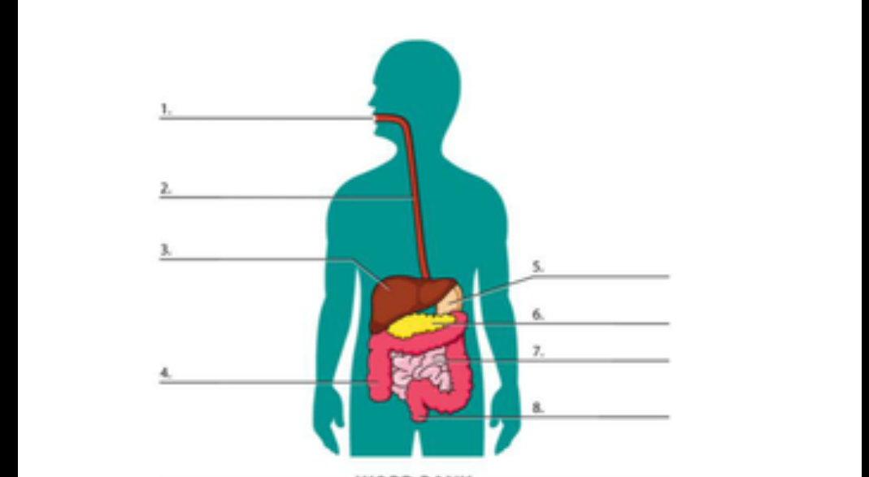

**Activity 06:**

**Fill in the blanks:**

1. Stomach produces ______________________acid.
2. when faeces (waste material) becomes thick and hard and difficult to pass out from your body this disease is called ____________________________.
3. The three main disorders of digestive system are

1.____________________

2._______________________

3.______________________

**Activity 07 : Choose the correct answer:**

1.Which of the following may be sign of constipation?

a. hard faeces

b. heart burn

c. headache

2. Indigestion is cured by taking tablet containing

a. acid

b. alkali

c. salt

3.which disease is not related to digestive system?

a. indigestion b. diarrhea c. constipation d. asthma

**Activity 08:**

**Match the following:**

|  |  |
| --- | --- |
| 1.Indigestion is usually caused by | diarrhea |
| 2.Germs get into the digestive system by eating spoiled food then white blood cells rush to destroy the germs and the liquid food is rushed through the digestive system this condition is called | Drinking more water and using food having fibers |
| 3.constipation is treated by | Eating food too quickly and not chewing it enough |

**Activity 09:**

**Give reasons:**

1. What is the reason for heartburn?

Ans._______________________________________________________________________________________________________________________________

2.Why should we use food having fibers and three litters water every day?

Ans._________________________________________________________________ ____________________________________________________________________________

**Homework:**

Do any one of the following

1. Draw and label the parts of human digestive system
2. Write the importance of digestion in human beings

Do any one of the following:

1. Make a power point presentation for the causes and treatments of disorders of digestive system

2. Make a chart to show the causes and treatments of indigestion, diarrhea and constipation.