**Pakistan School , Kingdom of Bahrain**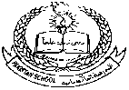

**E- Support and Learning Material / Session 2020-2021**

**Subject: General Science Grade : 8th**

**Book: Oxford Secondary Science 3 FIRST TERM**

**Unit 1: The Nervous System Pg. No: 2, 3, 4**

**Topics: The nerve cells and nerves, The Central nervous system, The brain**

**Short Questions & Answers**

**Q1)** What are nerve impulses?

**A:** Nerve impulses are messages which are carried to and from all parts of the body by the cells of the nervous system.

**Q2)** What are nerve cells?

**A:** Nerve cells (neurons) are cells of the nervous system possessing nucleus, cytoplasm and dendrites.

**Q3)** What are dendrites?

**A:** Dendrites are inputs of the nerve cell (neuron) along which nerve impulses travel into the cell.

**Q4)** What is an axon?

**A:** Leading out from the nerve cell (neuron), the cytoplasm forms a single long fibre called the axon.

**Q5)** What are nerves?

**A:** Nerves are bundles of axons or nerve fibres.

**Q6)** What are the two types of nerves?

**A:** The two types are sensory nerves which carry messages to and from the sense organs, which have receptor cells. The other type is motor nerves which communicate with the muscles, allowing them to contract and relax so that we can move our bones.

**Q7)** What are synapses?

**A:** As neurons do not touch one another, there are gaps between them called synapses.

**Q8)** What is the spinal cord?

**A:** It is a single tubular nerve cord, which is safely protected by the bones of the spine, the vertebrae.

**Q9)** What is the central nervous system?

**A:** Brain and spinal cord are the two parts making up the central nervous system.

**Q10)** Write a note on the brain.

**A:** Human brain weighs about 1.5kg. It has around 100 billion nerve cells and has a complex network of cells and nerve fibres. It receives and sends messages along nerve fibres. Messages are sent at a speed of upto 100 metres per second. The nerves connect the brain to the organs of the head and the spinal cord.

**Note:** The spelling of neurone can either be spelled as neuron or neurone.

**Questions & Answers**

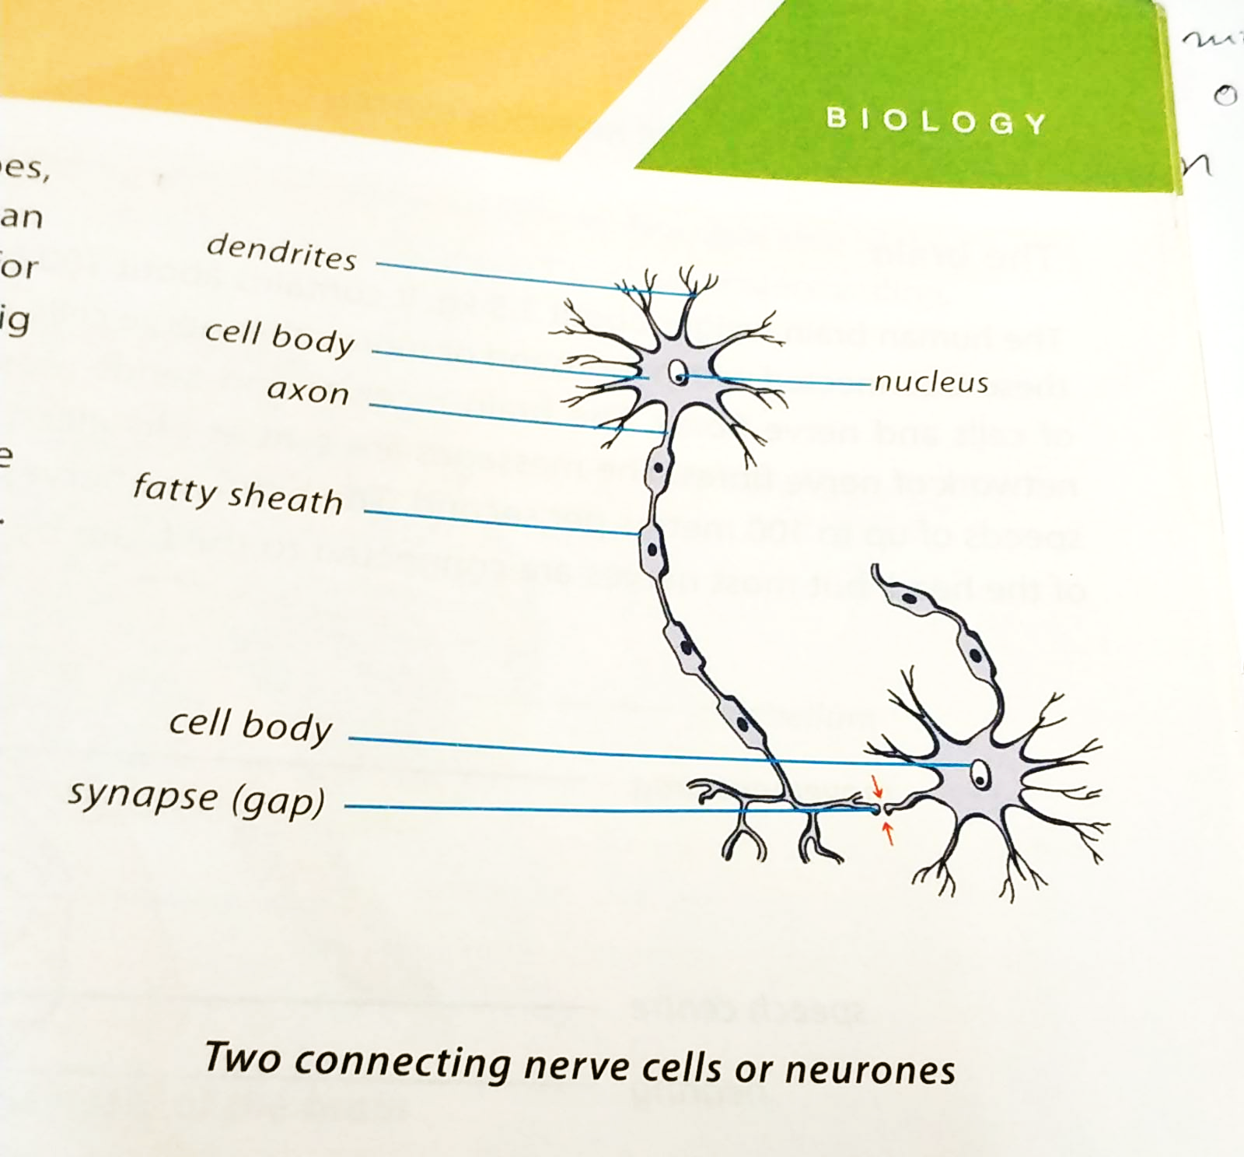

**Q1)** What are the nerve impulses?

**A:** These are messages carried by the cells of the nervous system.

**Q2)** What is the nervous system?

**A:**

1. The Nervous System:
2. The parts of the nervous system are the brain, spinal cord and nerves.
3. 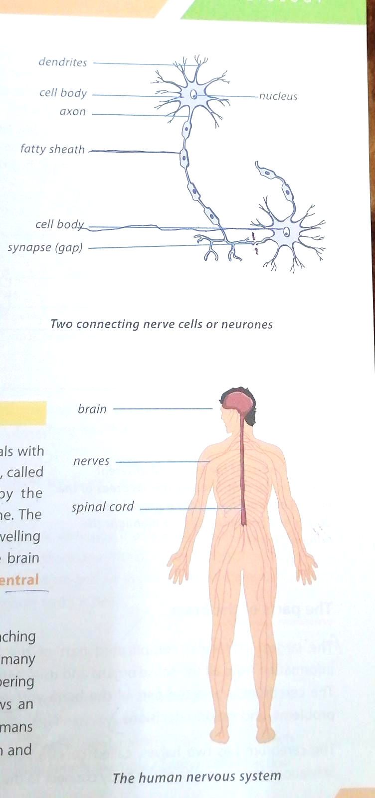The nervous system collects information about changes inside or outside of the body, and decides how the body should respond and control that response.
4. The sense organs have receptor cells which collect the information and send to the nervous system.

**Pakistan School , Kingdom of Bahrain**

**E- Support and Learning Material / Session 2020-2021**

**Subject: General Science Grade : 8th**

**Book: Oxford Secondary Science 3 FIRST TERM**

**Unit 1 The Nervous System Pg. No: 2-5**

**Topic: The parts of the brain**

**Short Questions & Answers**

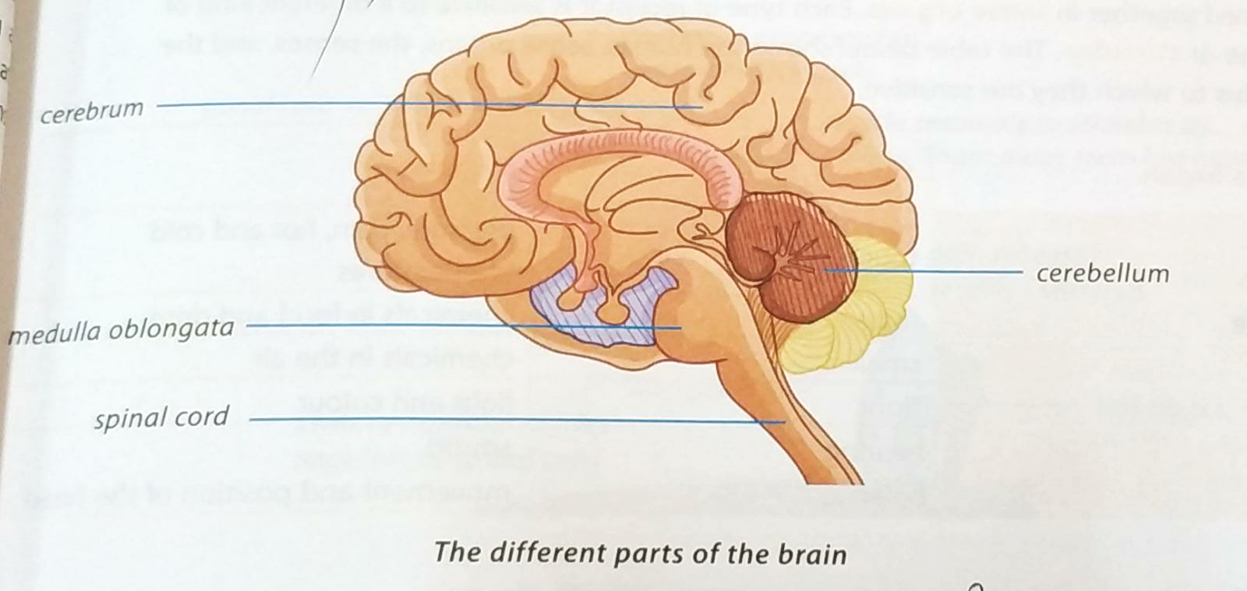

**Q1)** Name the parts of the brain.

**A:** The parts of the brain are:

1. Cerebrum
2. Cerebellum
3. Medulla Oblongata
4. Brain stem

**Q2)** Write down a short note about the cerebrum.

**A:** The largest and most complicated part of the human brain is the cerebrum. It controls our actions, behaviour and speech. It has two halves, which are called cerebral hemispheres.

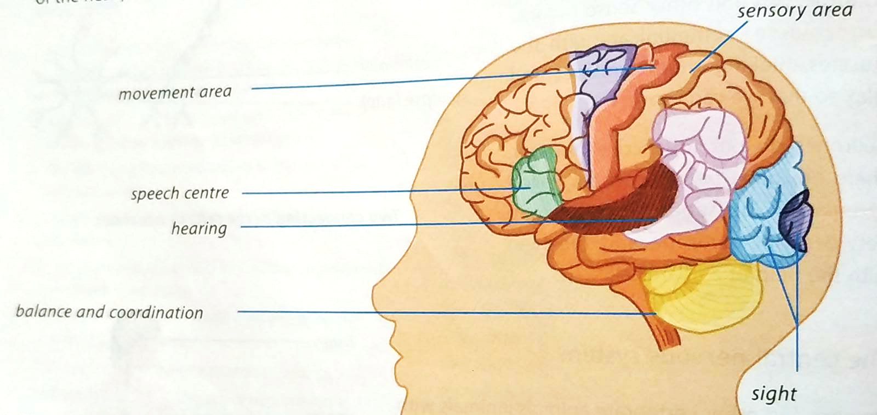

**Q3)** Describe the functions of the cerebrum.

**A:** The cerebrum receives information from all the sense organs and controls our actions, behaviour and speech. It is used for thinking, remembering things, solving problems and making decisions.

**Q4)** Which side of the cerebrum controls understanding?

**A:** The left cerebral hemisphere controls understanding, reading and thinking.

**Q5)** Discuss the functions of the medulla oblongata.

**A:** The medulla oblongata controls the involuntary actions, e.g. breathing, heart beat rate and regulates blood pressure and body temperature.

**MCQs**

1) The largest and most complicated part of the human brain is:

1. Cerebrum
2. Cerebellum
3. Medulla Oblongata
4. Brain Stem

2) This is the part of the brain you use for thinking, remembering things and making decisions:

1. Cerebellum
2. Cerebrum
3. Medulla Oblongata
4. Brain Stem

3) The right side of the cerebrum is important in:

1. Understanding
2. Reading
3. Thinking
4. Artistic and creative tasks

4) Brain stem is close to the spinal cord and controls:

1. Body’s automatic actions
2. Voluntary actions
3. Toning of muscles
4. All of the above

5) The medulla oblongata controls:

1. Blood pressure & body temperature
2. Voluntary actions
3. Insulin levels
4. All of the above

**Answers to MCQs**

1) a 2) b 3) d 4) a 5) a

**Homework:**

Do anyone.

Q1) Make a diagram of the brain showing its parts.

Q2) Draw a table showing names and functions of brain parts.

Q3) Prepare a powerpoint presentation of the brain parts.

**Pakistan School , Kingdom of Bahrain**

**E- Support and Learning Material / Session 2020-2021**

**Subject: General Science Grade : 8th**

**Book: Oxford Secondary Science 3 FIRST TERM**

**Unit 1: The Nervous System Pg. No: 4,5**

**Topics: The parts of the brain, Nerve Cells**

**Questions and Answers:**

**Q1)** What is the function of the brain stem?

**A:** It controls the automatic activities of the body, e.g. breathing and digestion.

**Q2)** Does the human brain need energy to do work?

**A:** The human brain needs a great deal of energy to do its work. Its weight is about 1.5kg and it uses about one-fifth of all the energy the body produces.

**Q3)** Does the human brain need oxygen?

**A:** Yes, the human brain needs oxygen to do its work properly. Without oxygen, brain cells are quickly damaged. After about 5 minutes without oxygen, the entire brain dies.

**Q4)** How are neurons adapted to carry out their function?

**A:** Neurons carry impulses in one direction only. The nerve impulses travel from sense organs, into the brain and spinal cord along sensory nerve cells, then travel to motor nerves, which carry them to muscles and produce actions.

A reflex action is an example of nerve cells in action.

**Q5)** Where are receptor cells present?

**A:** The receptor cells are present in the sense organs to collect information.

**Worksheet:**

Fill in the blanks.

1. The sense organs have _____________ that collect information.
2. The nervous system consists of ___________, ___________ and ____________ .
3. Information is processed in the ____________ and _____________.
4. A nerve cell is also called a ____________.

Mark True / False.

1. Synapses are gaps present between the neurons. _________
2. Sensory nerves do not carry messages to and from the sense organs. _________
3. Motor nerves contract and relax the muscles. __________
4. The spinal cord is a single tubular nerve cord. __________

Answer anyone.

Q1) Name the parts of the brain.

A:

Q2) Write down the functions of the cerebrum and cerebellum.

A:

**Pakistan School , Kingdom of Bahrain**

**E- Support and Learning Material / Session 2020-2021**

**Subject: General Science Grade : 8th**

**Book: Oxford Secondary Science 3 FIRST TERM**

**Unit 1: The Nervous System Pg. No: 6-7**

**Topic: Receptors, Reflexes, Voluntary Actions**

**Short Questions & Answers**

**Q1)** What are reflexes?

**A**: Reflexes

The spinal cord can control some of our actions without the brain being used at all. The automatic nervous response to a stimulus is called a reflex.

**Q2)** What are two types of reflexes?

**A:** There are two types of reflexes:

1. Spinal reflex:

In spinal reflex, impulses travel from the receptors present in sense organs to the spinal cord.

1. Cranial reflex:

In it, impulses are sent straight to the brain.

**Q3)** What is a stimulus?

**A:** Anything that stimulates or causes a living organism or part of the organism to do something is called a stimulus.

**Q4)** Name the five main sense organs and the senses to which they respond.

**A:**

|  |  |
| --- | --- |
| **Sense Organs** | **Corresponding senses to which they respond** |
| 1) Skin | Touch |
| 2) Tongue | Taste |
| 3) Nose | Smell |
| 4) Eyes | Sight |
| 5) Ears | Hearing, Balance |

**Q5)** What is the difference between a nerve and a nerve cell or neurone?

**A:** Nerves:

They are bundles of nerve fibres or axons. There are two types: a) Sensory Nerves and b) Motor Nerves

Neurone or Nerve Cell:

It has a nucleus and cytoplasm. It has many inputs or dendrites along which nerve impulses or messages travel into the cell. It has a single long fibre of cytoplasm called axon.

**Q6)** What is the autonomic nervous system?

**A:** The nerves which control involuntary actions are known as the autonomic nervous system.

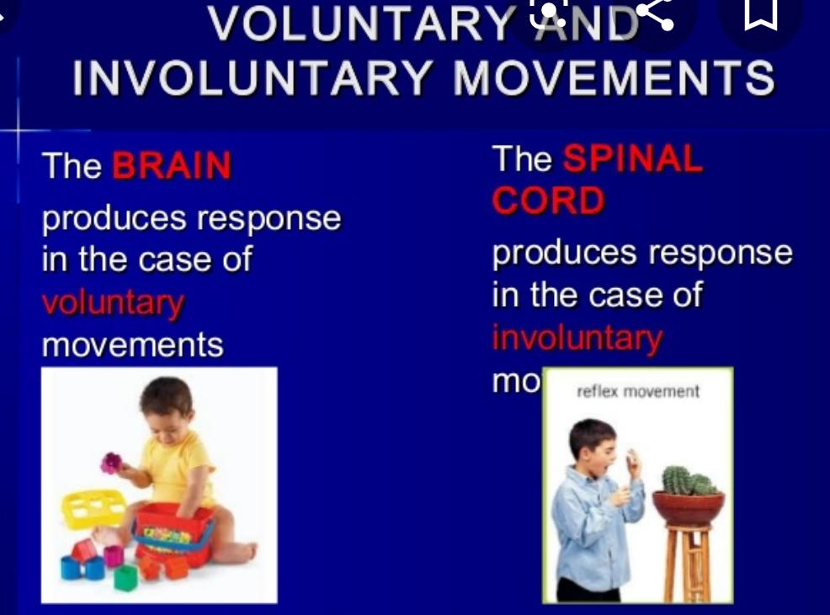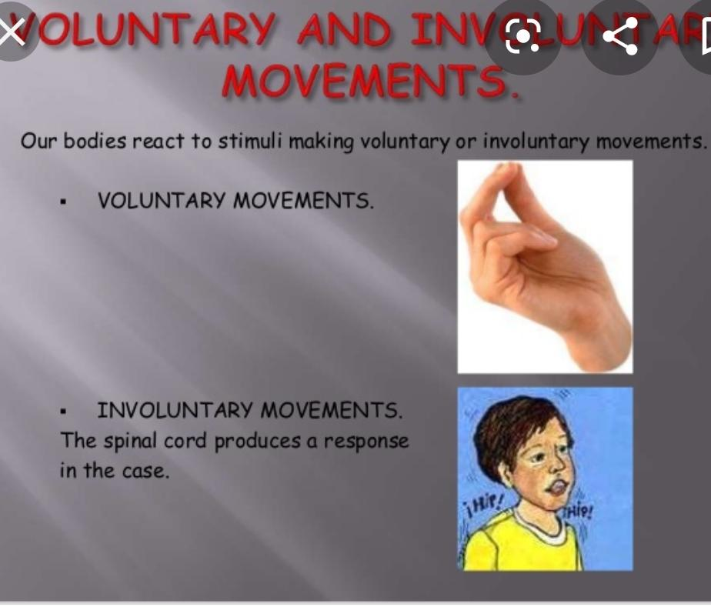

**MCQs**

1) Sense organs have cells which collect information about surroundings called:

1. squamous cells
2. skin cells
3. receptor cells
4. plant cells

2) Pressure, pain, hot and cold temperatures are stimulus for sense of:

1. taste
2. smell
3. sight
4. touch

3) The actions that our brain can control consciously are called:

1. reflex actions
2. voluntary actions
3. involuntary actions
4. spontaneous actions

4) The brain sends motor impulses along the nerves that run down the spinal cord in

1. reflex actions
2. voluntary actions
3. involuntary actions
4. spontaneous actions

5) An automatic nervous response by an animal or human being to a stimulus is called:

1. reflex action
2. voluntary actions
3. involuntary actions
4. spontaneous actions

**Answers to MCQs**

1) c 2) d 3) b 4) b 5) a

**Homework:**

Do anyone:

Q1) Write down the examples of cranial reflex and spinal reflex.

Q2) Draw a spinal reflex response to pain.

**Pakistan School , Kingdom of Bahrain**

**E- Support and Learning Material / Session 2020-2021**

**Subject: General Science Grade : 8th**

**Book: Oxford Secondary Science 3 FIRST TERM**

**Unit 1: Pg. No: 7 FIRST WEEK, DAY 5**

**The Nervous System**

**Topic: Voluntary and Involuntary Actions**

**Question & Answer**

**Q1)** Explain the difference between a voluntary action and an involuntary action.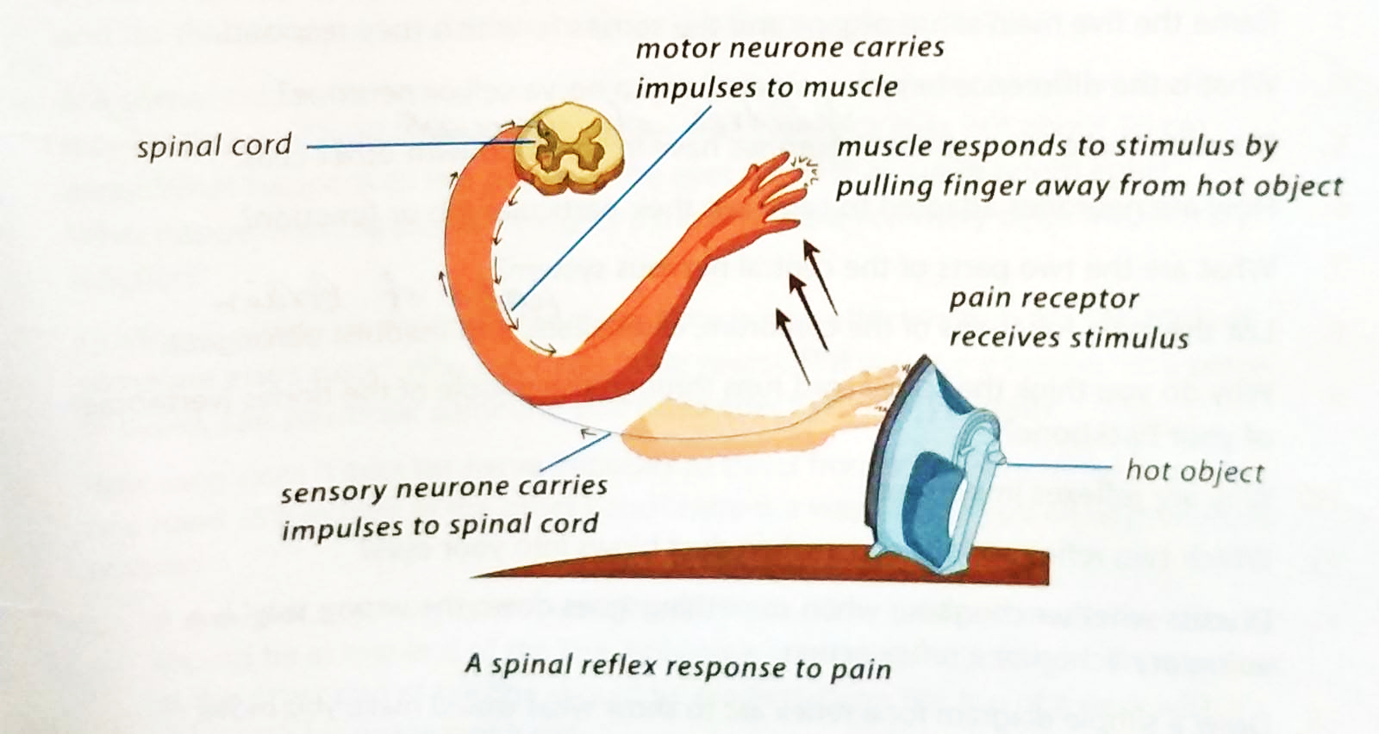

**A:** There are two main types of actions done by our body:

1. Voluntary actions:

These are actions our brain can control consciously, e.g. picking a book off the floor or kicking a ball. Nerve impulses reach our brain and are analyzed before you decide what action to take. The brain sends motor impulses along the nerve fibres that run down the spinal cord to send the messages to muscles to execute the correct action.

1. Involuntary actions:

These are actions that our brain does not control consciously. Some examples include digestion, breathing, heartbeat rate and sweating. The autonomic nervous system controls involuntary actions. The reflex actions are also a type of involuntary actions. Reflexes are important because they protect us from injuries.

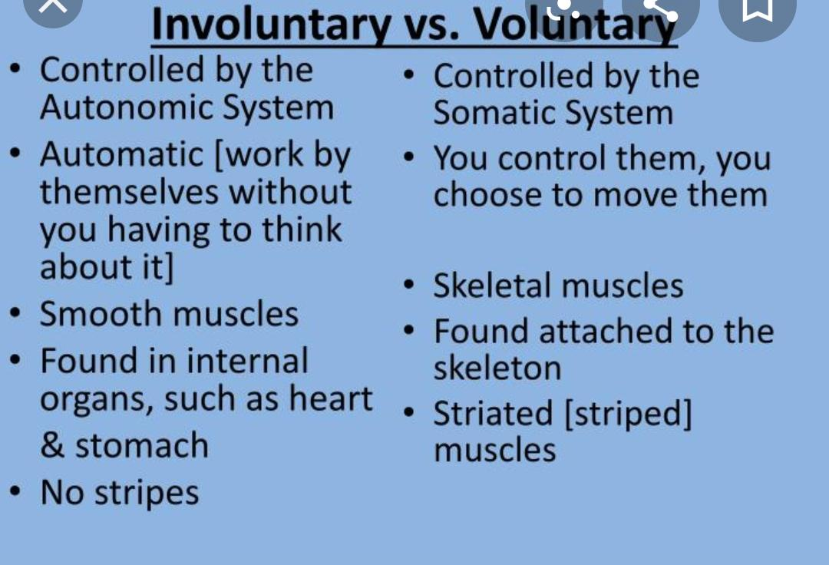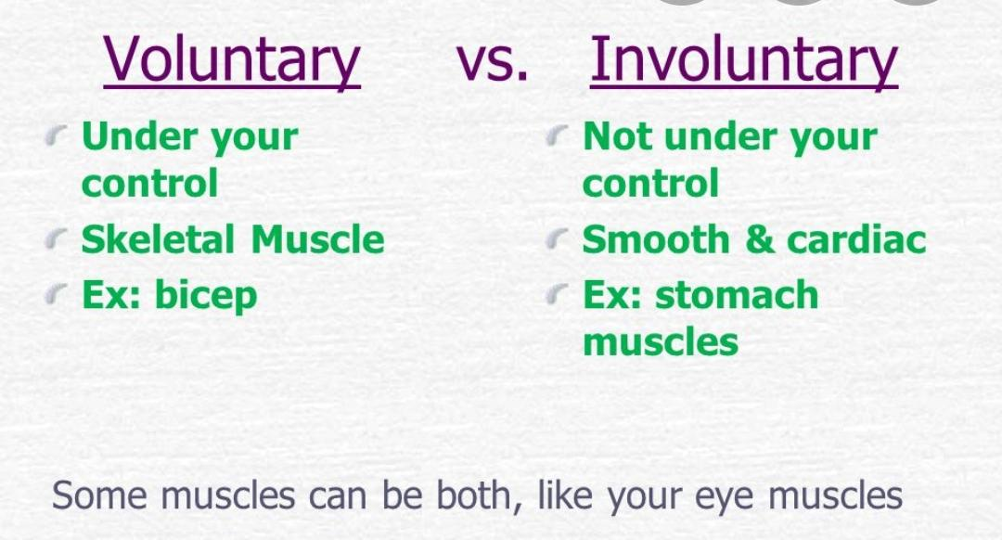

**Worksheet:**

Fill in the blanks.

1. Impulses travel from the pain receptors in your fingers to the ____________.
2. In _______________, impulses are sent to the spinal cord.
3. In _______________, impulses are sent to the brain.
4. The ______________ actions are also involuntary actions.
5. The brain receives and sends messages to organs and muscles along a ___________.

Mark True / False.

1. Human brain weighs about 1.5kg. ________
2. The brain has about 100 billion nerve cells. _______
3. The human brain does not send messages as tiny electrical impulses at a speed of 100 meters per second. _______
4. The brain does not have nerves which are directly connected to the organs of the head. _______
5. Most nerves are connected to the brain by way of the spinal cord. _______

Answer any two.

Q1) Explain the difference between a voluntary and involuntary action.

A:

Q2) Differentiate between central nervous system and autonomic nervous system.

A:

Q3) Which two reflex actions occur when dust blows into your eyes?

A:

Q4) Why is coughing a voluntary action or a reflex action when something like food goes into the wrong tube?

A:

**Homework:**

Do anyone:

Q1) Make a presentation of voluntary actions along with examples on an activity paper.

Q2) Make lists of voluntary and involuntary actions.