** Pakistan School , Kingdom of Bahrain**

**E- Support and Learning Material / Session 2020-2021**

**Subject: Social-studies Grade : 4**

**Book: Social-studies for Pakistan -- 4 FIRST TERM**

**Unit 1 : Geography**

**Lesson # 1 The Earth in space**

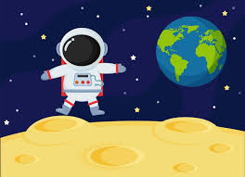

**Introduction( The Earth and space):**

* **One line answers of the questions.**

**1. What is north and south pole?**

Ans: The shape of the Earth is not round but spherical, meaning that it is slightly flattened at the two ends. These ends of the Earth are known as the North and South Poles.

**2. What are space probes?**

Ans: Space probes are the machines sent out into the space to find out more about the universe.

**3. What is an orbit?**

Ans: The path of an object or satellite around a planet or star is called an orbit. For example the path of the Earth round the Sun is called earth’s orbit.

**4. How much time the Earth take to rotate once?**

Ans: The Earth takes 24 hours or one day to rotate once.

**5. How long does Earth take to revolve around the Sun?**

Ans: The Earth takes one year to revolve around the Sun.

**6. Which satellite is called the Earth’s natural satellite?**

Ans: The Moon is called the Earth’s natural satellite.

**7. What is equinox?**

Ans: It is the time period during the year when the day and night are of equal length.

**Short answers of the questions.**

**1. Describe the shape of the Earth? What is this shape called?**

**Ans:** The Earth has a round shape like a ball. It is called a sphere.

**2. Where on the Earth’s surface is the Sun hottest throughout the year?**

Ans: Places that are close to the Equator are hot throughout the year.

**3. How are the seasons caused?**

Ans: The different seasons on the Earth are caused by its revolution round the Sun and by the tilt of the axis.

**4. What is an equator?**

Ans. An imaginary line that runs all the way round the middle of the earth is called equator.

**Detailed answers**

**Q : 1 Explain the difference between ROTATION AND REVOLUTION of Earth?**

When the Earth rotates on its axis it is known as rotation. The Earth rotates on its axis in 24 hours. This movement of the Earth causes day and night. When the Earth goes around the Sun, it is known as revolution. It takes the Earth 365 ¼ days to revolve around the Sun. This movement of the Earth brings the change in the seasons.<https://www.youtube.com/watch?v=cDed5eXmngE>

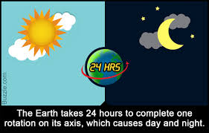

**Q. 2 Explain what a globe and a map are and the differences between them.**

Ans. A globe is a model of the Earth. The Earth is so large that we cannot see all of it at once. The globe shows what the Earth looks like. Flat maps are used to show parts of the Earth. In order to be able to read a map, it needs a title, scale, and a key.

**Assessment:**

**Read the chapter and do work page 6 and 7 from text book.**