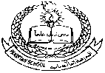

**Pakistan School , Kingdom of Bahrain**

**E- Support and Learning Material / Session 2020-2021**

**Subject: Social Studies FIRST TERM Grade : 6**

**CHAPTER 1: OUR COUNTRY IN THE WORLD Pg. No: 1 to 8**

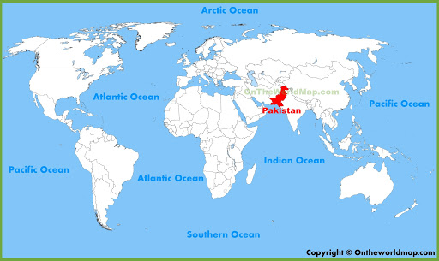

**TOPIC..GEOGRAPHY OF MUSLIM WORLD**

DETAILED QUESTION / ANSWERS

**Q#1(a).Where are most Islamic countries located? Why are they in this part of the world?**

Ans. Most Islamic countries are in the Middle East, Southern Asia, and Northern Africa.

The home of Islam is in Saudi Arabia and it spread outwards from here. Its progress was halted

by the solid barriers of Christianity in Europe and western Russia; by the virtually empty steppes

of central Asia; by the firmly established society in China; and the deserts of North Africa.

**(b). In which part of the world are there no Islamic countries?**

Ans. There are no Islamic countries in the Americas, Europe (apart from the tiny state of Albania where there are a few million Muslims), and in Australia.

**Q#2. In which part of Pakistan are the deserts located?**

Ans. In Pakistan deserts are located in south of Sindh and Balochistan. The Thar Desert which extends far into India and Pakistan and the Thal desert in the Indus valley. Cold deserts are found in the high mountains of the North.

**SHORT QUESTIONS/ ANSWERS**

(A).Where is Pakistan located in the subcontinent?

Ans. Pakistan is located in west of the subcontinent.

(B). What does a relief map show?

Ans. A relief map shows by means of different colors, the height of the land above sea level.

**TOPIC…PLATEAU AND MOUNTAIN RANGES OF PAKISTAN.**

**Q#3.Why, do you think, does the Punjab have the highest population in the country?**

Ans. The Punjab has been very fertile, producing bulk of agricultural products. Almost 80% of region is irrigated by a well-developed canal system that supports agriculture which is the main occupation of the people of Punjab. Therefore, 55% of the country’s population lives in the province of Punjab.

**SHORT QUESTION /ANSWERS**

(A).In which part of Pakistan are there mountains?

Ans. Much of the north and west of Pakistan consists of very high mountains.

(B).Write names of three famous mountain ranges of Pakistan?

Ans. Three famous mountain ranges of Pakistan are the Himalayas, the Karakoram and Hindu Kush.

(C).What is a mountain?

Ans. These are highest lands which are usually 2000 – 3000 metres above sea level. Mountains are sharp or pointed. In older mountains sharp points are usually worn out.

(D).What is a plateau?

Ans. These are areas of flat land above sea level. Some are fertile while others are poor land. 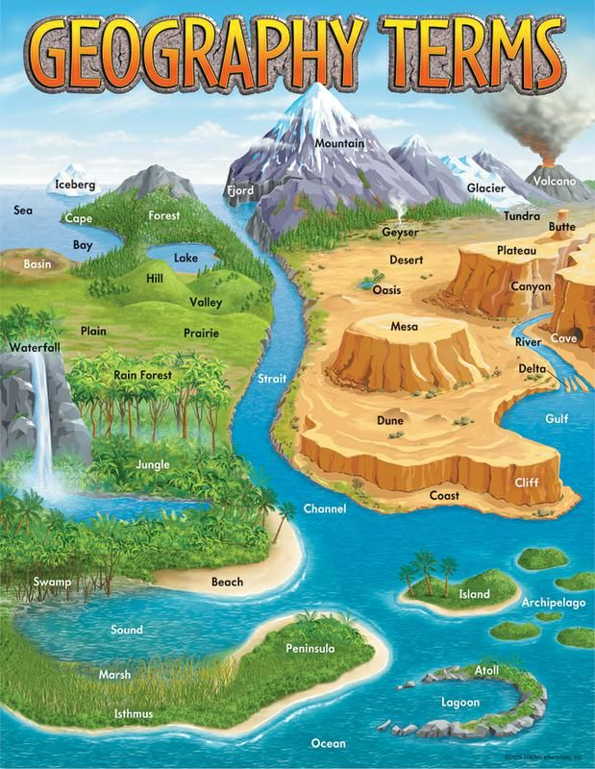

**Worksheet.**

Q.Complete the sentences by using correct words from brackets.

1.Mountains are the _________ lands. (flat, sandy, highest)

2.Hills are not as _______ as the mountains. (dry, big, sharp)

3.A hot dry place with hardly any plants is called ________.(plain, desert, plateau)

4.Areas of flat land at sea level are called __________.(valleys, deserts, plains)

**Homework.**

* Do Question 4 and 5 on notebooks.
* Look at map carefully and write names of at least 10 Islamic countries?