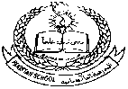

**Pakistan School, Kingdom of Bahrain.**

**E-Support and Learning Material/Session 2020-2021**

**Subject: Social Studies Grade: 8th**

**Book: 3 Secondary Social Studies for Pakistan. First Term Chapter:1 The Universe**

**Topic: The Universe Page#1**

**Q#1: Define Light Year.**

**Ans: Light year is the distance travelled by light in one year.**

**Q#2: What is Apollo 11?**

**Ans: Apollo 11 is a space shuttle which took the US astronauts to the moon in 1969. It was launched on 16 July and landed on the moon on 20 July, four days later.**

**Q3: What is solar system?**

**Ans: Solar system is the collection of eight planets and their moons, that orbit around the sun, together with smaller bodies in the form of asteroids, meteoroids and comets.**

**Q4: How does heat come from the sun?**

**Ans: The heat of the sun comes from a kind of nuclear explosion going on continuously in its heart. This heat is the source of all life on Earth.**

**Q5: How we can say that Saturn is an interesting planet?**

**Ans: Saturn is the second largest planet which has very short days and nights—less than half the duration of the Earth’s days and nights. It is made up of largely of gas, with an iron or rock core. Most of the people recognize Saturn by its seven gigantic ice rings.**

**Q6: Is there water on the surface of Moon?**

**Ans: It was long believed that there was no water on the Moon. However, feedback from space satellites show small pockets of ice on the Moon's surface facing away from the sun.**

**Q7: Why do we see the same side of the Moon?**

**Ans: The Moon rotates on its axis as it orbits the Earth. It takes 29 days to complete one rotation. This is why we always see the same side of the Moon.**

**Q8: How have the Hubble and Chandra telescopes helped scientists? Find out more about these telescopes.**

**Ans:** **The Hubble telescope is a space-based observatory which was launched in 1990. It has helped scientists to look further into space because, being in space and clear of the Earth’s atmosphere, it does not have problems with clouds which block the view of land-based telescopes, and is free from the dust and debris which is there. Because of its position in space and the clarity there, the Hubble can see more distant objects and also much more detail of the more familiar ones such as our planet. The information is sent back to Earth electronically.**

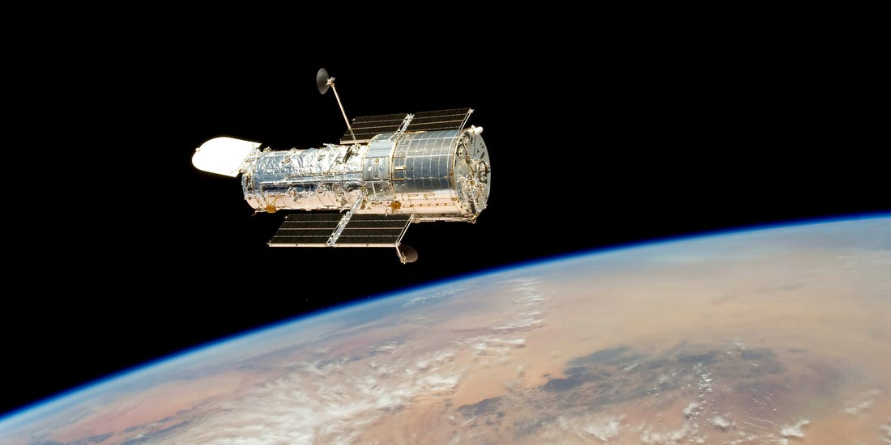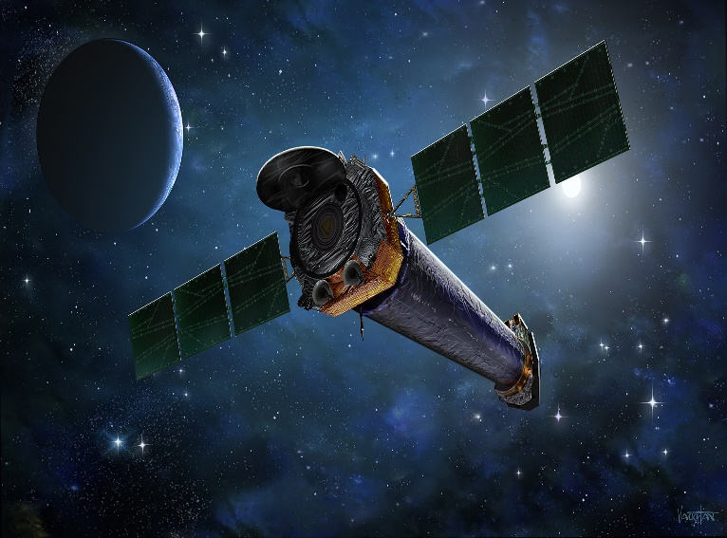

**Hubble Telescope Chandra Telescope**

**The Chandra telescope was launched on July 23, 1999. It consists of four pairs of mirrors and their support structure. Chandra is designed to observe X-rays from high-energy regions of the universe. Chandra is still a new telescope, but it has already made some amazing discoveries. It has found black holes all across the universe and also found proof for the first time of two super-massive black holes. It has also given clues about how the universe has evolved over time and even about the planets in our own neighborhood.**

**ASSESSMENT ACTIVITY**

**Q1: Select True and False.**

1. **Our Solar system has 7 planets.**
2. **Earth complete its round around the sun in 364 days.**
3. **Mercury is the nearest planet to Earth.**
4. **If you weighed 50kg on Earth, you would weigh almost 150 kg on Jupiter.**
5. **Saturn has 55 moons.**

**Q2:** **Match the solar system bodies in column A with their features in column B.**

|  |  |  |  |
| --- | --- | --- | --- |
|  | **A** |  | **B** |
| **a.** | **Sun** |  | **too close to the Sun** |
| **b.** | **Pluto** |  | **temp –140 °C to +17 °C** |
| **c.** | **Mercury** |  | **a star, centre of the solar system** |
| **d.** | **Mars** |  | **seven gigantic rings** |
| **e.** | **Saturn** |  | **no longer a planet** |

**Homework:**

**Make a diagram of our Solar System with planets and galaxies in your note book**