** Pakistan School , Kingdom of Bahrain**

**E- Support and Learning Material / Session 2020-2021**

**Subject: Social-studies Grade : 4**

**Book: Social-studies for Pakistan -- 4 FIRST TERM**

**Unit 1 : Lesson # 3 Climate**

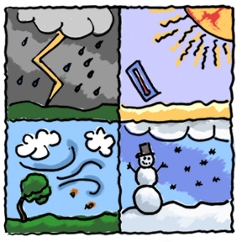

* **One line answers of the questions**

1. **How does the height of a place affect its climate?**

Ans: The higher the place is the colder the atmosphere becomes.

**2. What can happen to the climate in places where forests have been cut down?**

Ans: The climate of such places becomes dry because rainfall decreases.

**3. Name three factors that affect the climate of some region.**

Ans: a. Rainfall

b. Height or Altitude

c. Closeness to the sea

**Short Questions and answers.**

1. **What is the difference between weather and climate?**

Ans. **Weather** means the day to day conditions of heat and cold, humidity, dryness or rain in any place **while**

**Climate** is the weather conditions in a region over a long period of time

1. **What is the importance of climate for a region?**

Ans: Climate is an important factor because it has a great effect on people’s lives , plants , crops and on the land in an area.

1. **Why , do you think , is rainfall such an important factor for climate?**

Ans: Rainfall is an important factor for climate as it encourages plants growth and it cools and balances the temperature.

1. **What effects does closeness to the sea have on the climate of a place?**

Ans: Places close to the sea have the advantage of cool sea breezes blowing over the land and cooling it.

1. **Give examples of usefulness of weather forecasts.**

Ans: Weather forecasts help us to decide what to wear and whether to take an Umbrella , a sunhat , a coat or extra water with us when we go out.

1. **Name four climatic zones of Pakistan.**

Ans. Four climatic zones of Pakistan are

1. Highlands (mountains, cold)
2. Arid ( Deserts, hot and dry)
3. Semi-Arid ( hot summer, cold winter)
4. Coastal ( humid and mild )

**CHAPTER -- 3 CLIMATE**

**Assessment: 1**

**Fill in the blanks with suitable words.**

**(** people’s lives, rain, weather conditions, cool, less, equator seasonal, temperate, Monsoon, summer. )

1. Forests attract -------------.
2. Climate has a great effect on------------------.
3. The monsoon is a ---------wind.
4. Climate means -------------------------in a region over a long period of time.
5. Places close to the sea usually have ----------breezes.
6. The climate of a place can be very hot as on the --------------.
7. The western mountains get --------- rainfall.
8. Karachi has a -------------------climate.
9. -------------rains in Pakistan fall between the months of July and September.
10. In Pakistan , the monsoon arrives in the---------------

**Assessment: 2**

**Q:1 Match the column A with Column B**

|  |  |
| --- | --- |
| **Column A** | **Column B** |
| 1. Sindh and Balochistan are hot | atmosphere. (………..) |
| 2. Climate means | throughout the year. (…………..) |
| 3. The Earth is surrounded by | weather conditions. (…………..) |

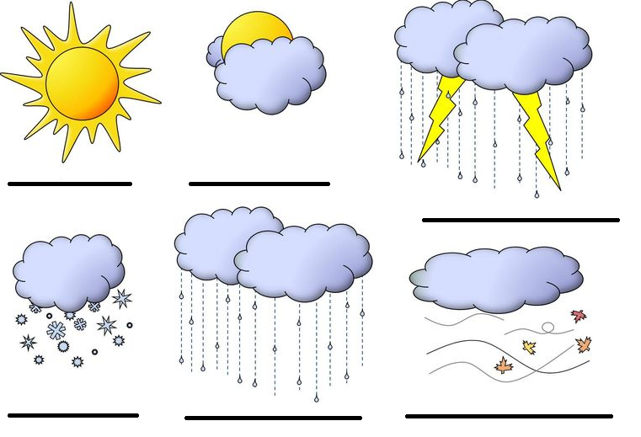**Q:2 Write the weather for each picture.**

**Assessment # 3:**

**Q:1 Choose the correct answer.**

1. Deserts are very ……………………….places. ( dry / rainy )

2. Karachi has a …………………………climate. ( cold / temperate)

3. Forests attract ……………………. ( rain / wind )

**Q:2 Fill in the blanks with suitable words.**

1. Where forests have been cut down , the amount of rainfall has………………………

2. In Pakistan , the monsoon arrives in the ………………………………….

3. In Pakistan, the winter rainfall is mainly in the…………………………………. of the country.

**Q:3 What do you know about the monsoon ?**

Ans:……………………………………………………………………………………………………………………………………………………………………………………………………………………………………………

**Homework to be done in the Text book**

Study the chapter # 3 and do following exercises.

**Page # 25** ( Ex: A ) , ( Ex: B ) and ( Ex: D )