**Pakistan School , Kingdom of Bahrain**

**E- Support and Learning Material / Session 2020-2021**

**Subject: Social Studies Grade : 6**

**BOOK: Oxford Secondary Social Studies for Pak--1 FIRST TERM**

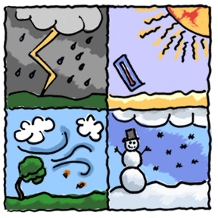 **Chapter 2: Weather and Climate Pg. No: 9 to 11**

**Q#1. Why is amount of rainfall so important for the climate?**

Ans. Rainfall is important in determining the climate of a place as less rainfall

can make a land dry and more rainfall affects the temperature of any place .

Crops and plants are also grown according to temperature of a place.

**Q# 2** .**What is a climate?**

Ans. Climate is the average weather condition over a whole year. The climate

of a country is very important. It decides what crops can be grown there and

how people live.

**Q. #3**.What is weather condition at Mount Kilimanjaro?

Ans. Mount Kilimanjaro is 5200 high is almost right on equator and its top is covered with snow all the year round.

**Q#4.Can you think of any other factor that might affect climate**.

Ans.(1).urban areas have higher temperature as compared to rural areas which have open space and more vegetation.

(2).size of a place; a small island has a different climate as compared to a land mass.

**Q#5.Listen the weather forecast and you see how air pressure is linked to fine or rainy weather In different parts of the country?**

Ans. Low air pressure will show strong or wet weather while high air pressure brings fine and dry weather.

**Q#6.Does air have weight?**

Ans.Air may not seem to have weight but it does .It is just that we do not normally feel it is just

**Q#7** **Name the factors that affect the temperature of a place.**

Ans. Temperature of some region depends up on the following factors

1. Distance from the equator
2. Altitude
3. Proximity ( nearness to the sea)
4. Ocean currents
5. Rainfall
6. Air pressure
7. Direction of the wind

**Sst 6th…chapter 2….worksheet and homework**

**Homework.**

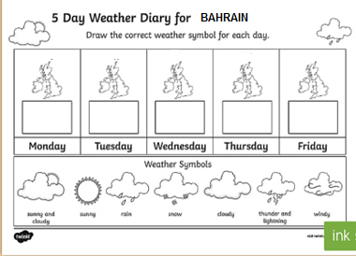

**WORKSHEET.**

Choose the correct options.

1. Climate is the average of the weather condition of _______.

a. Any one day b. few weeks c. whole year

2. The closer we are to the ________ the warmer and wetter it will be.

a.mountains b.equator c.deserts

3._______________ shows height of a place from sea level.

a.latitde b.altitude c.mountain

4.Places near the sea _______in summer and _________in winter.

a. hot and wetter b. cooler and milder c. warmer and dryer.

**Home work**

Search on internet and do question number 5 from pg. 11 of text book

**OR**

Write a note on how direction of wind can affect the temperature of certain region.