**Pakistan School , Kingdom of Bahrain**

**E- Support and Learning Material / Session 2020-2021**

**Subject: Computer Science Grade : 6**

**Book: Computer Education FIRSTTERM**

**Unit 1: The history of computer Week 1**

**Topic: computer evolution:**

**Objectives:** At the end of the lesson, students will be able to define a computer evolution.

**Q1. Write a short note on computer evolution.**

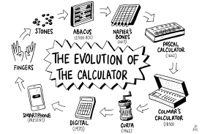

A Computer is an electronic machine which accepts the data, processed, Save,

the data according to our instruction .But do you know how the computer was developed?

The computers we use today are very different from the early devices that were invented for doing calculation.

Some of early calculating devices were as follows:

**Q2. What is Abacus?**

**The Abacus:**

1. 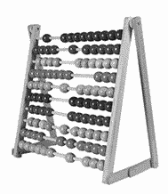It was one of the world’s first computers.
2. It was developed by Chinese about 5000 years ago.
3. It was built out of wood and beads
4. It was calculating machine for addition and multiplication

**Q3. Write down some features of pascaline.**

**The Pascaline:**

1. In 1641 Blaise Pascal invented the pascaline.
2. It was first mechanical calculator.
3. it consisted of a rectangular box with moveable wheels.
4. It was used for adding, subtracting, multiplying and dividing numbers up to the hundreds and thousands.

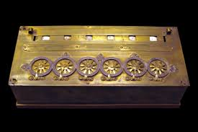

**Q4. Write a short note on Babbage’s Engine**

**Babbage’s Engine:**

1. The first calculating that can be truly called a computer. It was invented in England by Charles Babbage in 1835. Charles Babbage is called the father of computer.
2. Babbage’s dream was to build a machine that could do more than calculate big numbers.
3. It could receive instructions .it could process and store information. It could print the results. He planned to call it the Analytical Engine.

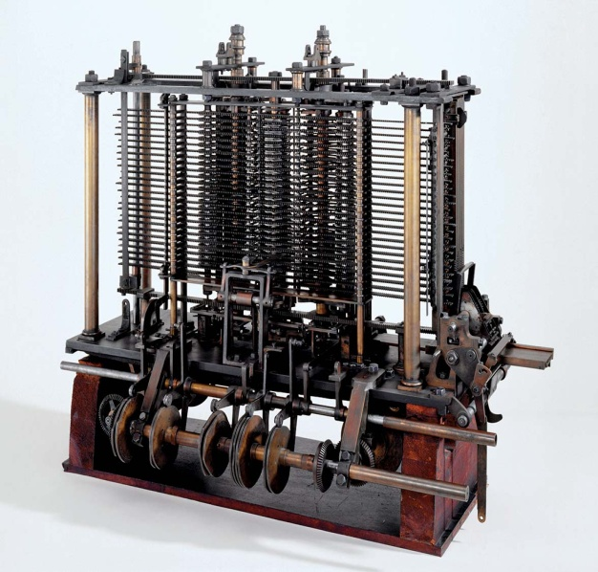

**Worksheet:**

1. **Fill in the blanks**
2. ___________________ is called the father of computer.
3. In _____________ the Pascaline was invented by ____________________.
4. ________________was developed by Chinese about 5000 years ago.
5. Analytical Engine was developed in ___________________________.
6. ________________consisted of a rectangular box with moveable wheels.

**True/False:**

1. The Abacus was one of the world’s first calculating computers.
2. Blaise Pascal made the first calculating machine in England.

**Homework**

**Define Abacus and Pascaline.**

**Write a short note on Babbage engine.**