

**Pakistan School, Kingdom of Bahrain**

**Subject: Maths E- Support and Learning Material**

**Class : 3**

**Activity No :1 Date: / /**

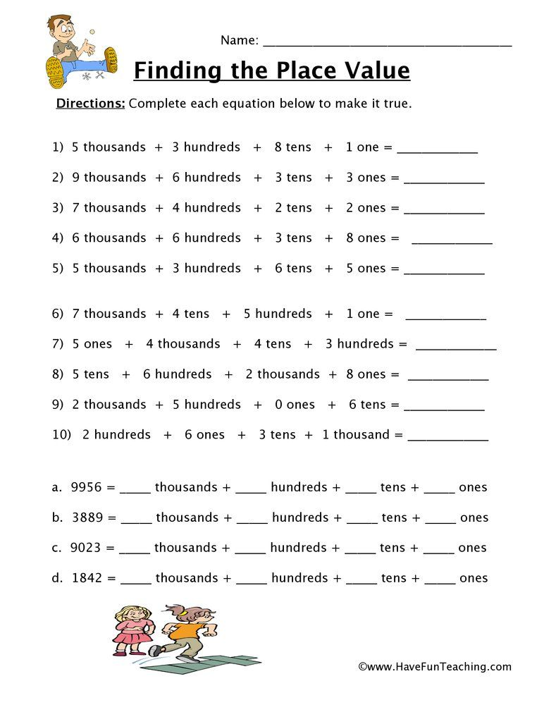 **Topic: Place value**

** Pakistan School, Kingdom of Bahrain**

**Subject: Maths E- Support and Learning Material**

**Class : 3 Name:___________________**

**Activity No : 2 Date: / /**

**Topic: Place value**

**Direction: find the value of the underlined digit.**

**1 : 3 4 5 6 = ________ 2 : 1 6 7 8 = _________ 3 : 2 5 3 1 = ________**

**4 : 10 5 6 = ________ 5 : 3 3 4 5 = ________ 6 : 1 8 5 1 = ________**

**Direction: read and write the numbers in 2 other forms.**

**Standard form : 3 4 5 6**

**Extended form : ___________________________________________**

**Word form: _______________________________________________**

**Standard form : ___________________**

**Extended form : ____________________________________________**

**Word form: Five thousand two hundred and thirty one**

**Standard form :**

**Extended form : 4000 + 800 + 90 + 1**

**Word form:**

**Direction : Use the number 8 9 7 6 for questions 1 – 3.**

**1: Write the digit in the thousand place: ______.**

**2: Write the value of the digit 7: ________.**

**3: Write the place that the digit 9 is in : ________.**

**Math book pg: 7 , 8 solve on Book.**