**Pakistan School , Kingdom of Bahrain**

**E- Support and Learning Material**

**Subject: Math Grade : 4**

**Unit 1: Numbers to 100 000**

**Lesson 1 : Number beyond 10 000**

**Q:1** Write the following in words.

1. 11 425

Eleven thousand, four hundred and twenty five.

1. 60 901

Sixty thousand, nine hundred and one.

***Practice: Q2 (B. Pg# 4)***

**Q:2** Write the following in numerals.

1. Eighty-five thousand, five hundred and two.

85,502

1. Twenty- one thousand, one hundred and eighty four.

21,184

***Practice: Q1 (B. Pg# 4)***

**Q:3** What does the digit **8** stand for?

1. 5**8**21

8 stands for hundred.

***Practice: Q4 (B. Pg# 4)***

**Q:4** Complete the following number sentences.

10 000 + + 300 + 20 + 5= 18 325

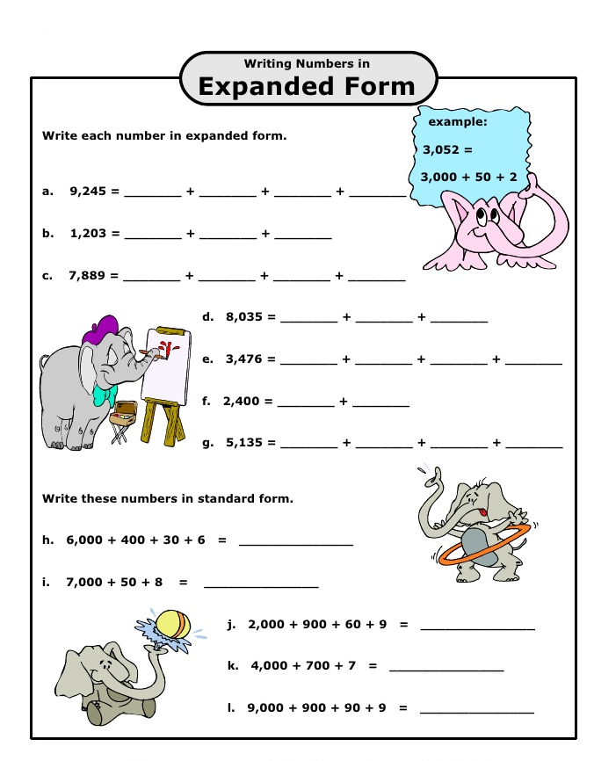 ***Practice: (B. Pg# 2 & 3)***

**Lesson 2: Comparing and ordering the number**

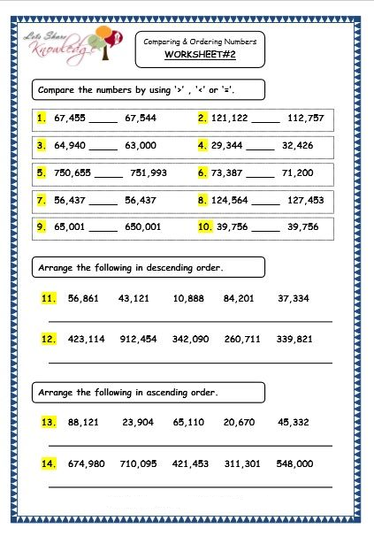***Practice: Q #1+2+3 (B. Pg# 7)***

**Lesson 3: Number Pattern**

**Q 2(a): Identify a number pattern for each of the following. What are the missing numbers?**

1. **988 , 998 , , , 1028 .**
2. **4037 , , 2037 , 1037 ,**

***Practice: (B. Pg#8+10 + 11 + 12)***

**Lesson 4: Round off to the nearest ten**

**Q:1** Round off each of the following to the nearest ten.

1. 18

**10 15 2 0**

**18 ≈ 20**

***Practice: (B. Pg# 15)***

**Round off to the nearest hundred**

**Q:1** Round off each of the following to the nearest hundred.

1. 4628

**4600 4650 4700**

**4628 ≈ 4600**

***Practice: (B. Pg# 17 + 18)***

**Round off to the nearest thousand**

**Q:1** Round off each of the following to the nearest **thousand**.

1. 46281

**46000 46500 47000**

**46281 ≈ 46000**

***Practice: (B. Pg# 20+21+22)***

**Lesson 5: Roman Numerals**

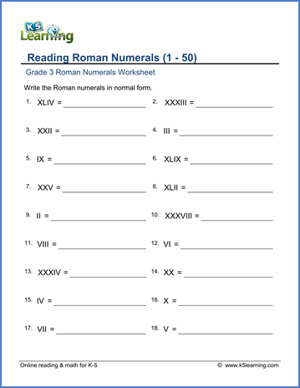

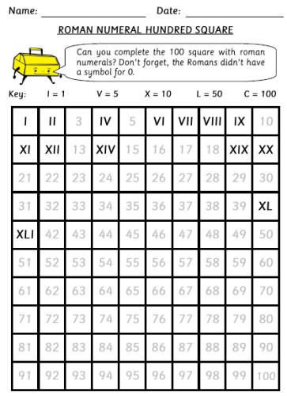

***Practice: (B. Pg# 24+25)***