** Pakistan School, Kingdom of Bahrain**

**E- Support and Learning material**

**Class H.KG (Topic: write in numbers)**

**Subject: Math (Isa Town / Manama)**

**Student Name: ________________________________________________**

Counting in figure 1 to 20:

|  |  |
| --- | --- |
|  |  |
|  |  |
|  |  |
|  |  |
|  |  |
|  |  |
|  |  |
|  |  |
|  |  |
|  |  |

Q2: book page no 2,3,4,5 read and write:

** Pakistan School, Kingdom of Bahrain**

**E- Support and Learning Material**

**Class H.KG (Topic: write in numbers)**

**Subject: Math (Isa Town / Manama)**

**Student Name: ________________________________________________**

Counting in figure2 1 to 50:

|  |  |  |
| --- | --- | --- |
|  |  |  |
|  |  |  |
|  |  |  |
|  |  |  |
|  |  |  |
|  |  |  |
|  |  |  |
|  |  |  |
|  |  |  |
|  |  |  |

Q2: Book page no 5,6,7,8,read and write:

** Pakistan School, Kingdom of Bahrain**

**E- Support and Learning Material**

**Class H.KG (Topic: write in numbers)**

**Subject: Math (Isa Town / Manama)**

**Student Name: ________________________________________________**

Counting in figure2 1 to 50:

|  |  |  |
| --- | --- | --- |
|  |  |  |
|  |  |  |
|  |  |  |
|  |  |  |
|  |  |  |
|  |  |  |
|  |  |  |
|  |  |  |
|  |  |  |
|  |  |  |

Q2: Book page no 5,6,7,8,read and write:

** Pakistan School, Kingdom of Bahrain**

**E- Support and Learning Material**

**Class H.KG (Topic: write in numbers )**

**Subject: Math (Isa Town / Manama)**

**Student Name: ________________________________________________**

Write in the house the missing numbers(1-50):

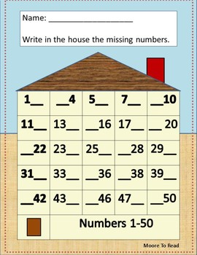

Q2: book page no 14,15,16,17,read and write: