 **PAKISTAN SCHOOL, KINGDOM OF BAHRAIN**

**E-Support and Learning Material**

**Subjects: MATHS Class LKG ( )**

**TOPIC: Number 1**

**Student Name: _________________________________________________**

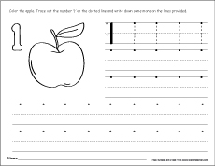Color, Trace and Write the Number 1

Text Book Page number 32- 33

Link. <https://youtu.be/jwQ3eeu5o9g>

 **PAKISTAN SCHOOL, KINGDOM OF BAHRAIN**

**E-Support and Learning Material**

**Subjects: MATHS Class LKG ( )**

**TOPIC: NUMBER 2**

**Student Name: _________________________________________________**

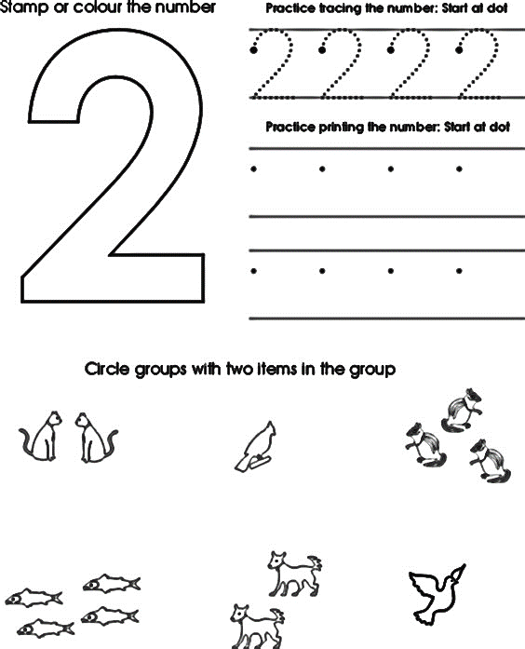Color, Trace and Write the number 2

Text Book Page number 14 – 15

**PAKISTAN SCHOOL, KINGDOM OF BAHRAIN**

**E Support and Learning Material**

**Subjects: MATHS Class LKG ( )**

**TOPIC: NUMBER 3**

**Student Name: _________________________________________________**

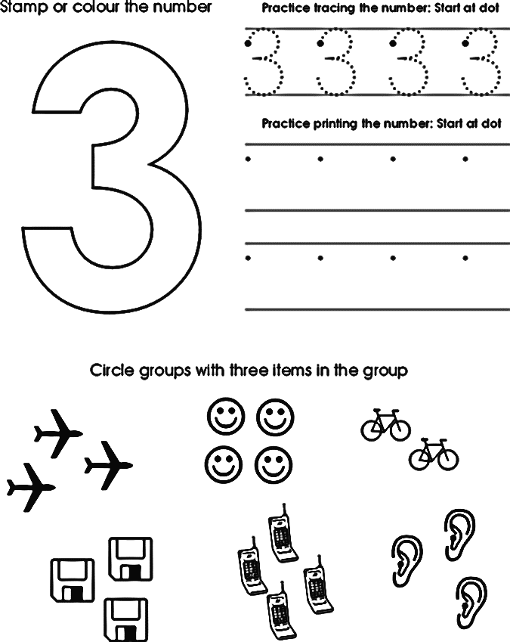

Text Book Page number 26-27

Trace and Color the Number 4 Text Book Page 28-29

**PAKISTAN SCHOOL, KINGDOM OF BAHRAIN**

**E-Support and Learning Material**

**Subjects: MATHS Class LKG ( )**

**TOPIC: NUMBER 4**

**Student Name: _________________________________________________**

Watch the link below and answer the following questions

Trace and color the number 4

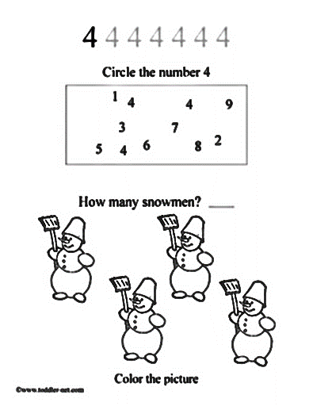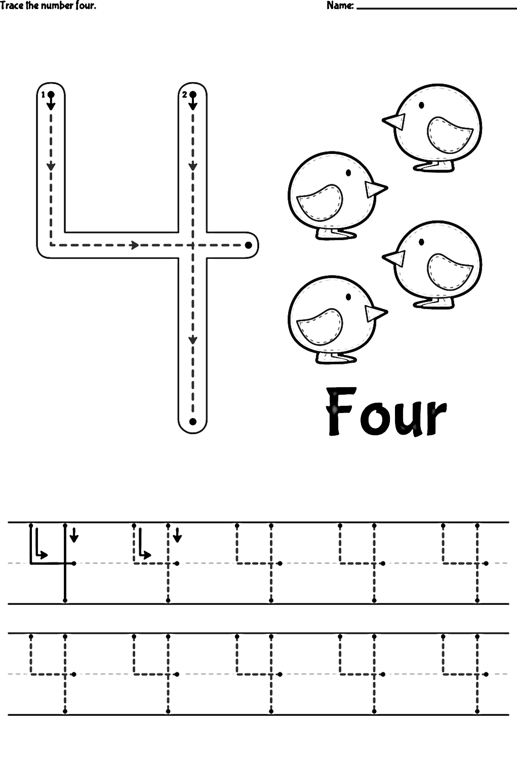

Link; <https://youtu.be/NDb5vsgJSxc>

Text Book page 42-43