** PAKISTAN SCHOOL, KINGDOM OF BAHRAIN**

**E-Support and Learning Material**

**Subjects: MATHS Class LKG ( )**

**TOPIC: NUMBER 5**

**Student Name: _________________________________________________**

Watch the link below to guide you solve the activity.

Trace and read the number 5

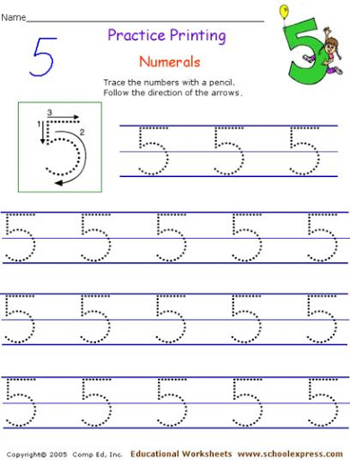

Text Book Page 38- 39

Link; <https://youtu.be/O6vw7SPPuMw>

**PAKISTAN SCHOOL, KINGDOM OF BAHRAIN**

**E-Support and Learning Material**

**Subjects: MATHS Class LKG ( )**

**TOPIC: REVISION (1- 5)**

**Student Name: _________________________________________________**

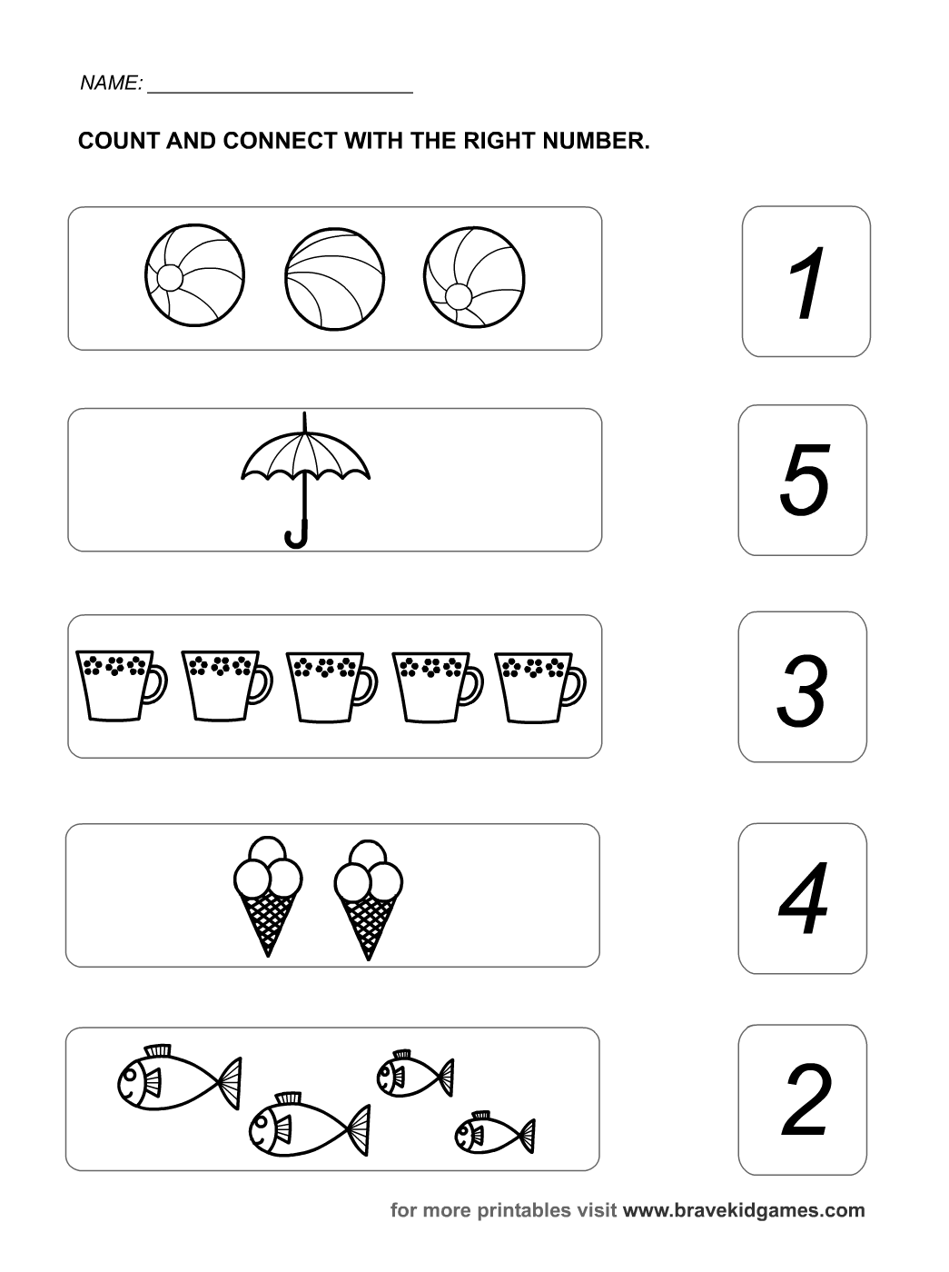

**PAKISTAN SCHOOL, KINGDOM OF BAHRAIN**

**E-Support and Learning Material**

**Subjects: MATHS Class LKG ( )**

**TOPIC: NUMBER 6**

**Student Name: _________________________________________________**

Watch the link below to help you complete the boxes

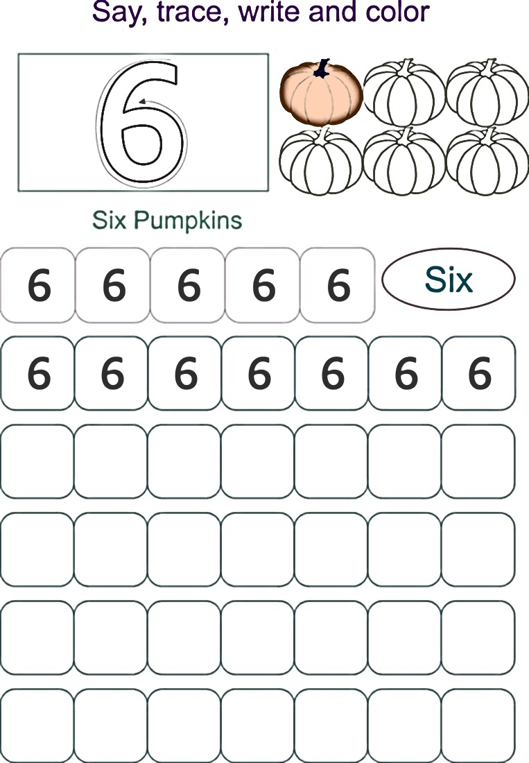

Text Book Page number 32-33

Link; <https://youtu.be/8vr1YxYjUAI>

**PAKISTAN SCHOOL, KINGDOM OF BAHRAIN**

**E-Support and Learning Material**

**Subjects: MATHS Class LKG ( )**

**TOPIC: NUMBER 7**

**Student Name: _________________________________________________**

Color, count and trace the number 7

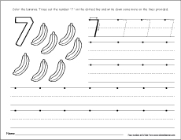

Circle the number 7

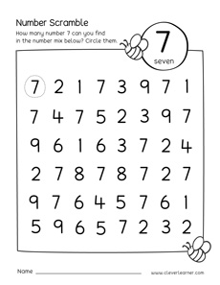

Text Book Page 40-41

Link; <https://youtu.be/WGdB07UP_VY>