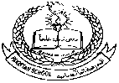**Pakistan School , Kingdom of Bahrain**

**E- Support and Learning Material**

**Subject: Math Name:________________________ Grade : 1 ( )**

* **Topic # 2. Table of 3**

**Q: - Write Table of 3 (1 to 5).**

|  |  |  |  |  |
| --- | --- | --- | --- | --- |
| **3** | **x** | **1** | **=** | **3** |
| **3** | **x** | **2** | **=** | **6** |
| **3** | **x** | **3** | **=** | **9** |
| **3** | **x** | **4** | **=** | **12** |
| **3** | **x** | **5** | **=** | **15** |

***\*Note: HW: learn well the table & write 2 times more.***

**Q: 1A- Circle the correct ans.**

**(Activity- 1)**

1. 3 x 2 = **( 9 6 )**
2. 3 x 1 = **( 5 3 )**
3. 3 x 3 = **( 9 10 )**
4. 3 x 5 = **( 20 15 )**

**Q: 1B- Match with the correct option.**

**(Activity- 2)**

* 1. 3 x 1 = **9**
  2. 3 x 2 = **15**
  3. 3 x 3 =  **3**
  4. 3 x 4 = **6**
  5. 3 x 5 = **12**

**Q: - Write Table of 3 (6 to 10).**

|  |  |  |  |  |
| --- | --- | --- | --- | --- |
| **3** | **x** | **6** | **=** | **18** |
| **3** | **x** | **7** | **=** | **21** |
| **3** | **x** | **8** | **=** | **24** |
| **3** | **x** | **9** | **=** | **27** |
| **3** | **x** | **10** | **=** | **24** |

***\*Note: HW: learn well the table & write 2 times more.***

**Q: 1A- Circle the correct ans.**

**(Activity-1)**

1. 3 x 6 = **( 18 22 )**
2. 3 x 7 = **( 17 21 )**
3. 3 x 8 = **( 19 24 )**
4. 3 x 10 = **( 30 15 )**

**Q: 1B- Fill in the blanks.**

**(Activity-2)**

|  |  |  |  |  |
| --- | --- | --- | --- | --- |
| **3** | **x** | **7** | **=** |  |
| **3** | **x** | **6** | **=** |  |
| **3** | **x** | **10** | **=** |  |
| **3** | **x** | **9** | **=** |  |
| **3** | **x** | **8** | **=** |  |

**Assessment**

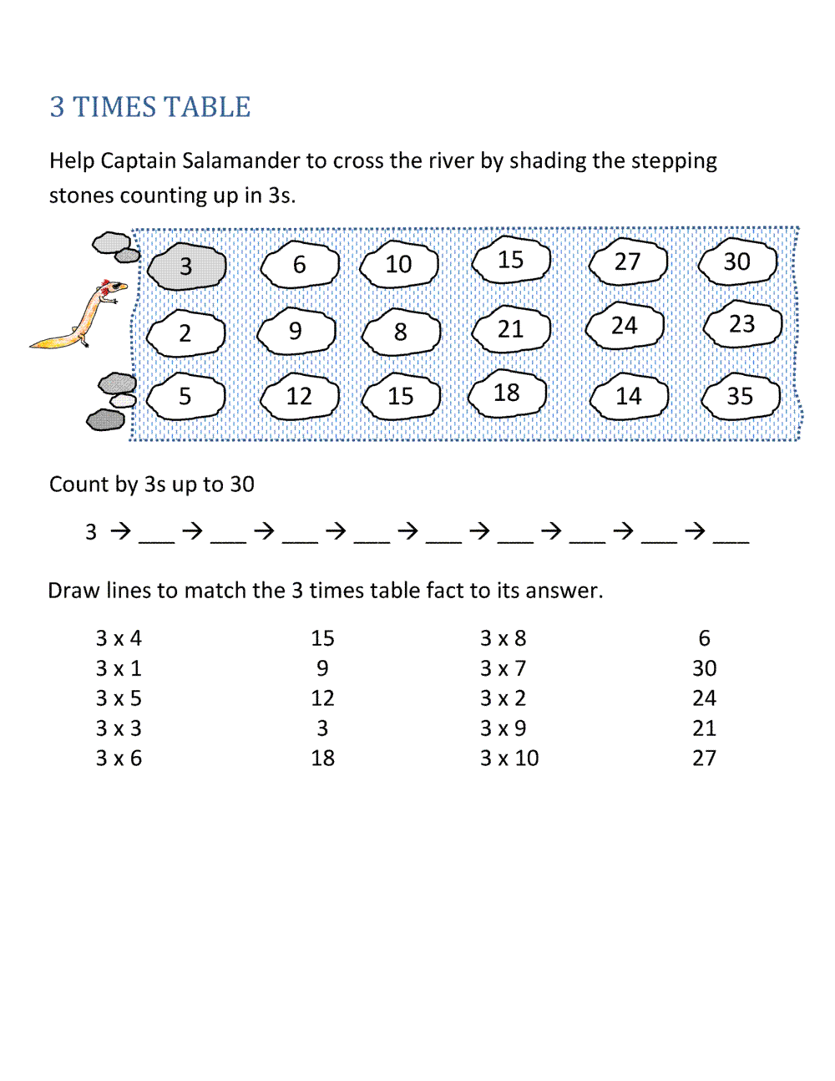

21

3