 Pakistan school ,Isa town kingdom of Bahrain

E-support and learning Material / session 2020-2021

Subject :Science Grade :3 Book : simply science 3

Unit No:1: Moving and growing 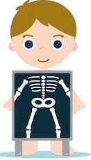

Topic: Skeleton pgs no: 2-3

Q1.Answer the following questions in detail.

a .What is a skeleton?

Ans .The bones inside our body all join up to form a frame is called a skeleton.

b. Describe in your own words why you need your skeleton.

Ans .We need a skeleton because

1.it gives our body a proper shape and strength

2.it protects our soft inner body organs.

3.It helps in body movement.

Q2.Give short answers of the following questions.

a.how many bones are there in your lower arm?

Ans: Two bones

b.What is the name of anly part of your skull that you can move /

ans.Jaw bone.

c.What do we call the part of the skeleton between your thigh and lower leg bone.

d.what do hospital doctors use to find out whether the bone is broken? 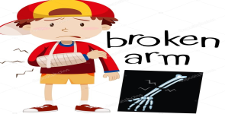

Ans.X-ray

e.What is the name of the jelly like substance in your long bones and what job does it do?

Ans.It is called marrow, it helps to make blood.