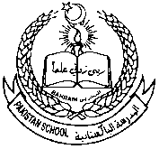 Pakistan school ,Isa town kingdom of Bahrain

E-support and learning Material / session 2020-2021

Subject :Science Grade :3 Book : simply science 3

Unit No:1: Moving and growing

Topic: Skeleton /more skeleton pgs no: 2-5

Note: Attempt any two worksheets

work sheet no:1

Q1.Label the parts of the skeleton with the help of given words.

(Skull , ribs , thigh bone , lower leg bone , spine or back bone , jaw bone , collar bone , pelvis , toe bone , knee cap )

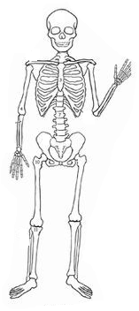

.

 Pakistan school ,Isa town kingdom of Bahrain

E-support and learning Material / session 2020-2021

Subject :Science Grade :3 Book : simply science 3

Unit No:1: Moving and growing

Topic: Skeleton pgs no: 2-3

Work sheet No : 2

Q1. Name the following.

1. our brain is protected in :__________________________

2. Cage of bones that helps to protect our heart and lungs.________________

3.Inside our backbone is our delicate :_________________________

Q2. which important functions does the skeleton have in the human body. tick the correct boxes.

a.protection b. health

c.movement d .comfort

e.Growth f .support

 Pakistan school ,Isa town kingdom of Bahrain

E-support and learning Material / session 2020-2021

Subject :Science Grade :3 Book : simply science 3

Unit No:1: Moving and growing

Topic: Skeleton pgs no: 2-3

Worksheet No: 3

Q3. Label parts of a thigh bone.

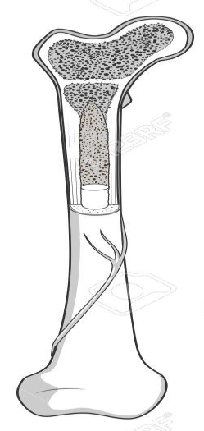 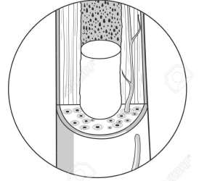

Q2.Match the column A with column B and write answer in column c.

|  |  |  |  |  |
| --- | --- | --- | --- | --- |
|  | Column A | Column B | | Column c |
| 1 | Total no of bones in an adult body | Ear bone | |  |
| 2 | The longest bone in human body | Hands and feet | |  |
| 3 | Smallest bone in the human body | Bones strong | |  |
| 4 | Over half of our bones are found in | 206 |  | |
| 5 | Calcium salts from milk and cheese help to make | Thigh bone |  | |

**Home work:**

Learn Q1( a & b ) and Q2( a---e) from notes.