 Pakistan school ,Isa town kingdom of Bahrain

E-support and learning Material / session 2020-2021

Subject :Science Grade :3 Book : simply science 3

Unit No:1: Moving and growing

Topic: More skeleton/Animals without back bones pgs no: 6 ,7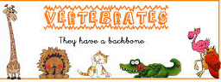 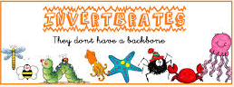

Q1.Answer the following questions.

a.What are vertebrate ?give examples.

Ans.Animals with a backbone and a skull are called vertebrate. for example cat , fish and bird etc

b.what are invertebrates? Give examples also.

Ans.animals without backbone and internal skeleton are called invertebrates. For example jelly fish ,earth worm and crab etc.

c.Explain in your own words what do you mean by external skeleton?

Ans.A shell or some other hard covering on the outside of an animal’s body is called its external skeleton.

Q.Fill in the blanks with suitable words.

1.A crab has an outside or external skeleton.

2. An Earthworm and jelly fish has no protection.

3.Insects and spiders have tough leathery skin.