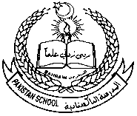 **Pakistan School, Kingdom of Bahrain**

**E –Support and Learning Material**

**Class H.KG (Topic: assignment: 1 )**

**Subject: Science (Isa Town / Manama)**

**Student Name: ________________________________________________**

**Parts of body**

**Q1: Match the following parts with their name:**

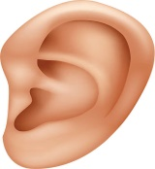

**Eye**

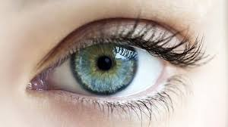

**Ear**

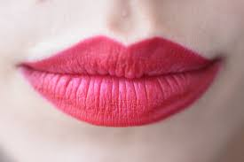

**Nose**

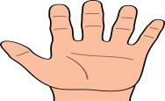 Eye

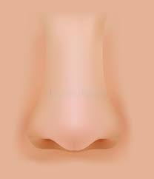

Hand

**Q2: Choose the correct answer and fill in blanks:**

**1: We see things with ours ------------. (Eyes ear)**

**2: We ------------------ with our ears. (Walk, listen)**

**3: We need ----------------- to carry the things. (lips ,hand)**

**4: I ----------------- the things with nose. (Smell, touch)**

**Q3:Write the name of each part:**

******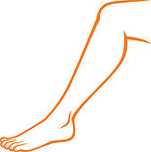(Eye ,Ear ,Leg ,** **Nose ,Teeth)**

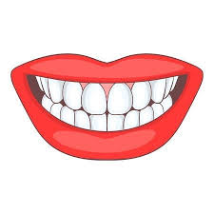

------------------------- ----------------------



----------------------------- ----------------------

----------------------

**Do Science Book pg : 4 , 5 , 6**