 Pakistan school ,Isa town kingdom of Bahrain

E-support and learning Material / session 2020-2021

Subject :Science Grade :3 Book : simply science 3

Unit No:1: Moving and growing

Topic: More skeleton / Animals without backbones pgs no: 5--7 worksheet no: 1

Q1. Match the skeleton with the animal.

bird 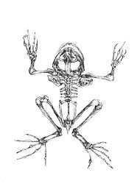

frog 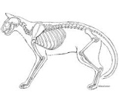

cat 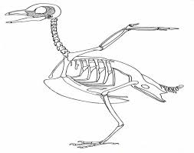

Q2.Name five main groups of vertebrates.

a._______________________________________

b.-______________________________________

c._______________________________________

d._______________________________________

e._______________________________________

**Home Work :**

Make a list of any five vertebrates or invertebrates paste their pictures also.

Learn Q1 (a , b & c).

 Pakistan school ,Isa town kingdom of Bahrain

E-support and learning Material / session 2020-2021

Subject :Science Grade :3 Book : simply science 3

Unit No:1: Moving and growing

Topic: More skeleton / Animals without backbones pgs no: 5--7 worksheet no: 2

Q1. Circle invertebrates with red and vertebrates with blue from the given animals.

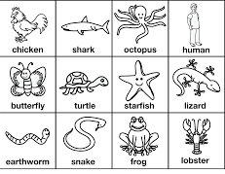Q2. Choose the correct answer.

1.Animals without back bone are called ____________________. ( invertebrates , vertebrates)

2.Crab and lobster have ____________________ skeleton. ( internal ,external )

3.Jelly fish is an __________________________.( invertebrates , vertebrates )

**Home Work** :

Search and write whether a tortoise is a vertebrate or invertebrate.

Learn worksheet no 1.

 Pakistan school ,Isa town kingdom of Bahrain

E-support and learning Material / session 2020-2021

Subject :Science Grade :3 Book : simply science 3

Unit No:1: Moving and growing

Topic: More skeleton / Animals without backbones pgs no: 5--7 worksheet no: 3

Q1. Circle animals with shells.

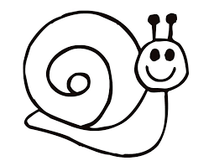 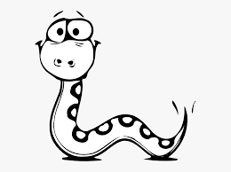 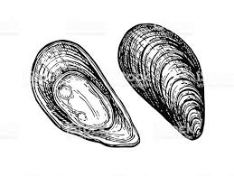

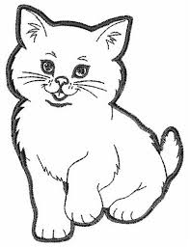 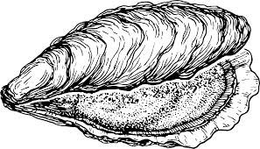 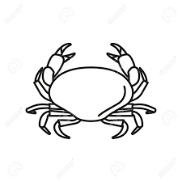

Q2. Name any three animals with shell.

a.____________________________ b.____________________________

c.____________________________

Q3.writewhether the statement is true or false.

a. All animals have internal skeleton.________

b. Animals without skeleton has no protection.____________

c. Scorpion and sea anemone are invertebrates.____________

**Home Work :** collect pictures of any five animals with shell. or

Collect pictures of any five animals with hard covering on their body.