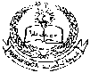 **E- Support and Learning Material / Session 2020-2021**

**PAKISTAN SCHOOL, M/O EDUCATION, KINGDOM OF BAHRAIN**

**Subject: Computer Grade: 2**

**Book: OXFORD KEYBOARD Book-2 (Third Edition)**

**FIRST TERM NOTES**

**Chapter 2:- Parts of a Computer (Week 3)**

**Topic 1: - The Computer— A Machine**

**OBJECTIVE**

The student should be able to:

* **Identify**  a computer system

(i) List the four main parts of a computer.

* **Describe** what the monitor is used for

1. The monitor and its resemblance with a television

**Q1. Write T for the true statement and F for the false one:-**

1. The CPU controls all the parts of a computer, except for the input devices. **_False___**
2. Speakers can be used to listen to music without disturbing others. **_False___**
3. A CD can store more data than a DVD. **_False___**
4. A USB can be easily carried in your pocket. **__True__**

**Q2 (a) what are the four main parts of a computer?**

Ans: There are four main parts of a computer

1. Monitor
2. CPU
3. Keyboard
4. Mouse

**Q2 (b) what is Monitor?**

Ans: Monitor look like a TV and can be used to see pictures.

**Q3. Label the four part of a computer system:-**

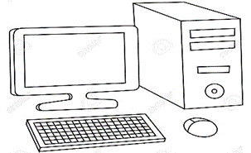

A………………….. B…………………..

.

C………………….. D………………….

1. __Monitor__
2. CPU____
3. Keyboard__
4. Mouse____

--------------------------------------------------------------------------------------------------------------------------