**E- Support and Learning Material / Session 2020-2021**

**PAKISTAN SCHOOL, M/O EDUCATION, KINGDOM OF BAHRAIN**

**Subject: Computer**

**Grade: 3**

**Book: OXFORD KEYBOARD Book-3 (Third Edition)**

**FIRST TERM NOTES**

**Chapter 1 (Topic 5: - Taskbar) Week 3**

**OBJECTIVE**

The student should be able to:

* **Identify** the position of the taskbar.
* **Describe** The left pane and right pane of the Start menu.

**Q1. (a) Fill in the blanks:-**

1. The taskbar is a long, horizontal bar at the bottom of the **__desktop__** screen.
2. The taskbar has buttons and **__icons__** of program open on the Computer.
3. The Start button is found at the bottom **_left__** corner of the Desktop.
4. The middle section of the taskbar displays the **_open**___ program.

**Q1. (b) True and False:-**

1. A folder is used to store a group of files. **__True__**
2. Any piece of information stored in a computer is Icon. **__False__**
3. A file can contain data and program. **__True__**
4. The middle section of the taskbar displays the open program. **__True__**
5. The Start button is found at the bottom right corner of the Desktop. **__False__**

**Q2. Circle or Underline the correct options:-**

1. Double-clicking the __________ mouse button can open any program on the desktop.

(i)Right **(ii) Left_** (iii) both i & ii (iv) none of these

2. The start menu is divided into how many panes?

(i)One **(ii) Two_** (iii) Three (iv) Four

3. A folder can contain

(i) Folder’s (ii) File’s **(iii) both i & ii** (iv) none of these

1. Any piece of information stored in the computer is in the form of a ______.

(i)Taskbar **(ii) File__** (iii) Icons (iv) desktop

5. Double-click the program icon to _________ the program.

(i)Open (ii) New **(iii) Start** (iv) desktop

**Q3.Answer the following:-**

**1. What does the left pane of the Start menu show?**

Ans: The left pane of the Start menu shows the recently opened programs.

**2. Why might you not be able to move the taskbar? Also, offer a solution.**

Ans: We might not be able to move the taskbar if it is locked. To unlock it, right-click an empty space on thetaskbar; a context menu will appear. Click on the ‘Lock the Taskbar’ checkmark so it disappears.

**3. Outline the steps required to change the position of a taskbar?**

**Ans:** The steps required to change the position of the taskbar:

i. Click the mouse directly on the taskbar.

ii. Hold the mouse button, dragging it to whichever place on the desktop you want it.

iii. The taskbar can be moved to the left, right, top, or bottom of your desktop.

iv. Release the mouse once you have placed the taskbar in the desired position.

**Chapter 1 (Text-Book Pg 8)**

**Application –Based Questions:-**

1. Rahman’s father has purchased a new computer to be used by Rahman at home.
2. **Which type of operating system should he install ------ single-user or multi-user?**

Ans: He should install Single-user operating system.

1. **Give one example of a popular operating system that he could install?**

Ans: Windows 7 or Windows 8

1. **Observe the following figure and answer the questions given below:**

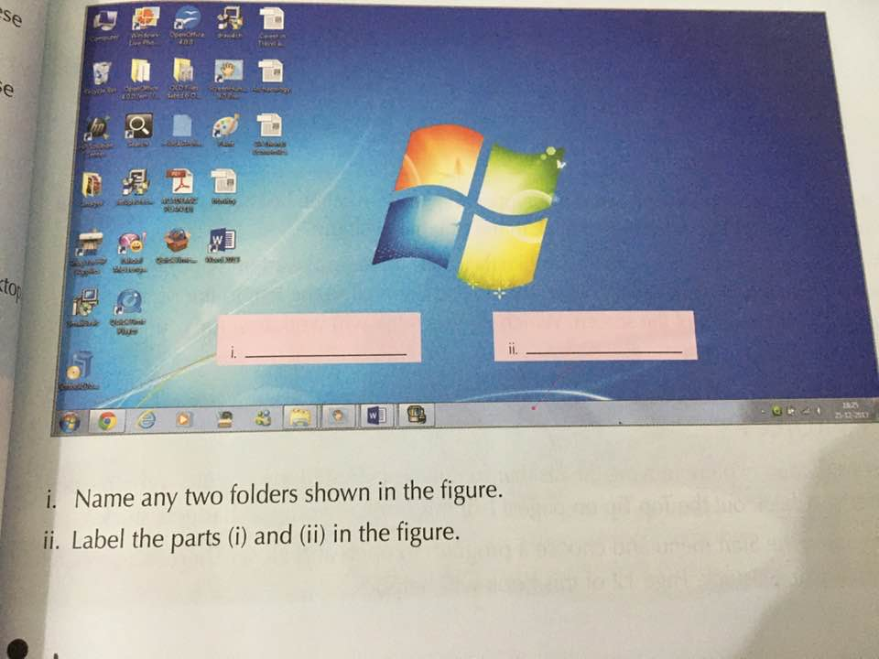

1. **Name any two folders show in the figure?**

Ans: Images, Open Office 4.0.0

1. **Label the parts (i) and (ii) in the figure?**

Ans: (i) Start button (ii) Taskbar

**Chapter 1 (Text-Book Page 9)**

**PROJECT:-**

1. **Find out which operating system is loaded on the computer:**
2. **In of your school’s computer lab**

Ans: Windows 7 operating system

1. **At your home**  Ans: __________________
2. **Look at the desktop of a computer and the draw :**
3. **Any two icons on the desktop**



My PC

**Ans**

1. **Icons of a folder and of the recycle bin**

**Ans**

Recycle Bin

Folder