**Pakistan School, Kingdom of Bahrain**

**E- Support and Learning Material / Session 2020-2021**

**Subject: Computer Grade: 4**

**Book: Oxford Keyboard Book 4 (Third Edition) FIRST TERM**

**Unit 2: Input and Output Devices Week 3**

**Topic: Input Devices**

**Objectives:**

The student should be able to:

* name various input devices.
* identify the concept of a pointing device.
* specify the uses of various input devices.

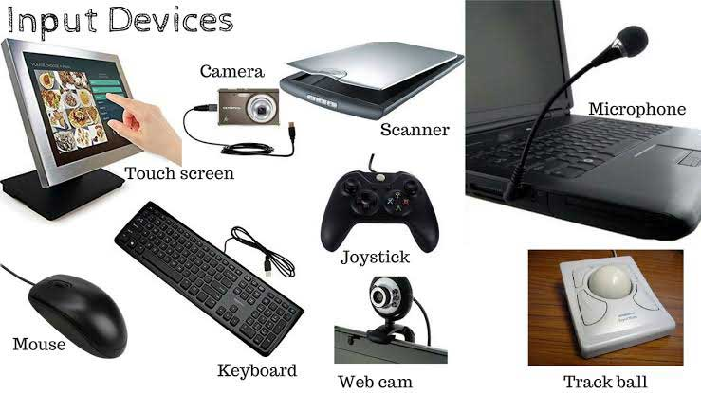

**Q.1 What is an input device? Name any two input devices.**

**Ans.** The devices that we use to enter data into a computer are called input devices. Mouse and keyboard.

**Q.2 What is a pointing device?**

Ans. A pointing device, is a hardware input device that allows the user to move the mouse cursor in a computer program.

**Q.3 Write down the names of pointing devices?**

Ans

1. Mouse
2. Trackball
3. Joystick
4. Light pen

**Q.4 What do you know about a keyboard?**

Ans. A keyboard is an input device. It has many keys on it. It is used to enter data into the computer. It has some extra keys that are used for various functions.

**Q.5 What do you know about a mouse?**

Ans. The mouse is commonly used input device. It has two or more buttons that perform different functions. The scroll wheel acts as a third button.

**Q.6 What is the use of a scanner?**

Ans. A scanner is an input device. It is used to scan or transfer pictures, drawings or text to the computer. Flatbed scanners are some of the most commonly used scanners.

**Q.7 What do you know about a web camera?**

Ans. It is an input device. It is also called Webcam. It is used to take images that can be viewed on a computer. It is also used for video chatting.

**Q.8 Which type of camera is used to record still photos?**

Ans. Digital camera is used to record still photos.

**Q.9 Cameras are often an integral part of a computer, specially a laptop or hand held device. What are the advantages and disadvantages of having a camera within a computer? Give examples to illustrate your response.**

Ans. Some examples to explain the uses of cameras are:

* Cameras built into the computer offer quick communication with people who are not physically around. It is better than a traditional telephone conversation because you can see the other person as you speak.
* It makes distance learning easier because the instructor can explain concepts visually using sketches and diagrams and conduct online training sessions or group study.

**Q.10 An architect is designing the floorplan of a house. Which do you think is the best input device to use for the task? Will he need more than one type of input device?**

Ans. The best input device for an architect to design the floorplan of a house is a light pen. It enables the architect to draw directly on the screen. Drawing smooth straight lines is easier to do with a light pen than a mouse.

* **Choose the correct option.**

1. An input device used to take video with sound and still photographs.

1.printer 2.digital camera 3.scanner 4.none of these

**b.**  It reads and scans text and pictures directly into the computer.

1.monitor 2.printer 3.scanner 4.none of these

**c.** Which of these is a pointing device?

1.mouse 2.keyboard 3.monitor 4.printer

* **Complete these sentences using suitable words given.**

|  |  |  |  |  |  |
| --- | --- | --- | --- | --- | --- |
| **keyboard** | **mouse** | **trackball** | **input** | **Web camera** | **microphone** |

1. Input devices enable you to enter data into the computer.
2. A trackball has a ball on the top, which is rolled with a finger to move the pointer.
3. A microphone is used to input and record voice, sound and music on a computer.
4. A web camera takes a series of images that can be viewed on a computer.
5. Mouse is a pointing device.
6. Keyboard have many keys on it.

**Homework: Ref. Book Page # 11**

* You want to copy some pictures from a book to your computer. Name the device you should use for this purpose and why?