

**E-support and learning Materials /session 2020-2021**

**Subject: Computer Grade: 1**

**Unit 2**: Parts of a computer

**NOTES**

**PAKISTAN SCHOOL, M/O EDUCATION, KINGDOM OF BAHRAIN**

**FIRST TERM (Week 3)**

**Topic:** Parts of computer

**Objectives:-**

* Identify parts of computer
* Describe parts of the computer

**Q1: Name the parts of computer:**

|  |  |  |  |
| --- | --- | --- | --- |
| **mouse** | **monitor** | **CPU** | **keyboard** |

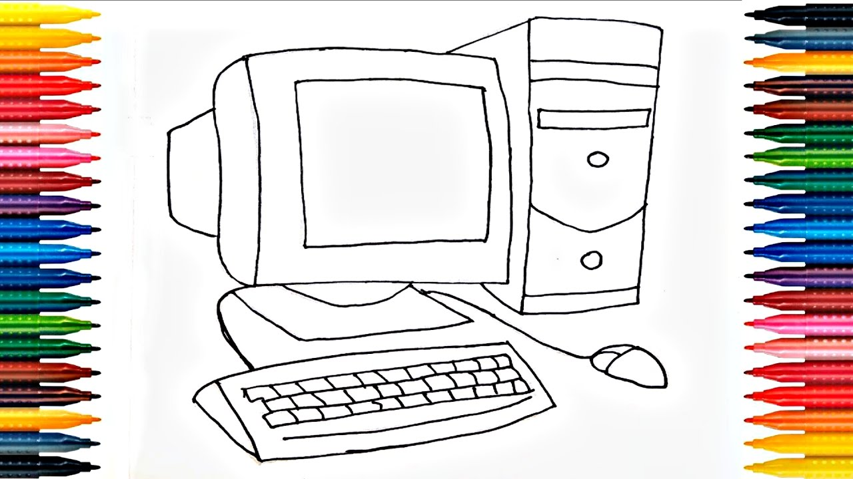

Monitor

Keyboard

Mouse

CPU

**Q2: Match the followings**

1. CPU typing
2. Keyboard looks like a television
3. Monitor brain of a computer