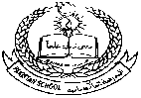**Pakistan School , Kingdom of Bahrain**

**E- Support and Learning Material / Session 2020-2021**

**Subject: English Grade : 1**

**Grammar Club : Unit 1 - A and an**

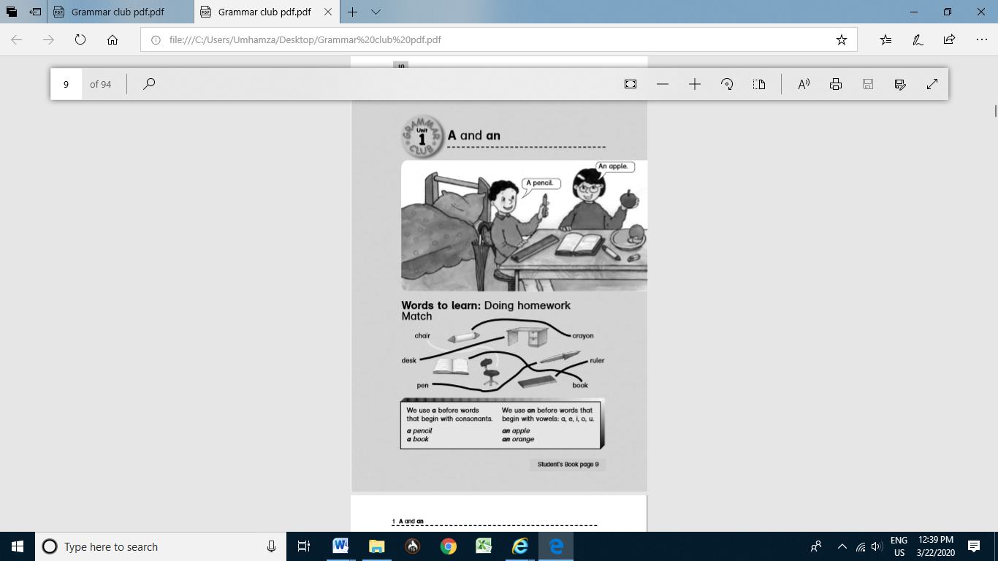

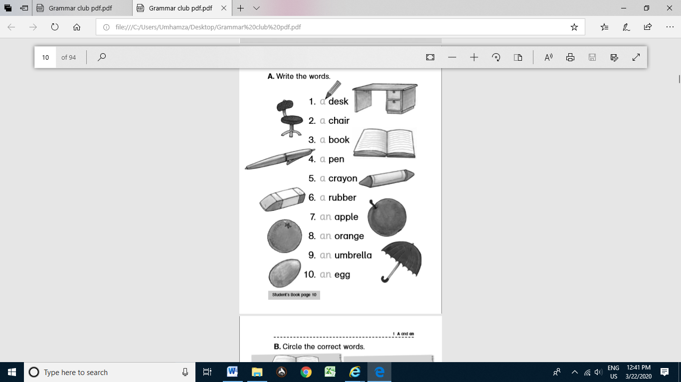

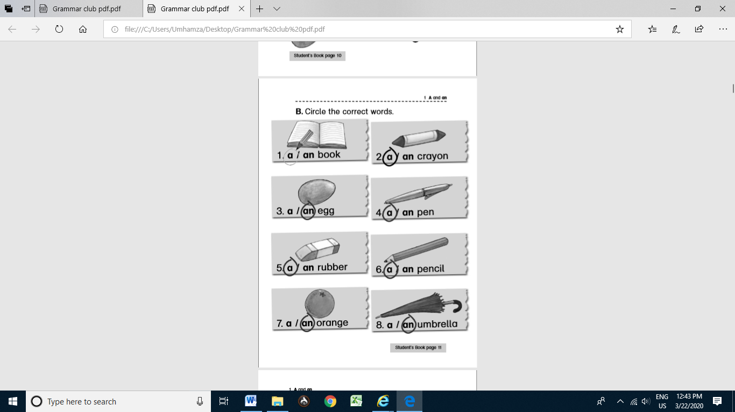

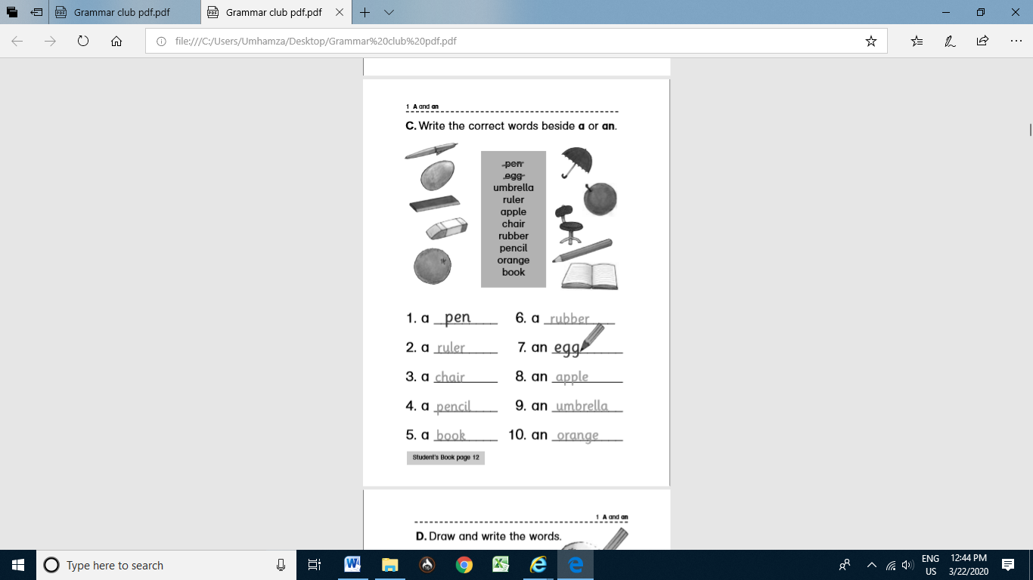

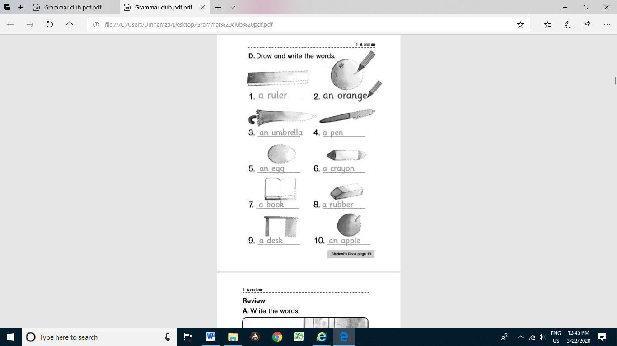

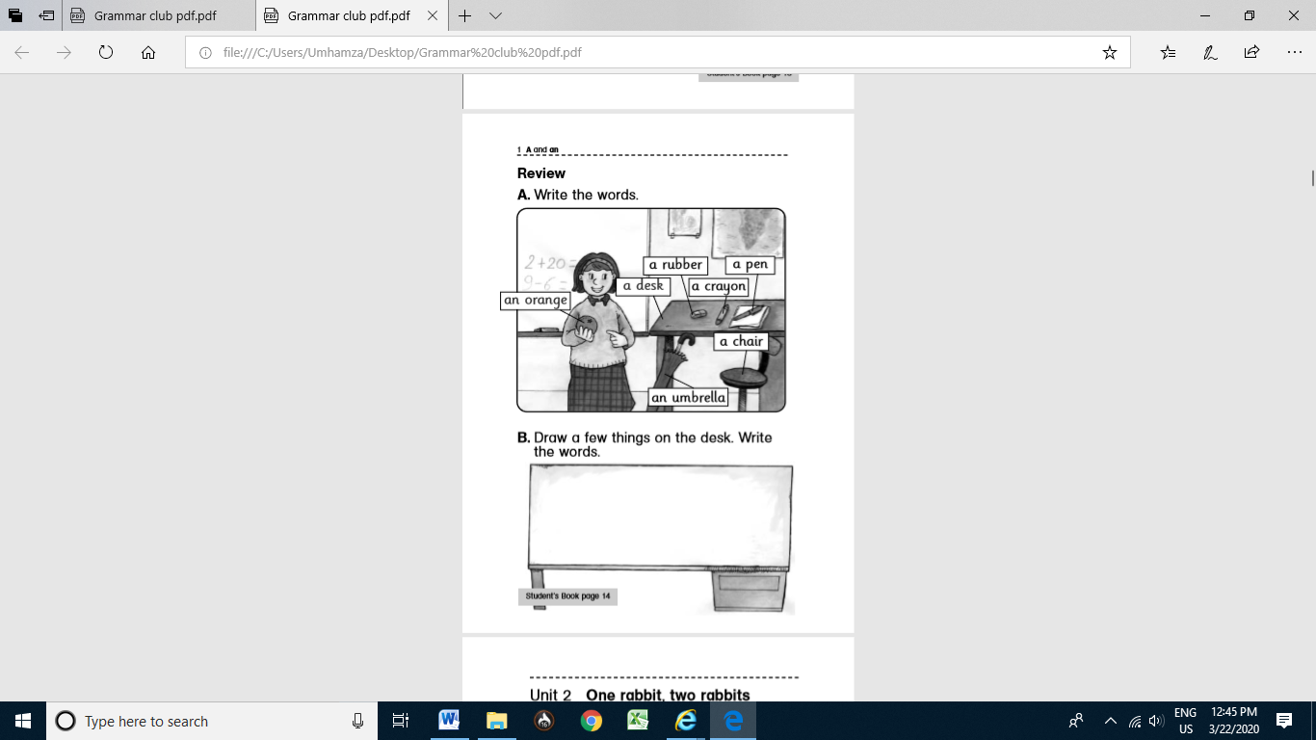

**Composition: Myself**

[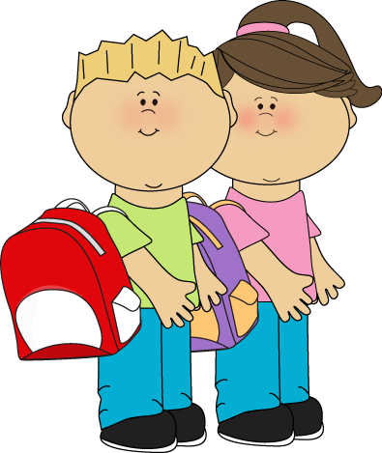](https://www.google.com/url?sa=i&url=https://www.pinterest.com/pin/283445370270450163/&psig=AOvVaw2fuIpGotKSe-eHvNHQbBUe&ust=1584952329097000&source=images&cd=vfe&ved=0CAIQjRxqFwoTCMCR7NnVregCFQAAAAAdAAAAABAN)

1. I am a boy / girl.

2. My name is ____________ .

3. I am seven years old.

4. I am in Grade 1.

5. I go to Pakistan School.

6. I live in Bahrain.

HOMEWORK:

Write and learn this composition.