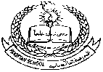**Pakistan School , Ministry of Education , Kingdom of Bahrain**

**E-Support and Learning /Session 2020-2021**

**Subject : English - Grade : I**

**First Term**

**Book: Student Book 1 Pg.No – 9**

**Unit 2 : Ali’s Bedroom**

**Complete the sentences using the given words. (Page # 9, Exercise 1)**

full of paper , on the bed , some books , blue stripes , red carpet

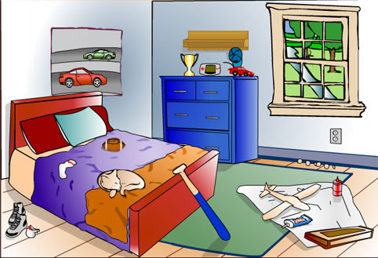

1. There is a **red carpet** on the floor.

2. The cat is on **the bed**.

3. The curtains have **blue stripes**.

4. The bin is **full of paper**.

5. On the desk there are **some books**.

**Fill in the missing letters (vowels). (Page # 9, Exercise 2)**

1. b **e** d Ali sleeps in this.

2. b **i** n It is full of rubbish.

3. b **o** x This is full of toys.

4. c **a** t It is asleep on Ali’s bed.

5. l **a** m p It gives light.

**Make sentences.**

1. **book**: The book is on the table.

2. **bed**: I sleep on my bed.

3. **cat**: I have a pet cat.

**Draw the pictures for the given naming words.**

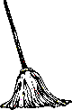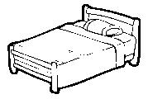

1. bed 2. mop

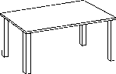

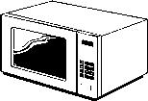 3. table 4. oven

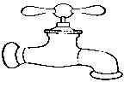

5. tap

**Home Work: Draw and colour your bedroom.**

|  |
| --- |
|  |

Pakistan School , Ministry of Education , Kingdom of Bahrain

E-Support and Learning /Session 2020-2021

Subject : English - Grade : I[](https://www.google.com/url?sa=i&url=https://creazilla.com/nodes/6267-panda-with-bamboo-clipart&psig=AOvVaw3YGF29ddU7NaIxbnmbcPX1&ust=1584685424704000&source=images&cd=vfe&ved=0CAIQjRxqFwoTCIij0LDzpegCFQAAAAAdAAAAABAD)

Short Vowels – Worksheet

[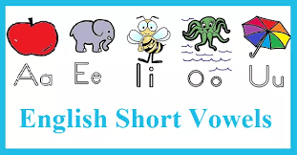](https://www.google.com/url?sa=i&url=https://www.englishhints.com/english-vowels.html&psig=AOvVaw18YRUYB6ZQiSmWRMm53X39&ust=1585040424549000&source=images&cd=vfe&ved=0CAIQjRxqFwoTCLjkyfWdsOgCFQAAAAAdAAAAABAD)

There are 26 letters in English Alphabets.

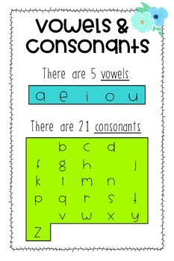Aa Bb Cc Dd Ee Ff Gg Hh Ii Ji Kk Ll Mm Nn Oo Pp Qq Rr Ss Tt Uu Vv Ww Xx Yy Zz



Consonant + Vowel +Consonant

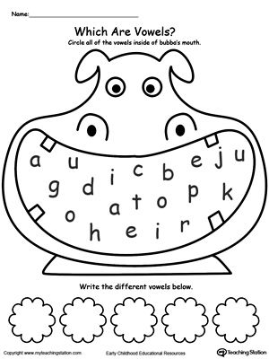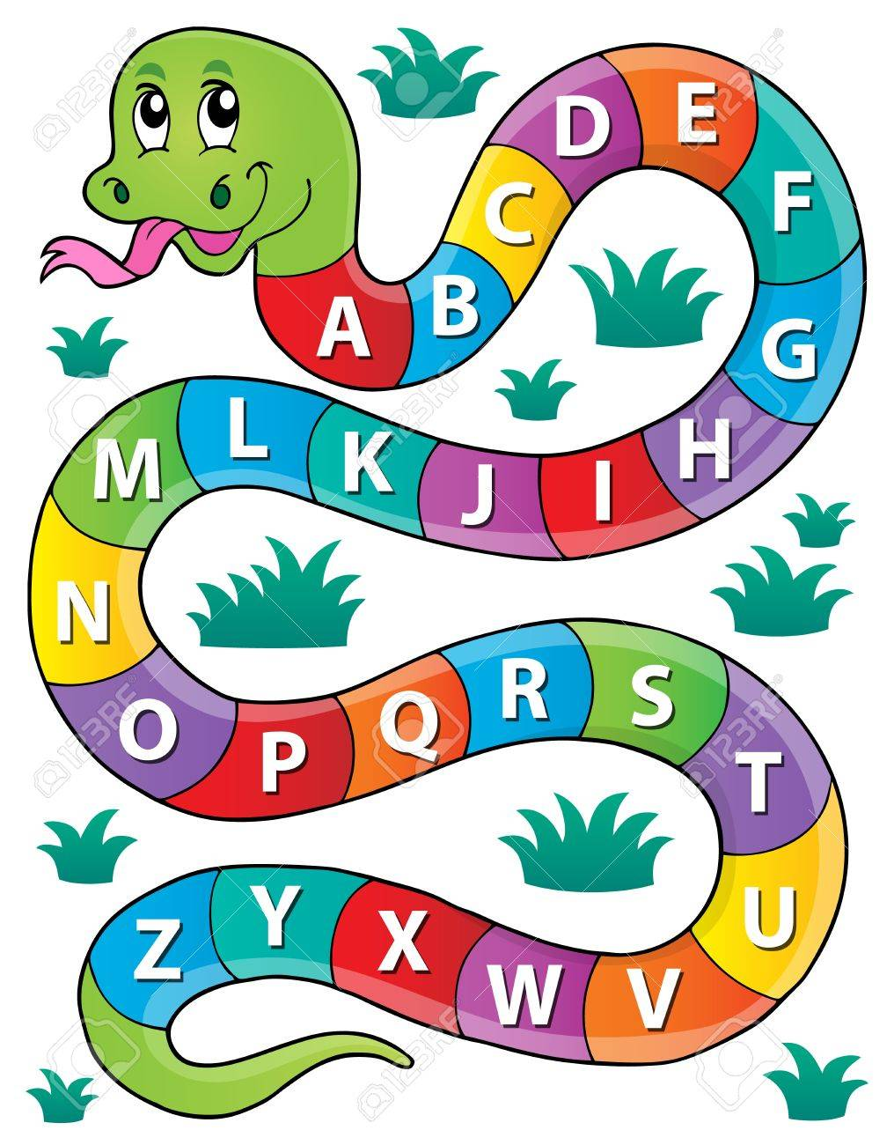 Q1. Q2. Circle the Consonants

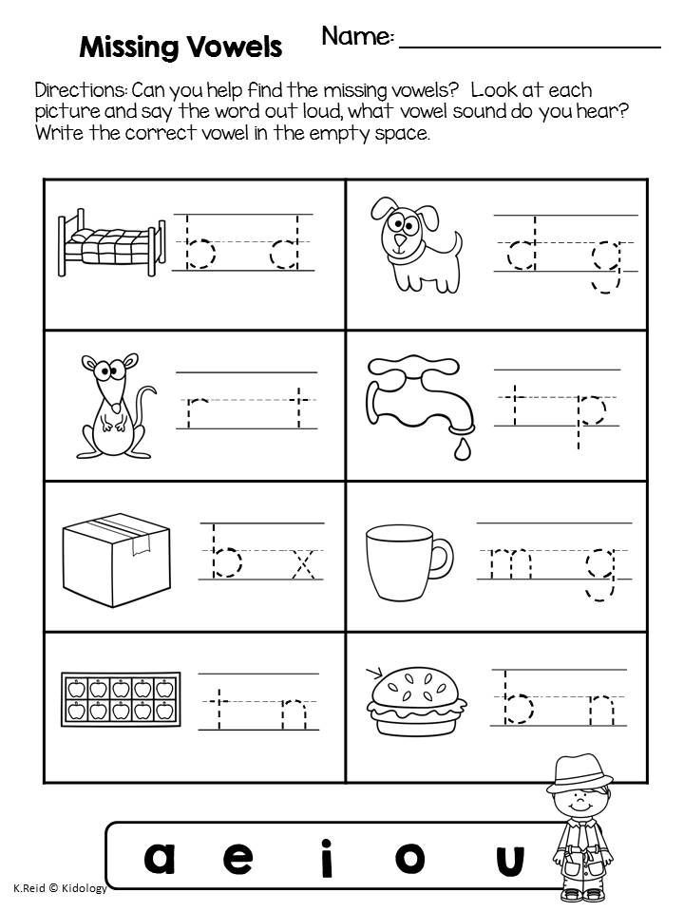Q3(a). Fill in the missing vowels to complete the words:

Q3(b) Look at the pictures and fill in the CVC words:

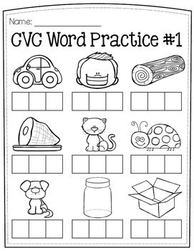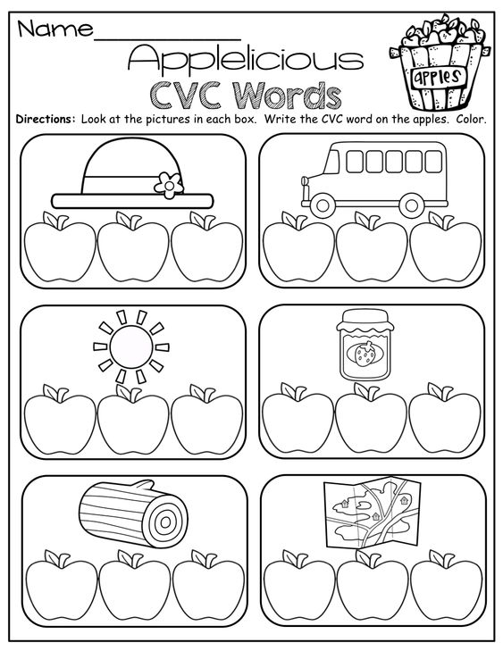

|  |  |  |  |  |  |  |  |  |  |  |  |  |  |  |  |  |
| --- | --- | --- | --- | --- | --- | --- | --- | --- | --- | --- | --- | --- | --- | --- | --- | --- |
| **Content Accuracy** | | | | **Creativity** | | | | **Completeness** | | | | **Neatness** | | | | **Total Points** |
| **1** | **2** | **3** | **4** | **1** | **2** | **3** | **4** | **1** | **2** | **3** | **4** | **1** | **2** | **3** | **4** |  |
| **1- Excellent 2 – Good 3- Satisfactory 4- Needs Improvement** | | | | | | | | | | | | | | | | |

**Rubric:**