**Pakistan School , Ministry of Education , Kingdom of Bahrain**

**E-Support and Learning /Session 2020-2021**

**Subject : English - Grade : 10**

**Unit 1 : Hazrat Muhammad (SAW)- an Embodiment of Justice**

**Pg. 5 Ex. A: Give the meaning of each word as used in the lesson**:

|  |  |  |  |  |  |
| --- | --- | --- | --- | --- | --- |
| **SN** | **Word** | **Meaning** | **SN** | **Word** | **Meaning** |
| **1** | **model** | **example** | **7** | **commandment** | **a Divine rule** |
| **2** | **piety** | **quality of being pious** | **8** | **upheld** | **to support** |
| **3** | **eternal** | **Something which lasts forever** | **9** | **destitute** | **a poor and penniless** |
| **4** | **earned** | **gained** | **10** | **proclaimed** | **Declared** |
| **5** | **sermon** | **a religious talk** | **11** | **transcends** | **to go beyond normal limits** |
| **6** | **revenge** | **To hurt in return** |  |  |  |

**Pg.5 Ex. B: Choose the appropriate synonym of the following words:**

|  |  |  |
| --- | --- | --- |
| **SN** | **Words** | **Synonyms** |
| **1** | **equitable** | **fair** |
| **2** | **ancestor** | **forefather** |
| **3** | **foe** | **enemy** |
| **4** | **firm** | **persistent** |
| **5** | **glorious** | **splendid** |

**Pg.6 Ex. C: Give meaning of the following phrasal verbs and use these phrasal verbs in sentences of your own:**

|  |  |  |
| --- | --- | --- |
| **SN** | **Phrasal Verb** | **Sentence** |
| **1** | **guilty of** | **She is found guilty of stealing.** |
| **2** | **belong to** | **This book belongs to me.** |
| **3** | **exchange for** | **He exchanged rupees for dollars.** |
| **4** | **in accordance with** | **You should study in accordance with your time table.** |

**Reading and Comprehension:**

**Pg.6 Ex. A: Choose the right option:**

**1. In Paragraph 1 general details of Holy Prophet’s (SAW) characteristics are given.**

**2. The key idea of paragraph 2 is that Hazrat Muhammad (SAW) was just and fair even before his Prophethood.**

**3. Examples given in paragraph 3 and 4 show that Hazrat Muhammad (SAW) was a just head of the state.**

**4. Paragraph 5 shows that The justice of Hazrat Muhammad (SAW) was a source of peace and security for non-Muslims.**

**5. To whom did the Holy Prophet (SAW) give the following advice?**

**‘’When two men come to you for judgement , never decide in favour of one without hearing the arguments of the other, it is then most likely that you will know the truth.’’ Ans: Hazrat Ali (RA)**

**Pg. 8 Ex. C: Answer the following questions:**

**How did the Holy Prophet (PBUH) resolve the issue? ( Pg. 2)**

**Ans. The Holy Prophet (PBUH) resolved the issue by proposing a very fit plan for the setting of the blackstone.  
Why did the Quraish think that the Holy Prophet (SAW) would  favor  them? (Pg. 2)  
Ans. Quraish thought that the Holy Prophet (PBUH) would favour them because he himself was the member of the Quraish family. Moreover, they thought that the Hazrat Usama Bin zaid was close enough to the Holy Prophet (PBUH) to make appeal on behalf of that guilty woman.  
Why did non-Muslims trust the Holy Prophet (PBUH)? (Pg. 3)  
Ans.  The Holy Prophet (PBUH) did justice in every case, brought to him by friend or foe. Therefore, the Muslims trusted the Holy Prophet ( PBUH).**

**What advice did the Holy Prophet (PBUH) give to Hazrat Ali(RA)? (Pg.3)  
Ans. The Holy Prophet (PBUH) advised  Hazrat Ali (RA) not to decide any matter without hearing both the parties and without knowing the truth.  
  
What does the word “proclaimed” mean? ( Pg. 4)  
Ans. ' To proclaim' means "to declare something in a formal manner or officially.**

**1. How can people achieve perfection in the moral ,spiritual and social areas of life ?  
Ans. People can achieve perfection in their moral, spiritual and social areas of life by seeking light, instructions and guidance from the Holy Prophet’s message and life.**

**2. How did the Holy Prophet  (SAW) set high and noble  ideals for all mankind?  
 Ans.The Holy Prophet (PBUH) set very high and noble ideals for mankind by practically following the commandments of Allah in every field of life.**

**3. How were people of Makkah convinced of the Holy Prophet ‘s justice even before his prophet hood?**

**Ans. The Holy Prophet (SAW) did justice in every case. His dealing with people was always fair. Before his Prophethood , he very wisely and justly resolved the issue of setting the Black Stone. Therefore, the people of Makkah were convinced of his justice even before his prophethood.  
  
4.  What standards of justice did the Holy Prophet (SAW) practice as head of the state of Madinah?  
 Ans. As head of the state of Madinah, the Holy Prophet (PBUH)  practiced high standards of justice. He decided every matter on merit. He did justice irrespective of  colour, race  or creed.  
  
5. What made non-Muslims bring their suits to the Holy Prophet (PBUH)?  
Ans. The Holy Prophet (PBUH) was fair, just and kind to everyone.The Holy Prophet (PBUH) was very strict in doing justice. Therefore, the non-Muslims brought their cases to him for decision.  
  
6. How does  Quran describe the personality of the Holy Prophet (PBUH)?  
Ans. The Holy Quran describes the personality of the Holy Prophet (PBUH)  as follows: “Indeed, in the messenger of Allah (Mohammad),you have a perfect example to follow for him who hopes for (the meeting with) Allah and the Last Day and remembers Allah much.’’**

**Grammar :**

**Pg. 8-9 Ex. A: Identify whether each underlined word is a concrete or an abstract noun:**

|  |  |  |
| --- | --- | --- |
| **SN** | **underlined words** | **concrete/abstract** |
| **1** | **effort , studies** | **Abstract** |
| **2** | **justice , truthfulness** | **Abstract** |
| **3** | **balls , basket** | **concrete** |
| **4** | **trader, customers**  **trust** | **concrete**  **abstract** |
| **5** | **care**  **pet** | **abstract**  **concrete** |

**Pg.9 Ex.B: Choose whether each sentence needs an indefinite article ( a,an ), a definite article (the), or no article:**

|  |  |  |  |
| --- | --- | --- | --- |
| **1** | **a** | **6** | **The** |
| **2** | **The** | **7** | **----** |
| **3** | **----** | **8** | **The** |
| **4** | **the** | **9** | **a** |
| **5** | **a** | **10** | **----** |

**Pg. 10 Ex. C : Underline the noun phrase in the following sentences:**

**1. This is an old-fashioned hat.**

**2. We discovered Fahad’s plans.**

**3. A rolling stone gathers no moss.**

**4. The recent flood caused heavy damage.**

**5. An oral presentation can be interesting.**

**Pg.10 Ex.D: Fill in each blank with past indefinite or past continuous tense of the verb in brackets:**

|  |  |
| --- | --- |
| **1** | **What were you doing when I called you last night.** |
| **2** | **I was sitting in the café when you called me.** |
| **3** | **When you arrived at the bus stand , who was there?** |
| **4** | **Shamsa was watching a film when she heard the noise.** |
| **5** | **We were playing tennis when Javed hurt his ankle.** |

**Pg.10 Ex. E: Punctuate the following paragraph:**

**During the Sermon, an Ansari seeing some men from the tribe of Banu Tha ‘lba sitting there stood up and pointed toward them and said, ’’Oh Messenger of Allah! Their ancestors killed a member of our family. We appeal to you to get one of them hanged in exchange for that.’’ The Holy Prophet (SAW) replied, ‘’ The revenge of the father cannot be taken on his son.’’**

**Subject : English - Grade : 10 ASSIGNMENT – 1**

**Concrete and Abstract Nouns:**

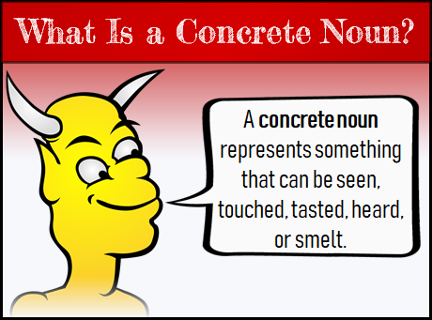 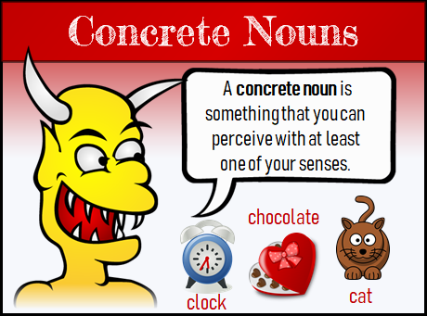

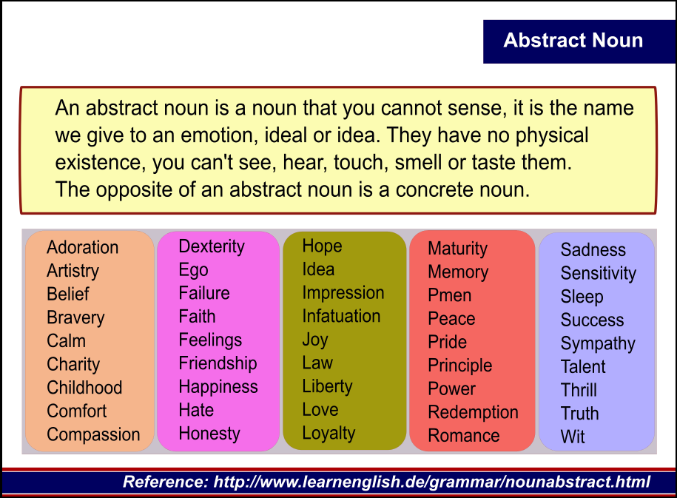

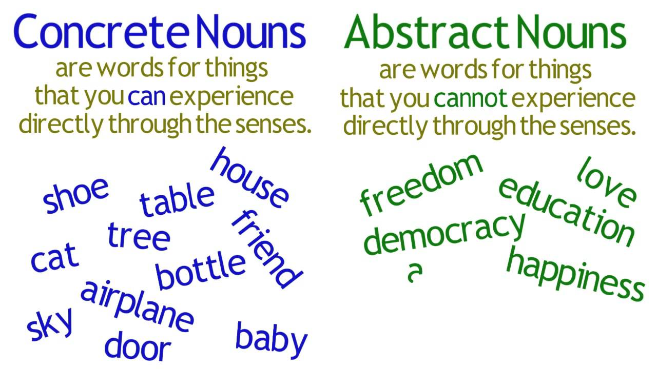

**Q1.**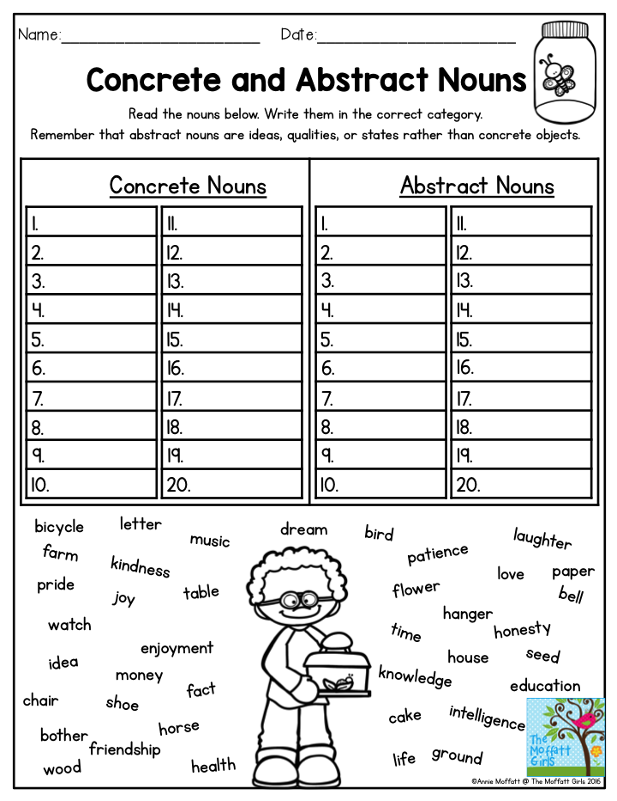

**Q2: Decide whether each underlined word is a concrete or abstract noun. Then write concrete or abstract on the line.**

**1. I’ll have to look that word up in the dictionary. _______________**

**2. Give those caged birds their freedom! _______________**

**3. My grandparents are staying with us for a whole month. _______________**

**4. I forgot to write in my diary last week. _______________**

**5. Maya is known for her honesty and her kind heart. _______________**

**6. Jake didn’t have the courage to talk to the principal. _______________**

**7. We could hear the ambulance sirens in the distance. _______________**

**8. There has been peace between the two countries for years. _______________**

**9. Everyone feels loneliness from time to time. _______________**

**10. I hope you have some success today at the tennis match. _______________**

**11. Graham gave me his old baseball glove. _______________**

**12. The kitchen is full of the most wonderful smells. _______________**

**13. Did you have any trouble finding my house? _______________**

**14. Ann bought new clothes to wear to school. _______________**

**15. Send me a postcard from Brazil. _______________**

|  |  |  |  |  |
| --- | --- | --- | --- | --- |
| **Rubric:** | **Ex.** | **Go.** | **Sat.** | **NI** |
| **Content Accuracy** | **1** | **2** | **3** | **4** |
| **Creativity** | **1** | **2** | **3** | **4** |
| **Completeness** | **1** | **2** | **3** | **4** |
| **Neatness** | **1** | **2** | **3** | **4** |
| **1-Excellent 2- Good 3- Satisfactory**  **4- Needs improvement** | | | | |

**Noun Phrase:**

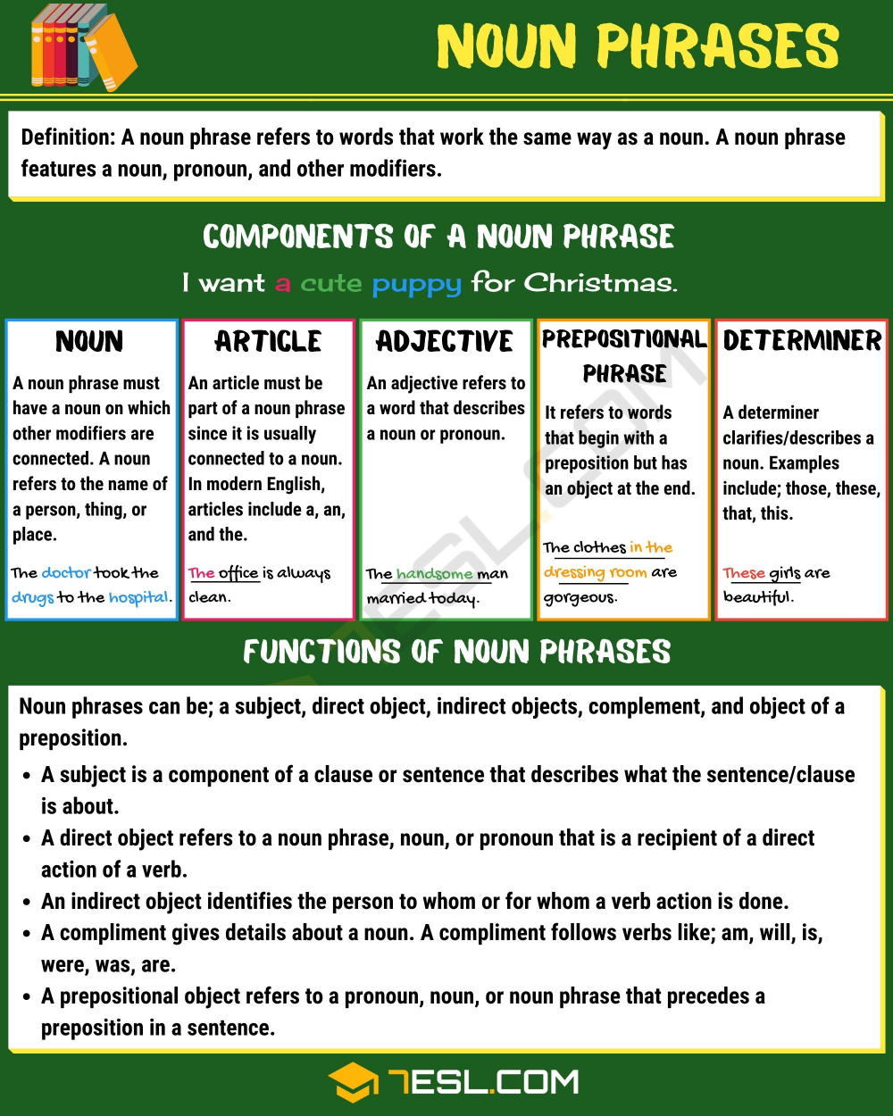

Q3.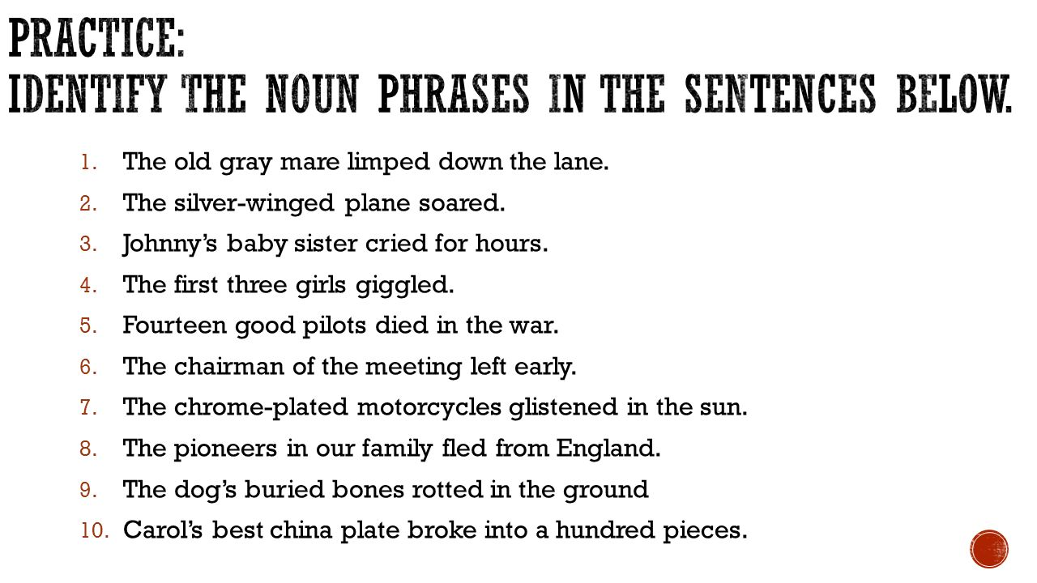

**1. The quick, brown fox jumped over the lazy dog.**

**2. The end of the season is hard for some athletes.**

**3. The young puppy chased its tail.**

**4. The box in the attic is full of memories.**

**5. A sailor’s best friend is a wide, open sea.**

**6. Grandma cooked a meal for ten people, even though**

**there were only four of us.**

|  |  |  |  |  |
| --- | --- | --- | --- | --- |
| **Rubric:** | **Ex.** | **Go.** | **Sat.** | **NI** |
| **Content Accuracy** | **1** | **2** | **3** | **4** |
| **Creativity** | **1** | **2** | **3** | **4** |
| **Completeness** | **1** | **2** | **3** | **4** |
| **Neatness** | **1** | **2** | **3** | **4** |
| **1-Excellent 2- Good 3- Satisfactory**  **4- Needs improvement** | | | | |

**Writing Skills: Pg. 13 Ex. B**

**Write an essay on ‘’ Hazrat Muhammad (SAW) as an Exemplary Judge.’’ (150-200 Words)**

* **Follow the mind map given on Pg. 13**
* **1st Paragraph – Introductory Paragraph with clear central thought.**
* **2nd and 3rd Paragraph key ideas with supporting details/examples.**
* **4th Paragraph – Concluding Paragraph.**

**Rubric for marking essays at Grade X level as Prescribed in National Curriculum For English 2006 (Textbook Pg.164)**

|  |  |  |  |  |
| --- | --- | --- | --- | --- |
| **Content:**  **Convincing,specific** | **4** | **3** | **2** | **1** |
| **Point of View:**  **Clear , Appropriate** | **4** | **3** | **2** | **1** |
| **Essay Organization:**  **Logical , Orderly development to conclusion** | **4** | **3** | **2** | **1** |
| **Language use and Style:**  **Sentence Structure**  **Vocabulary**  **Style: Interesting,in flow** | **4** | **3** | **2** | **1** |
| **Mechanics:**  **Correctness in Punctuation ,Spelling and Grammar.** | **4** | **3** | **2** | **1** |
| **Total:** | **4** | **3** | **2** | **1** |
| **Key: 4 – Excellent 3- Good**  **2- Satisfactory**  **1- Needs Improvement** |  |  |  |  |

**Note: To be done on a separate sheet and filed up**.