

**PAKISTAN SCHOOL , KINGDOM OF BAHRAIN.**

**E-Support and Learning Material/Session 2020-2021**

**Subject: English Grade: 2**

**TOPIC: NOUN.**

**DEFINITION:**

The name of a person , place , thing and animal is called a noun.

For example: boy , cat , Manama , school , Aisha , Ahmed , elephant , table , pen etc .

**ACTIVITY**

**Q: Choose the given nouns and write in correct column.**

|  |  |  |  |  |  |  |  |  |  |  |  |
| --- | --- | --- | --- | --- | --- | --- | --- | --- | --- | --- | --- |
| copy | market | pencil | dog | Ali | hospital | Amina | garden | bag | teacher | tiger | zebra |

|  |  |  |  |
| --- | --- | --- | --- |
| **person** | **animal** | **thing** | **place** |
| Ali | dog | pencil | market |
| Amina | tiger | copy | hospital |
| teacher | zebra | bag | garden |

**Q: Underline the nouns from these sentences.**

**1 :** She is a **girl. 2:** I like to eat **mangoes.**

**3:** He plays with a **ball. 4:** They watch **cartoons.**

**5:** We go to **masjid. 6:** You read a **book.**

**PAKISTAN SCHOOL , KINGDOM OF BAHRAIN**

**E-Support and Learning Material/Session 2020-2021**

**Subject: English Grade: 2**

**Topic: Noun WORKSHEET**

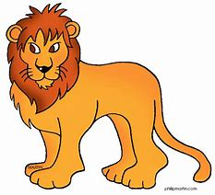 **Q: Look at the pictures and write the noun under each picture.**

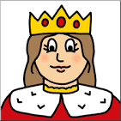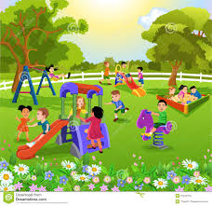



**Q: Encircle the nouns in the given sentences:**

1: The birds are flying.

2: The girls are going to market.

3: He sleeps at night.

4: We eat chocolate .

5: You saw a snake.

**Homework:** Write any 3 nouns and use them in sentences.

 S**PAKISTAN SCHOOL , KINGDOM OF BAHRAIN.**

**E-Support and Learning Material/Session 2020-2021**

**Subject: English Grade: 2**

**TOPIC: PUNCTUATION (QUESTION MARK-? ) (Full stop - . ) TEXT BOOK PAGE (10)**

**Q: Add question marks in these sentences.**

**1**: Can tigers run fast **?** 2: Are giraffes taller than elephants **?**

3: How fast can a cheetah run **?** 4: What is your favourite animal **?**

**TOPIC : PUNCTUATION. (CAPITAL LETTER AND QUESTION MARK ) TEXT BOOK PAGE (44)**

**Q: Add capital letters and question marks in these sentences.**

1: will you help me empty the dustbin

Ans: **W**ill you help me empty the dustbin **?**

2: how many cans did they collect

Ans: **H**ow many cans did they collect **?**

3: why are so many useful things thrown away

Ans: **W**hy are so many useful things thrown away **?**

4 : how do we know that so many cans are thrown away

Ans: **H**ow do we know that so many cans are thrown away **?**

5: can we find ways to use them again

Ans: **C**an we find ways to use them again **?**

**PAKISTAN SCHOOL , KINGDOM OF BAHRAIN**

**E-Support and Learning Material/Session 2020-2021**

**Subject: English WORKSHEET Grade: 2**

**Topic: Punctuation ( Capital letter , Full stop , Question mark )**

**S Q: Add the missing capital letters in these sentences.**

**1:** the calf was born near the creak .

**Ans: _______________________________________________________________________**

**2:** you were going to pakistan .

**Ans: ______________________________________________________________________**

**3:** my friends were walking in front of adhari garden .

**Ans: ______________________________________________________________________**

**4:** on a sunny day the sky looks blue .

**Ans: _______________________________________________________________________**

**Q: Add the missing question marks or full stops in these sentences.**

1: Can you help me ________

2: The monkeys like to eat banana _______

3: What is your favourite fruit _______

4: Did he wear a hat ________

5: The leaves are green in colour ______