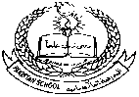

**Pakistan School , Kingdom of Bahrain**

**E- Support and Learning Material / Session 2020-2021**

**Subject: English Grade : 4**

**Book: Grammar Club book 4 FIRST TERM**

**Unit 1: Some and any Pg. No: 9-14**

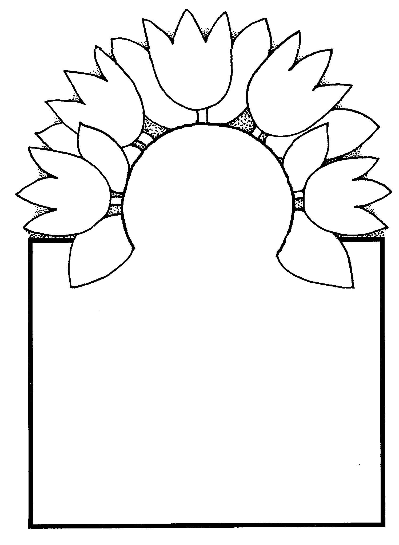

Naming Words.

A word used to name a person , place , animal or a thing is called a

naming word or a noun. Examples:

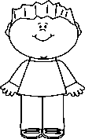

Persons: Mother , father , brother , sister , Ali , Sana.



Places: School , Bahrain , Pakistan , garden , zoo , hospital.

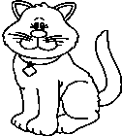

Animals: Cat , dog , bird , fish , horse , cow , sheep , rabbit.

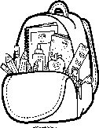

Things: Ball , car , apple , bag , chair , table , pen , book , orange.

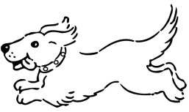**Q1. Circle the naming words in the given sentences.**

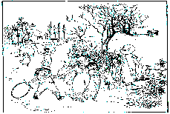 1. The dog is running.

 2. I am going to the garden.

3. The book is on the table.

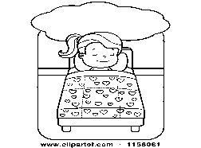

 4. Sana is going to sleep.

5. T The pen is broken.

**Q2. Name the following:**

1. Two naming words that name a person.

Ans. ________________________ , ________________________

2. Two naming words that name a place.

Ans: ________________________ , _________________________

3. Two naming words that name an animal.

Ans: ________________________ , _________________________

4. Two naming words that name a thing.

Ans: ________________________ , _________________________

**Q3. Write the given naming words in the correct column.**

|  |
| --- |
| Lion Ahmed Garden Chair Mother Rabbit        School House Pencil Teacher Star Dog |

|  |  |  |  |
| --- | --- | --- | --- |
| **Person** | **Place** | **Animal** | **Thing** |
| 1. | 1. | 1. | 1. |
| 2. | 2. | 2. | 2. |
| 3. | 3. | 3. | 3. |

|  |  |  |  |  |
| --- | --- | --- | --- | --- |
| **Rubric:** | **Ex.** | **Go.** | **Sat.** | **NI** |
| **Content Accuracy** | **1** | **2** | **3** | **4** |
| **Creativity** | **1** | **2** | **3** | **4** |
| **Completeness** | **1** | **2** | **3** | **4** |
| **Neatness** | **1** | **2** | **3** | **4** |
| **1-Excellent 2- Good 3- Satisfactory**  **4- Needs improvement** | | | | |

 **Pakistan School , Isa Town , Kingdom of Bahrain**

**E- Support and Learning Material / Session 2020-2021**

**Subject: English Grade : 4**

**Book: Grammar Club book 4 FIRST TERM**

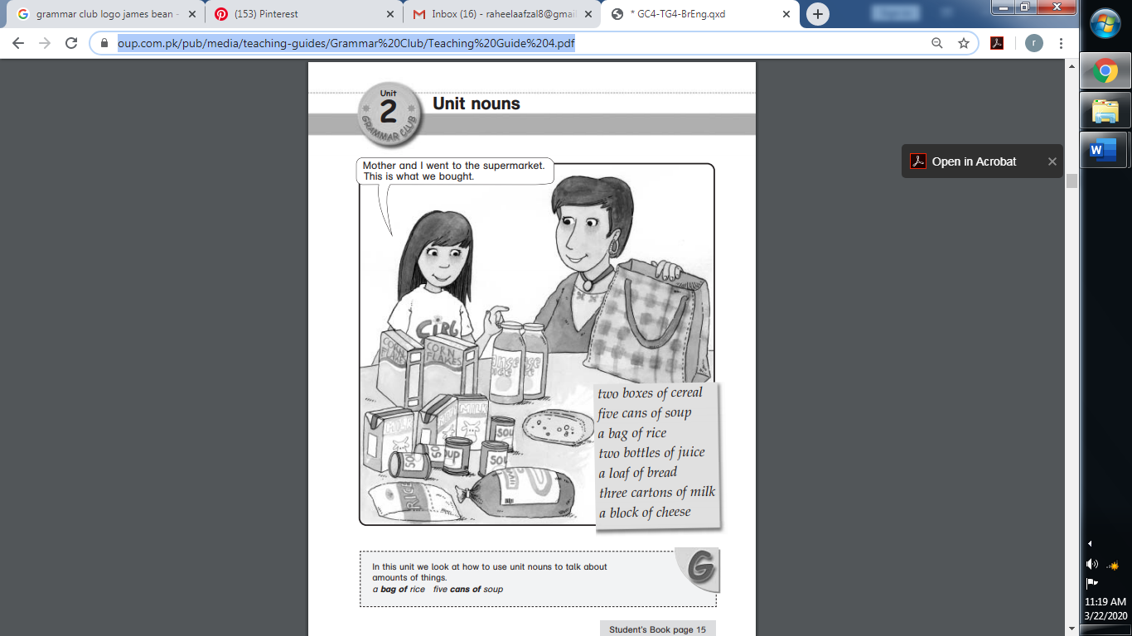 **Unit 2: Unit nouns Pg. No: 15-17**

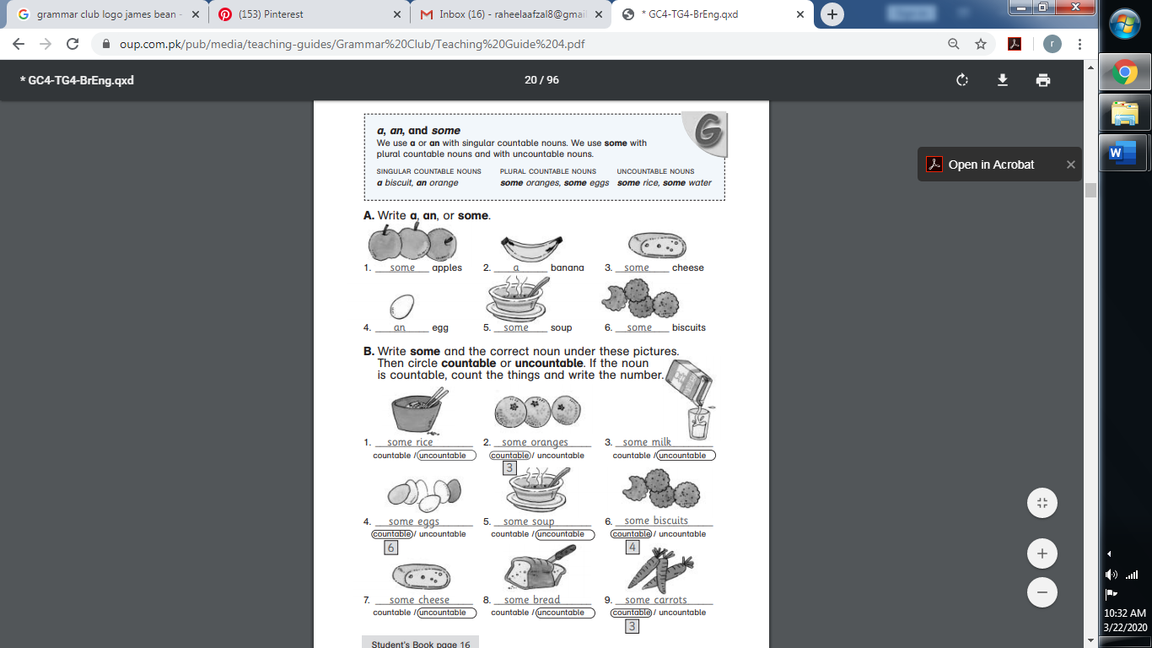

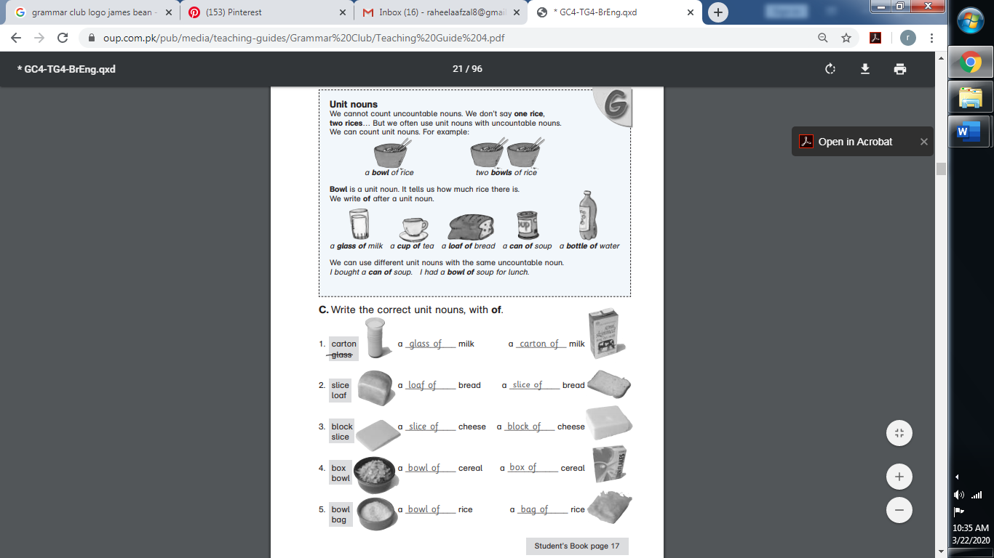

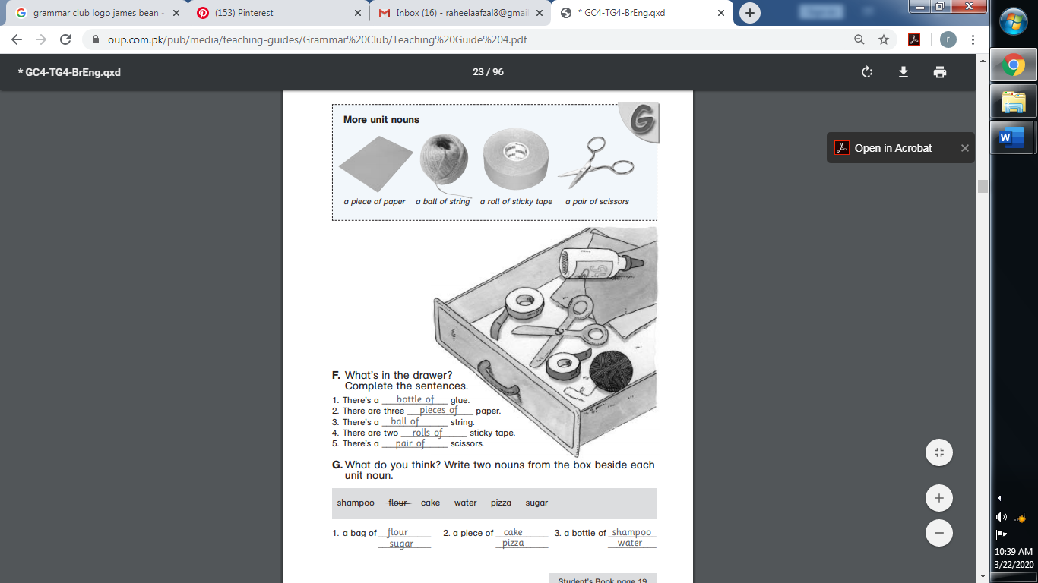**Unit 2: Unit nouns Pg. No: 18-20**

