**Pakistan School , Kingdom of Bahrain**

**E- Support and Learning Material / Session 2020-2021**

**Subject: English Grade : 6th**

**Book: Student Book 6 FIRST TERM**

**Unit:- 3 Nuclear Disaster Pg. No: 14**

|  |  |  |
| --- | --- | --- |
| **Sr no.** | **Words** | **Meanings** |
|  | Sprinkle | to scatter in small drops |
|  | Blink | to close and open eye |
|  | Terrible | dreadful |
|  | Bump | a small raised area |
|  | Altar | a raised platform used as center of worship in Christian ceremonies and services |

|  |  |  |
| --- | --- | --- |
| **Sr no.** | **Words** | **Sentences** |
|  | Sprinkle | Sprinkle chocolate on top of the cake. |
|  | Blink | I'll be back before you can blink. |
|  | Terrible | I had a terrible dream last night. |
|  | Bump | The baby had a bump oh his forehead. |
|  | Altar | The priest bowed down before the altar. |

**Comprehension Skills (page :- 15)**

**Answer the following questions :-**

|  |  |
| --- | --- |
| **Q1.** | The first two sentences are an unusual opening for a story. How is the writer trying to make you feel? |
| **Ans.** | The writer wants to represent the total destruction caused by nuclear explosion. |
| **Q2.** | Why does Ann think that someone is coming? |
| **Ans.** | She felt that someone is coming towards her who can give her harm. And she was scared due to solitude also. |
| **Q3.** | Why do you think she is afraid ? |
| **Ans.** | By looking at total destruction she was feeling insecure. Her loneliness was also the cause of her fear. |
| **Q4.** | What do you think has happened to the rest of Ann’s family? |
| **Ans.** | Her father, brother and cousin wanted to know the actual situation caused by war so they visited other areas. They found dead bodies everywhere. When they got back, they were sick and upset. |

**Subject: English Grade : 6th**

**Unit:- 3 Nuclear Disaster Worksheet**

**Q1. Select any one picture of Nuclear disaster and search about it :**

**Fukushima Chernobyl-The World’s Worst**

** Nuclear Disaster**

** ________________________________________________________________________________________________________________________________________________________________________________________________________________________________________________________________________________________________________________________________________________________________________________________________________________________________________________________________________________________________________________________________________________________________________**

|  |  |  |  |  |
| --- | --- | --- | --- | --- |
| **Rubric:** | **Ex.** | **Go.** | **Sat.** | **NI** |
| **Content Accuracy** | **1** | **2** | **3** | **4** |
| **Creativity** | **1** | **2** | **3** | **4** |
| **Completeness** | **1** | **2** | **3** | **4** |
| **Neatness** | **1** | **2** | **3** | **4** |
| **1-Excellent 2- Good 3- Satisfactory**  **4- Needs improvement** | | | | |

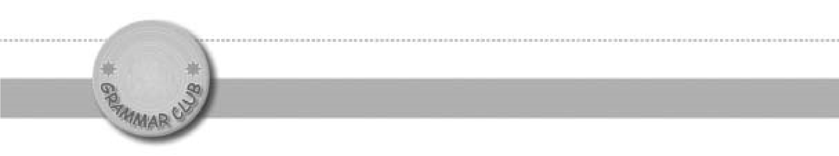

The present perfect

:

for

and

since

**Unit**

**1**

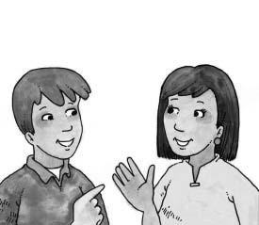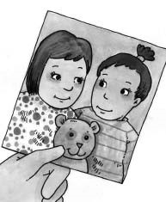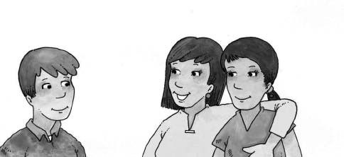

How long have you

and Tina been friends?

We met when we were

five years old.

Now we’re twelve. We’ve been friends for seven years.

|  |  |  |  |  |
| --- | --- | --- | --- | --- |
| In this unit we look at how to use the present perfect tense to talk about a period of time that started in the past and continues to the present.  How long have you and Tina been friends?  We’ve been friends for seven years. | | | | |
| Complete this table using past participles from the box.  The present perfect  We can use the present perfect tense (  have  or  has    +  past participle  to  )  talk about a situation that began at some time in the past and is still true now.  For example:  My cousin Brad is staying with  Now it’s Monday. Brad  has been  here for two days.  me. He arrived on Saturday.  This timeline shows the length of time we are talking about:  Brad is here now.  Brad arrived.  (    (  Brad has been here  for two days  .  In sentences like this, we always use a time expression such as  for two days  .  To make the present perfect tense, we use  has  or  have  with the past participle of  a verb.  I  have  been  or  (  I’ve  been  )  we  have  been  (  or  we’ve  been  )  you  have  been  (  or  you’ve  been  )  you  have  been  or  (  you’ve  been  )  he, she, or it  has  been  they  have  been  or  (  they’ve  been  )  (  or  he’s  ,  she’s  ,  it’s  been)  SATURDAY  MONDAY (TODAY)  SUNDAY  worn played owned known worked lived ~~been~~  taught | | | |
|  |  |  |  |
| VERB | PAST PARTICIPLE | VERB | PAST PARTICIPLE |
| be | been | know | knew |
| teach | taught | work | worked |
| play | played | wear | worn |
| live | lived | own | owned |

|  |
| --- |
| for  We use for to talk about a period, or length, of time. We use it with time expressions such as thirty minutes, two days, six weeks, ten years, or a long time.  I’ve been here for two days. Grandma has lived in this house for a long time. |

1. Write sentences using these words. Use the present perfect and for.
2. Mr Zia ä teach ä art at our school ä ten years

Mr Zia has taught art at our school for ten years.

1. My parents ä be ä married ä fifteen years

My parents have been married for fifteen years.

1. Amy ä know ä Andy ä a long time

Amy has known Andy for a long time.

1. The students ä be ä in the library ä half an hour

The students have been in the library for half an hour.

1. Mrs Khan ä own ä that car ä ten years

Mrs Khan has owned that car for ten years.

|  |
| --- |
| since  We use since to talk about a point in time – the time when something started. We use it with time expressions such as nine o’clock, Thursday, yesterday, April, 2003, or last week.  I’ve been here since Saturday. Grandmother has lived in this house since 1976. |

C.Read sentence a. Then write sentence b using the present perfect and since.

1. a. My aunty moved to Hong Kong in 2003.

My aunty live in

* 1. My aunty has lived in Hong Kong since 2003.

1. a. Father started working at the bank in 2000.

Father work at

* 1. Father has worked at the bank since 2000.

1. a. We came to school at nine o’clock.

Weä be ä in

* 1. We have been in school since nine o’clock

D. Complete these sentences using has been or have been with a word or phrase from the box and since.

cold and windy asleep  ~~away~~  in hospital friends

1. Father is in Los Angeles this week.

He has been away since Monday.

1. Ross broke his leg while he was playing football.

He Saturday.has been in hospital since

1. Ben and Andy are good friends.

They 2004.have been friends since

1. The weather was good last week, but then it changed.

It Sunday.has been cold and windy since

1. Joanna went to bed early tonight.

She seven o’clock.has been asleep since

E. Now write the five sentences from D again using contractions (He’s, They’ve…).

1. He’s been away since Monday.

2. He’s been in hospital since Saturday.

3.They’ve been friends since 2004.

4. It’s been cold and windy since Sunday.

5. She’s been asleep since seven o’clock.

|  |
| --- |
| We can also use longer time expressions after since. For example:  I’ve liked chocolate since I was a child.  I’ve sat next to Jo since I started school. |

F. Read sentence a. Then write sentence b using the present perfect with since and the underlined words.

1. a. Max started wearing glasses when he was seven. Max ä wear

b. Max has worn glasses since he was seven.

1. a. I met Saira when she came to this country. I ä know
   1. I have known Saira since she came to this country.
2. a. Father met Jeff when they were at school. Father ä know
   1. Father has known Jeff since they were at school.

G.Write for or since.

1. I’ve been ill __________ three days. for
2. I’ve known my friend Rosie __________ a long time.for
3. The weather has been beautiful __________ we arrived in Thailand.since
4. We’ve been on holiday __________ two weeks.for
5. Andy has been afraid of spiders __________ he was little.since
6. I’ve had a cold __________ Sunday. since
7. Mother has been on the phone __________ fifteen minutes.for 8. I’ve owned this computer __________ December.since

|  |
| --- |
| How long...?  We use How long with the present perfect to ask about a length of time. We put have or has before the subject.  How long haveyou been at this school?  How long hasshe lived in that flat? |

H. Write “How long” questions using these words. Change the verbs to past participles.

1. you ä live ä here

How long have you lived here?

1. your parents ä be ä married

How long have your parents been married?

1. Mrs Ali ä teach ä at this school

How long has Mrs Ali taught at this school?

1. you ä know ä Jodie

How long have you known Jodie?

1. Carl ä play ä football

How long has Carl played football?

1. your father ä work ä for that bank

How long has your father worked for that bank?

1. you ä own ä this bicycle

How long have you owned this bicycle?

|  |
| --- |
| ~~two weeks~~  I started school 2005 three years four months Thursday eight o’clock January five minutes I was five years old a long time half an hour |

Review : Put these time expressions into two groups: the ones that go with for and the ones that go with since. Write them with for or since.

for since

for two weeks since I started school

for three years since 2005

for four months since Thursday

for five minutes since eight o’clock

for a long time since January

for half an hour since I was five years old

B. Write for or since.

1. I’ve known Maria __________ we were six years old.since
2. It’s been hot __________ June. since
3. We’ve been at the shopping centre __________ two hours.for
4. Akif and Zara have been friends of our family __________ years.for
5. Kathy has liked reading __________ she was very young.since
6. I’ve been awake __________ six o’clock this morning.since

C.Answer these questions using for and since.

1. How long have you been at school today?

I’ve been at school ______________________________ (use for in this sentence)

I’ve been at school ______________________________

(use since in this sentence)

1. How long have you known your best friend?

I’ve known my best friend ______________________________ (use for

I’ve known my best friend ______________________________ (use since)