**Pakistan School , Kingdom of Bahrain**

**E- Support and Learning Material / Session 2020-2021**

**Subject: English Grade : 7**

**Book: Student Book 2 FIRST TERM**

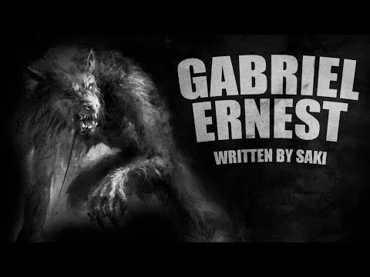 **Unit 1.3 Pg. No: 16to 17.**

**Q.1 Vocabulary Words. Page 10 to 12**

|  |  |  |
| --- | --- | --- |
| Hail | Irritated | Enter |
| Relish | Poaching | Bloodless |
| Astounding | Vanished |  |

**Q.2 Words Meanings. Page**

|  |  |  |
| --- | --- | --- |
| **No.** | **Words** | **Meanings** |
| **1** | Hail | Come |
| **2** | Irritated | Annoyed |
| **3** | Poaching | Steal |
| **4** | Astounding | Amazing |
| **5** | Vanish | Disappear |

**Q.3. Words sentences. Page 18**

|  |  |  |
| --- | --- | --- |
| **No.** | **Words** | **Sentences** |
| 1 | **hail** | This boy hails from Toyko. |
| 2 | irritated | She has irritated me a lot. |
| 3 | poaching | The boy tried to draw the possible poaching operation. |
| 4 | astounding | Something astounding happened. |
| 5 | vanished | The boy vanished in the thick forest. |

**Q.4 Comprehension. Page .17.**

**Choose the best answer for each question.**

**1. When Van Cheele meets the boy he is walking__________**

1. On the beach B**. through a wood**. C.in town

**2.The boy said he__________**

A. didn’t sleep B. slept well at night C. sleepwalked

**3.Van Cheele said that the hares were ______________**

A. Caught with dogs B .**not easily caught** C. easily caught.

**4.The boy said that he hunted__________________**

A. with a dog B. during the day. C. **on four feet**.

**5.Van Cheele artist friend saw the wolf_____________**

A. before sunset 2 . during sunset. C.**after sunset.**

**Q. 5 Answer the questions.**

**1.Why does Van Cheele think the boy hunts with a dog?**

1. Van Cheele thinks the boy hunts with a dog because the boy said that in the night he hunts on four feet.

**2.How do you think the writer wants you to feel when he writes that the boy feeds on child flesh.?**

1. The writer wants us to feel horrified when he writes that the boy feeds on child flesh.

**3. Do you think the boy is frightened of Van Cheele or not? Why.?**

1. No, he was not frightened of Van Cheele because they were having a normal conversation.

**4.What do you think Van Cheele means when he says to the boy.**

**You're rather talking through your hat?**

A. He means that it was difficult to catch hares in the hillside.

**5. List the 5 adjectives which the writer uses to describe the wolf?**

**A**. 1.Wild- looking 2. large

3. blackish in color 4. gleaming fangs

5. cruel, yellow eyes

**SPELLING….. ie.. ei**.

**These are the rules to help you choose ie. Or ei.**

**So i… before e… When the sound is ee.**

**i before e. e.g. p*ie*ce.**

**except after c.. e.g. rec*eive.***

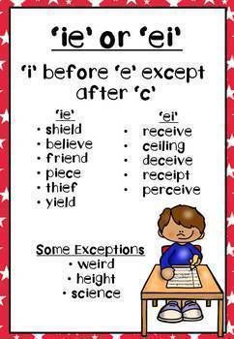

**Copy these headings and put the words in the box under the correct heading.**

|  |  |  |
| --- | --- | --- |
| **ie=ee sound** | **ei= follow c** | **ei=not ee sound** |
| thief | deceive | Their |
| shield | deceit | Rein |
| chief |  | Heir |
| brief |  |  |
| field |  |  |
| shriek |  |  |
| priest |  |  |

**Grammar and Punctuation page 19.**

**GRAMMAR AND PUNCTUATION.**

**Conjunction are words we use to join sentences.**

**The most common conjunctions are and and but.**

**Copy these sentences and join them with and or but.**

1.Van Cheele saw the boy. He stopped and spoke to him.

Van Cheele saw the boy and he stopped and spoke to him.

2.The boy said he caught hares.Hares were not easy to catch.

The boy said he caught hares but hares were not easy to catch.

3.The water was very cold. The boy dived in.

The water was very cold but the boy dived in.

4.The boy was standing on the hill. He was watching the sunset.

The boy was standing on the hill and he was watching the sunset.

4.The sun had disappeared. It was cold and grey.

The sun had disappeared and it was cold and grey.

6.He could not see the boy. He could see a large wolf.

He could not see the boy but he could see a large wolf.

1. **Use the conjunctions in the box to complete the sentences below.**

|  |  |  |  |  |
| --- | --- | --- | --- | --- |
| and | but | so | because | or |

1.The boy was not worried **but** frightened when Van Cheele spoke to him.

2.He lived in the woods **because** he had nowhere else to go.

3.Van Cheele **and** his friend had seen the strange boy.

4.The world turned cold and grey **because** the sun had set.

5.Van Cheele was puzzled **so** he asked his friend about the boy.

**Subject: English WorkSheet -1 Grade:7**

**Name: _________________________________**

**Q1. Answer very briefly:**

**Q1.Whom did Van Cheele meet in the wood?**

**_________________________________________________________________________________________________________________**

**Q2.What did the boy feed on?**

**________________________________________________________________________________________________________________**

**Q3. Who else had seen the boy in the woods?**

**________________________________________________________________________________________________________________**

**Q4. Suggest a suitable title for the story.**

**________________________________________________________**

**Conjunctions**



Conjunctions are words that join two or more words, phrases or clauses.

Example; for, and, nor, but, or, yet, so.

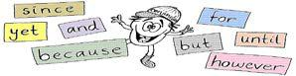

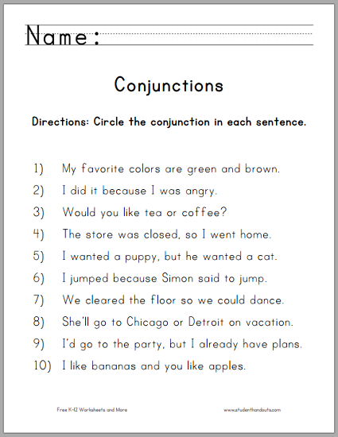

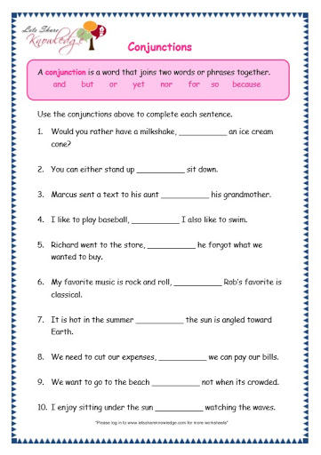

|  |  |  |  |  |
| --- | --- | --- | --- | --- |
| **Rubric:** | **Ex.** | **Go.** | **Sat.** | **NI** |
| **Content Accuracy** | **1** | **2** | **3** | **4** |
| **Creativity** | **1** | **2** | **3** | **4** |
| **Completeness** | **1** | **2** | **3** | **4** |
| **Neatness** | **1** | **2** | **3** | **4** |
| **1-Excellent 2- Good 3- Satisfactory**  **4- Needs improvement** | | | | |