 **Pakistan School , Kingdom of Bahrain**

**E- Support and Learning Material / Session 2020-2021**

**Subject: English Grade : 8**

**Unit 1.3 I'm your father's spirit ( page 16 to 19 )**

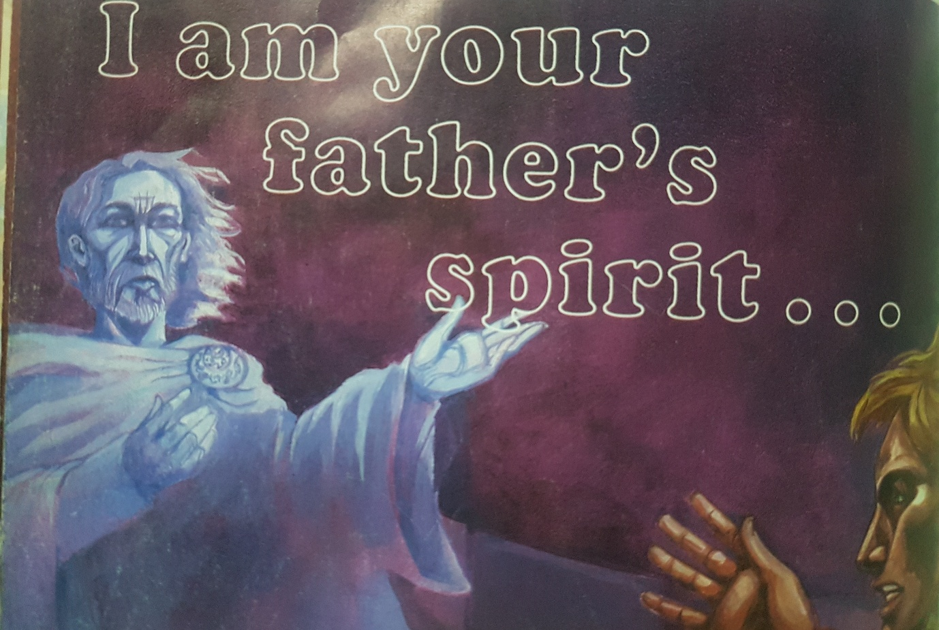

**Vocabulary.**

|  |  |  |
| --- | --- | --- |
| Compelling | Lure | Grasped |
| Solemn | Wicked | Traitor |
| Stoop | Horrible | Vanished |

**Words Meanings**

|  |  |  |
| --- | --- | --- |
| **No.** | **Words** | **Meanings** |
| **1** | Frenzied | Very excited or upset |
| **2** | Prostrate | Flat |
| **3** | Implored | Begged , appealed |
| **4** | Vengeance | revenge |
| **5** | Sulphurous | Very unpleasant |
| **6** | Infinite | Limitless |

**Words Sentences**

|  |  |  |
| --- | --- | --- |
| **No.** | **Words** | **Sentences** |
| 1 | Frenzied | There was no getting away from his frenzied assault. |
| 2 | Implored | I implore you to leave now. |
| 3 | Prostrate | The police found the body in prostrate position. |
| 4 | Sulphurous | The sulphurous odour maddened us. |
| 5 | Vengeance | He wanted vengeance after his bike was stolen. |
| 6 | Infinite | She has infinite patience when she is dealing with the children. |

**Comprehension. 7**

**Choose the best answer for each question. Page 17**

1. The ghost of Hamlet’s father has been seen;
   1. At the wedding b) **on the battlements**  c) at the bottom of the cliff.
2. The ghost wanted to speak to;
   1. **Hamlet** b) Marcellus c) Claudius
3. Hamlet's father was murdered by;
   1. His wife b) Horatio c) **Claudius**
4. He was killed by;
   1. **Poison** b) stabbing c) strangling
5. Hamlet's father wants Hamlet to;
   1. Forgive his murder b) forget about the murder  **c) kill his murder**

**Questions Answers page 18**

1. **Majestic figure.** This phrase is used for Hamlet's father who appears with grace.
2. **The snake that bit me now wears my crown.** It is used for Hamlet's uncle, Cladius who gave poison to the king and became a king.
3. **I scent the morning air.** These words are spoken by the ghost who could not survive in the sunlight.

**Q2. Ehen Hamlet sees the ghost , why do you think he began to cross himself?**

**Ans.** After seeing his father's ghost Hamlet began to cross himself because he wanted Gods mercy for his father's soul.

**Q3. Explain in your own words why you think Marcellus and Horatio do not want Hamlet to follow the ghost?**

**Ans.** They do not want to follow the ghost because by following the ghost Hamlet could fall into the sea headlong.

**Q4.The ghost does not want Hamlet to harm his mother. What will her punishment be?**

**Ans.** The ghost does not want Hamlet to harm his mother because he wants his mother to realize her sins and repent over it in her life.

**Grammar and punctuation page 19**

**Exercise A page 19**

**1.Royal**  Dane 2. **dead** voice

**3.Beautiful** tomb 4.**red** flame

**5.Great** flagstone 6. **brutal** murder

**Exercise B page 19**

1 The majestic figure  **……………………. the figure was majestic**

2 the frightening ghost …………………….. **the ghost was frightening**

3 the brutal murder  **…………………. the murder was brutal**

4 the dreadful news **……………… the news was dreadful**

5 the poisonous snake  **the snake was poisonous**

**Exercise C page 19**

1.He is a gentle man. 2.I saw a horrible scene. 3.That was a dangerous attack.

**Exercise D page 19**

1.The well was deep. 2.The cow was wild. 3.His skin was pale.

**Work Book page . 19**

**Underline the adjectives in these sentences.**

1. The poor man could not find a job.
2. After taking the medicine, the young boy was well.
3. The bad apple in the bowl had made the other fruit rot.
4. She was glad when the exam had finished.
5. The stormy weather caused damage to the house.

**Use these adjectives in sentences of your own.**

1. The park is looking very **peaceful** and quiet.
2. The room was filled with **hideous** furniture.
3. He gave a **magnificent** performance.
4. He bought curtains made of **cheap** material.

**Decide whether you could use these adjectives before or after a noun or both.**

|  |  |  |  |
| --- | --- | --- | --- |
| **Adjective** | **Before** | **After** | **Both** |
| Afraid |  |  |  |
| Kind |  |  |  |
| Curious |  |  |  |
| Alone |  |  |  |
| Puzzling |  |  |  |

 **Pakistan School , Kingdom of Bahrain**

**E- Support and Learning Material / Session 2020-2021**

**Subject: English Grade : 8**

**Topic: Pronouns and Kinds of Pronouns**

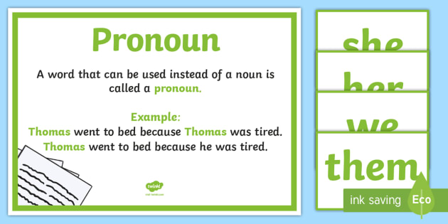

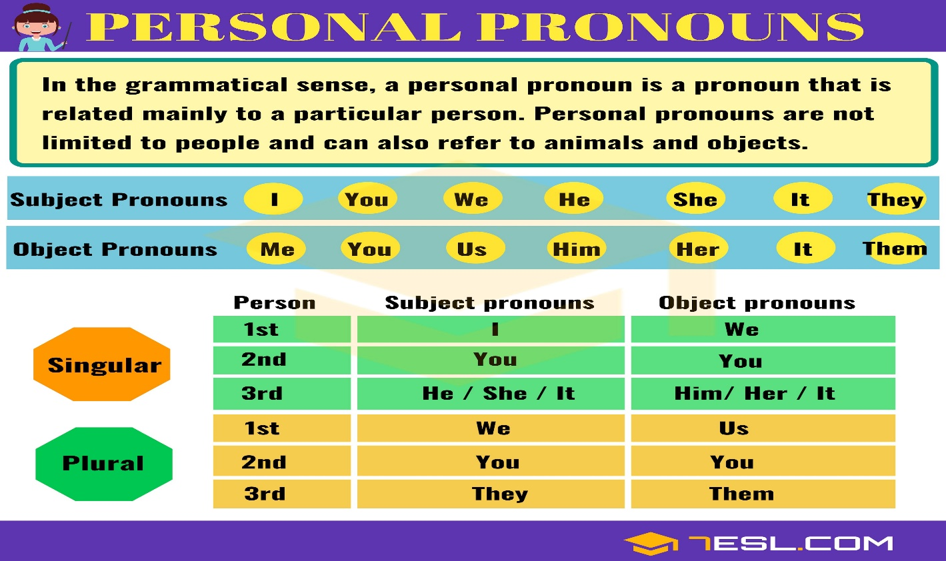

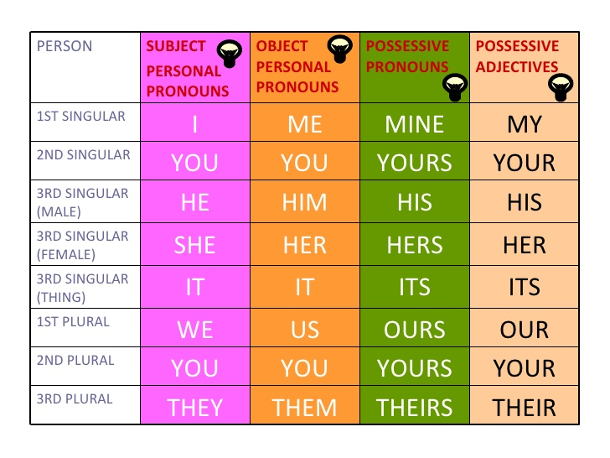

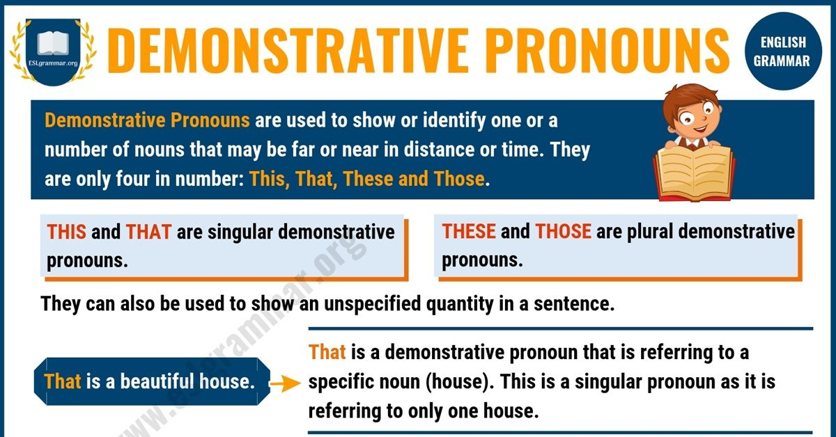

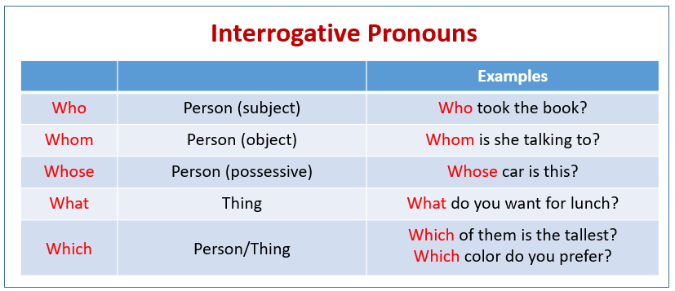

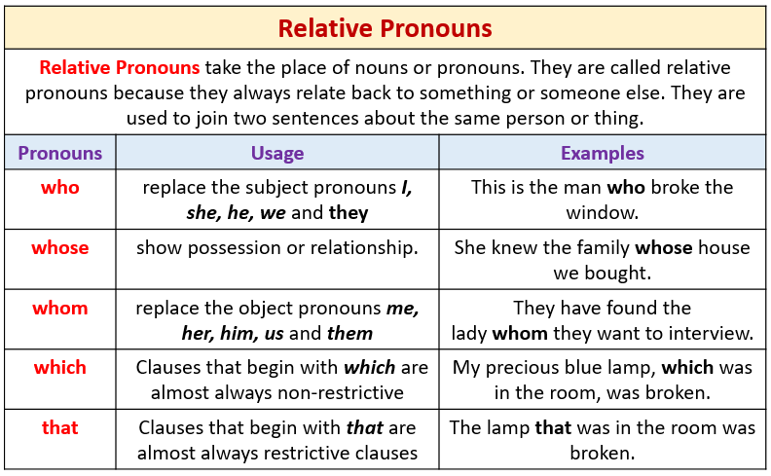

**WORKSHEETS – Kinds of Pronouns – Grade 8**

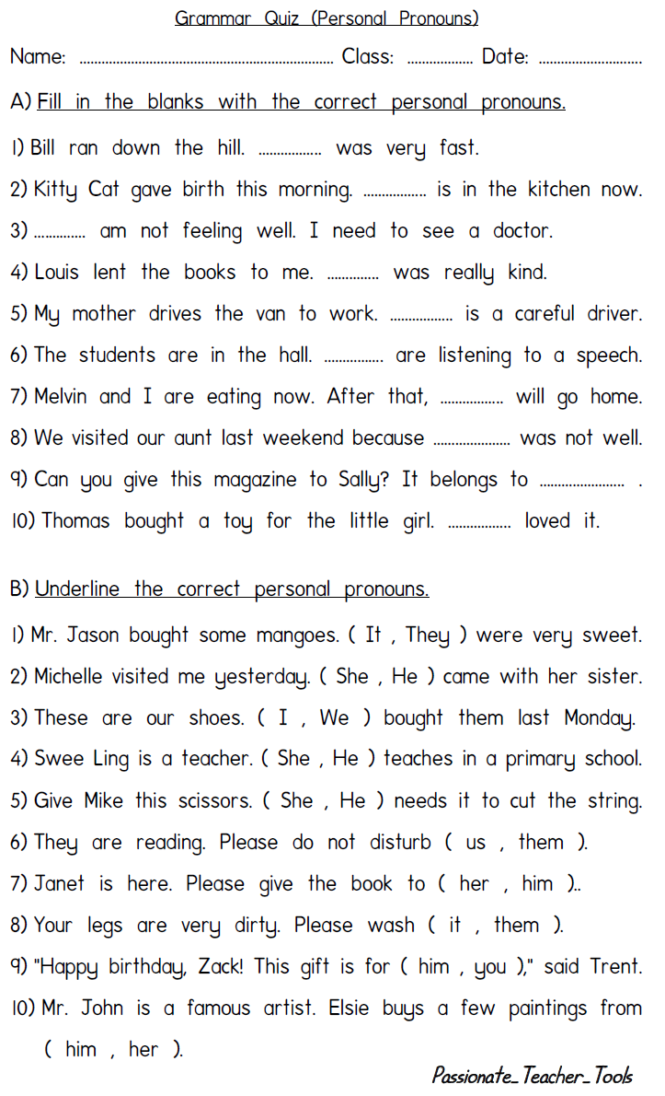

**Grammar Quiz – Demonstrative Pronouns**

**Name: ____________________________ Class: _______ Date: _________**

**Complete each sentence with one of the following demonstrative pronouns: this, that, these, those.**

**1. Do you see ________________________ bird over there?**

**2. ________________________ newspaper I’m holding has today’s news.**

**3. Place the vase on ________________________ table in the corner.**

**4. Mary wants ________________________ lamps displayed on the top shelf.**

**5. ________________________ is the best movie I’ve ever seen.**

**6. ________________________ shoes are hurting my feet.**

**7. Could you toss me one of ________________________ pillows?**

**8. How much is ________________________ jacket hanging on the far rack?**

**9. Jamal thinks ________________________ peaches in my basket have gone bad.**

**10. ________________________ children across the street are jumping rope.**

**Grammar Quiz – Interrogative Pronouns**

**Name: ____________________________ Class: _______ Date: ___________**

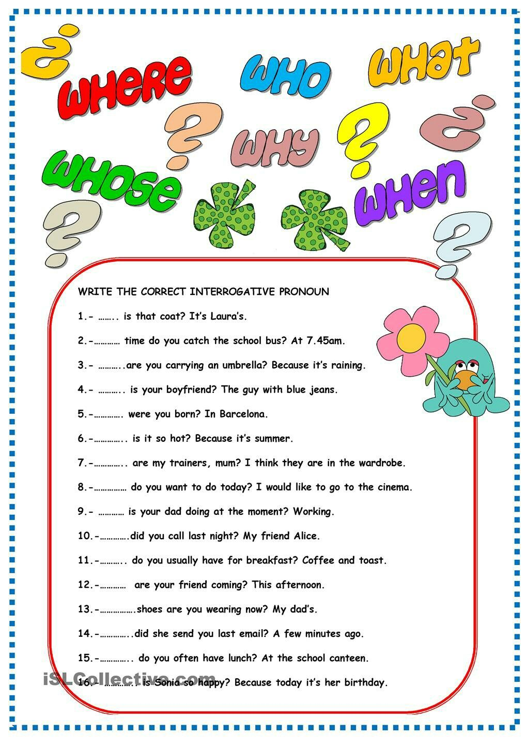

**Grammar Quiz – Relative Pronouns**

**Name: ____________________________ Class: _______ Date: ___________**

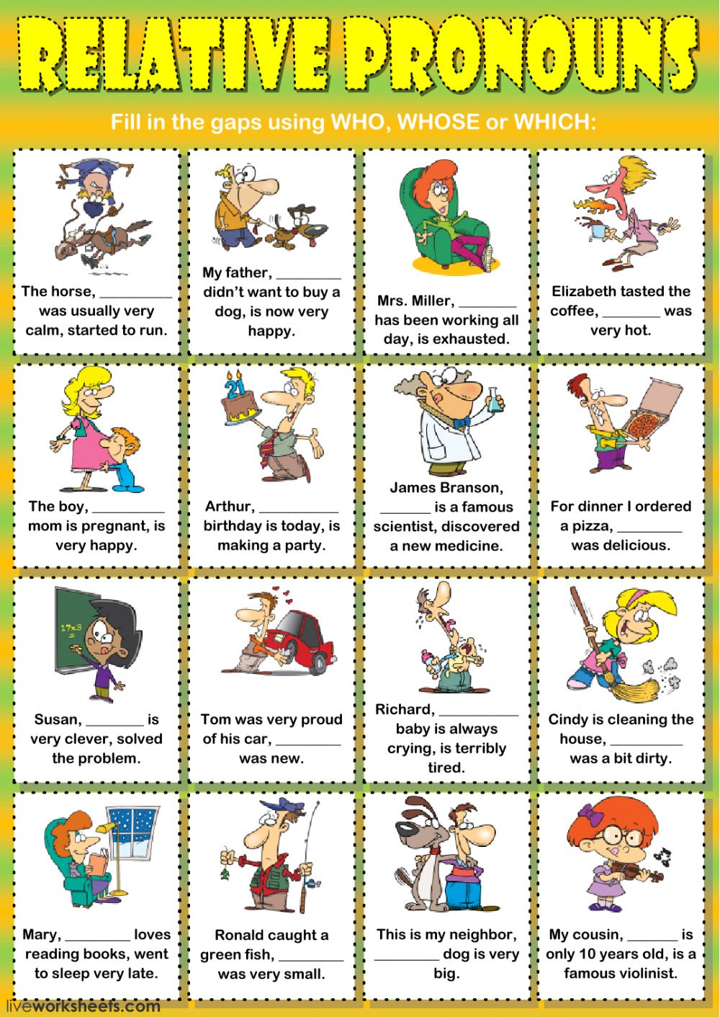

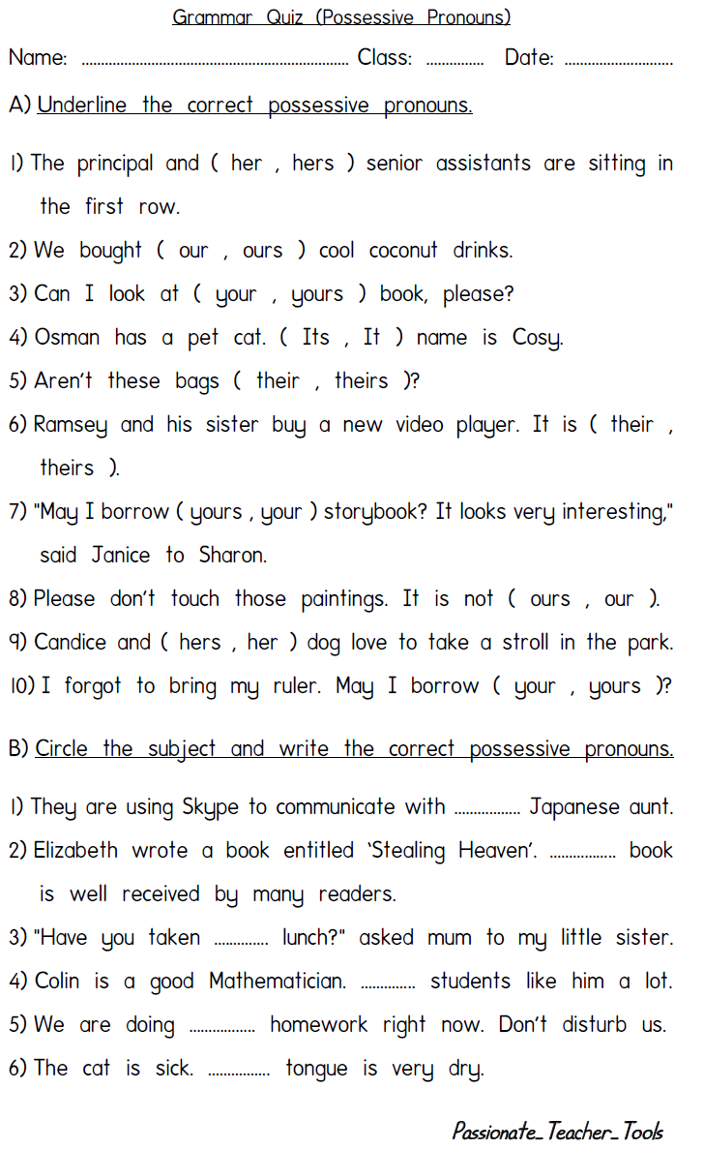

**HOMEWORK**

**Unit 1.3: ( Writing Assignment )**

**Persuasion**

**Make notes on the following before writing up your interview.**

**Name of the Detective inspector. ………………………………………………………..**

**Explain how you came to meet the ghost?**

**…………………………………………………………………………………………………………………………………………**

**…………………………………………………………………………………………………………………………………………….**

**…………………………………………………………………………………………………………………………………………….**

**Questions the Detective Inspector might ask.**

**…………………………………………………………………………………………………………………………………………….**

**………………………………………………………………………………………………………………………………………………**

**………………………………………………………………………………………………………………………………………………**

**Words and phrases the Detective Inspector might use to suggest he/she does not believe you.**

**………………………………………………………………………………………………………………………………………………**

**………………………………………………………………………………………………………………………………………………**

**………………………………………………………………………………………………………………………………………………**

**How will you convince him/ her that you are telling the truth?**

**……………………………………………………………………………………………………………………………………………………………………………………………………………………………………………………………………………………………………..……………………………………………………………………………………………………………………………………..**

**How do you finally get the Detective inspector to believe you ?**

**Use the appropriate adjectives from the box for the given nouns.**

|  |
| --- |
| beautiful, large, dead , bright, brutal |

* 1. **……………** flower
  2. ……………flagstone
  3. ……………voice
  4. ……………flames
  5. ……………murder

**Q.2 Underline the adjectives from the given sentences.**

1. She was glad when the exam had finished.
2. After taking the medicine, the poor boy was well.
3. He is a kind man at all.
4. I like peaceful atmosphere.
5. I saw a horrible scene.

**Q.4 Try to use the given adjective after a noun in sentences of your own.**

1. Deep ……………………………………………………………………….
2. Wild ………………………………………………………………………..
3. Pale ……………………………………………………………………….

|  |  |  |  |  |
| --- | --- | --- | --- | --- |
| **Rubric:** | **Ex.** | **Go.** | **Sat.** | **NI** |
| **Content Accuracy** | **1** | **2** | **3** | **4** |
| **Creativity** | **1** | **2** | **3** | **4** |
| **Completeness** | **1** | **2** | **3** | **4** |
| **Neatness** | **1** | **2** | **3** | **4** |
| **1-Excellent 2- Good 3- Satisfactory**  **4- Needs improvement** | | | | |