**Pakistan School , Ministry of Education , Kingdom of Bahrain**

**E-Support and Learning /Session 2020-2021**

**Subject : English - Grade : 9**

**Unit 3: Media and its Impact**

**Pg. 25 Ex. B: Answer the following questions:**

**Q: What type of information does media provide?**

Ans: Media is the most powerful and influential source of communication, information and knowledge. It makes us aware of important incidents and realities of our daily life. It also provides us information about new innovations and technologies.

**Q: Is TV taking away the habit of reading?**

Ans: Yes, media is taking away the habit of reading because watching TV requires less efforts and a little skill of language. Moreover, watching TV is less costly than reading books. Thus, TV is taking away the habit of reading.

**Q1:  What is the most important function that media performs?**

Ans. The most important and effective function of media is its role as the most powerful device of communication. Communication is such a thing because of which we can watch and listen to the news as they are happening. Media not only informs us but entertains also.Media raises awareness about social issues and has also become a mouthpiece of the downtrodden.

**Q2:  What are the two major means of communication?**

Ans. The two major means of communication are electronic media and print media. The electronic media includes film,radio,television, internet and print media includes books,magazines and newspapers.Now-a-days media has become an integral part of our lives.

**Q3: How does media provide entertainment?**

Ans. Media entertains us by showing films, plays, by playing music, by printing stories, columns and funny things. Now-a-days game shows are particularly, more entertaining and thus are popular.

**Q4: What happens when media is allowed to play its role unchecked?**

Ans. If media is allowed to play its role unchecked, the mean, selfish and business-minded persons would try to exploit common men using it dishonestly. It may also spread false news and work for its own interest only.

**Q5: Give three reasons in support of your favourite TV programme.**

**Ans: I like news programme for the following three reasons:**

1. It provides us important information.
2. It makes us aware of the changing circumstances.
3. It provides us entertainment showing latest news about interesting and strange incidents of the current world.

**Pg. 26 : Vocabulary:**

**Ex. A: Explain the following phrases as used in the text.**

**geared up, global village, a click away, constructive role, raise awareness, to keep an eye, a mouth piece of downtrodden.**

|  |  |
| --- | --- |
| Geared up | Get ready |
| Global village | To overcome distance |
| A click away | Very fast |
| Constructive role | Vital role |
| Raise awareness | To make something known |
| Keep an eye | To be vigilant |
| A mouthpiece of the downtrodden | A speaker for those who are in trouble |

**Ex. B : Put these words in relevant columns to identify the part of speech these words belong to.**

|  |  |  |
| --- | --- | --- |
| **Nouns** | **Adjectives** | **Adverbs** |
| Media | False | Eagerly |
| Audience | Constructive | Loudly |
| Information | Corrective |  |
| Communication | global |  |
| Impact |  |  |
| Means |  |  |

**Pg. 26 :Grammar:**

**Ex. A :Change the following words into nouns, fill in the blanks with nouns.**

save (safety) , excited (excitement) , devastating (devastation) , active (activity) , helpless (helplessness) , hopeless (hopelessness) , able (ability), justify (justifiication)

1. Doctors are concerned with the **safety** of the patients.
2. In a state of **excitement** she cried loudly.
3. Floods often cause large scale **devastation.**
4. Positive **activity** will keep you healthy.
5. Her **hopelessness was quite obvious.**
6. She was in a state of **helplessness.**
7. She has the **ability** required for the job.
8. Have you any **justification** of this act?

**Ex. B : Identify personal, possessive, reflexive and indefinite pronouns.**

1. This is my book. **(possessive)**
2. Salman is absent because he is ill. **(personal)**
3. You will hurt yourself. (reflexive)
4. Nobody was there to rescue the child. **(indefinite)**

**Ex. C. Identify pronoun errors and rewrite the following sentences correctly.**

1. media plays a very constructive role for society. It raises awareness about many social issues like corruption, terrorism, drug addiction and violation of human rights.

2. I would conclude the discussion by saying that media plays a positive role and has a corrective impact if it works honestly.

3. Good. Very well conclusion. I am happy that all of you have participated in this discussion and have expressed yourselves very well.

**Ex. D: Complete the sentence choosing the right option.**

1. Media **plays a** very constructive role for the society. (play/plays)
2. Media **has** also become a mouthpiece of the downtrodden. (has/have)
3. I am happy that all of you **have** expressed yourselves very well. (has/have)
4. Their feelings and opinions **are** expressed through it. (is/are)
5. Film, radio, television, the internet, books, magazines and newspapers **provide** us information as well as entertainment. (provides/ provide

**Pg. 28 Ex. E: Change the voice.**

|  |  |
| --- | --- |
| **Active** | **Passive** |
| Media helps people to share knowledge. | People are helped by media to share knowledge. |
| Their feelings and opinions are expressed through it. | It expresses their feelings and opinions. |
| Media attracts the attention of a very large audience. | The attention of a very large audience is attracted by media. |
| After entering the house, we switched on the television. | The television is switched on by us after entering the house. |
| It not only informs us but also entertains us. | We are not only informed but also entertained by it. |

**Ex. F : Change the paragraph into Past Indefinite Tense**:

Media helps helped people to share knowledge of the world.

Their feelings and opinions are were expressed through it.

Media attracts attracted the attention of a very large audience.

Have Had you noticed that the first thing we do did soon after entering the house is was to switch on the television?

**Ex. G: Punctuate the following**:

There are two means of communication electronic media and print media. The media includes film , radio , television , internet , books , magazines and newspapers . It provides us information as well as entertainment .

**Pg. 30 – Writing an E-Mail:**

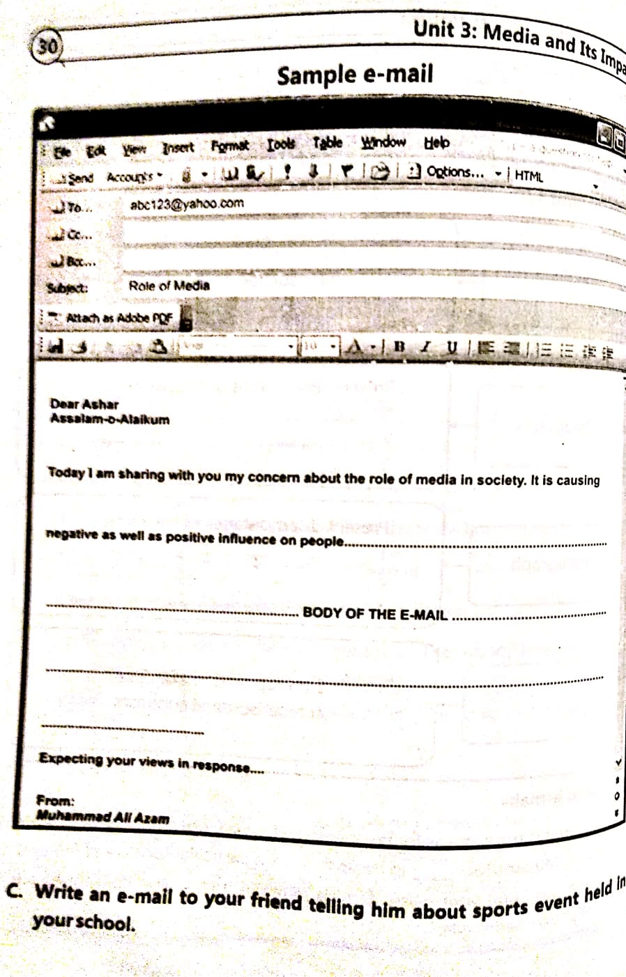

**Subject : English - Grade : 9** **Unit 3: Media and its Impact**

**WORKSHEET**

**KINDS OF PRONOUNS:**

**Personal – Possessive – Demonstrative – Interrogative – Reflexive/Reflective – Emphatic/Emphasizing / Intensive -Indefinite – Distributive – Relative-Reciprocal**

**Use this link to understand the kinds of pronouns:**

[**https://www.slideshare.net/studentsandteachers/pronouns-3844689**](https://www.slideshare.net/studentsandteachers/pronouns-3844689)

**Active -Passive Voice – Indefinite Tenses**

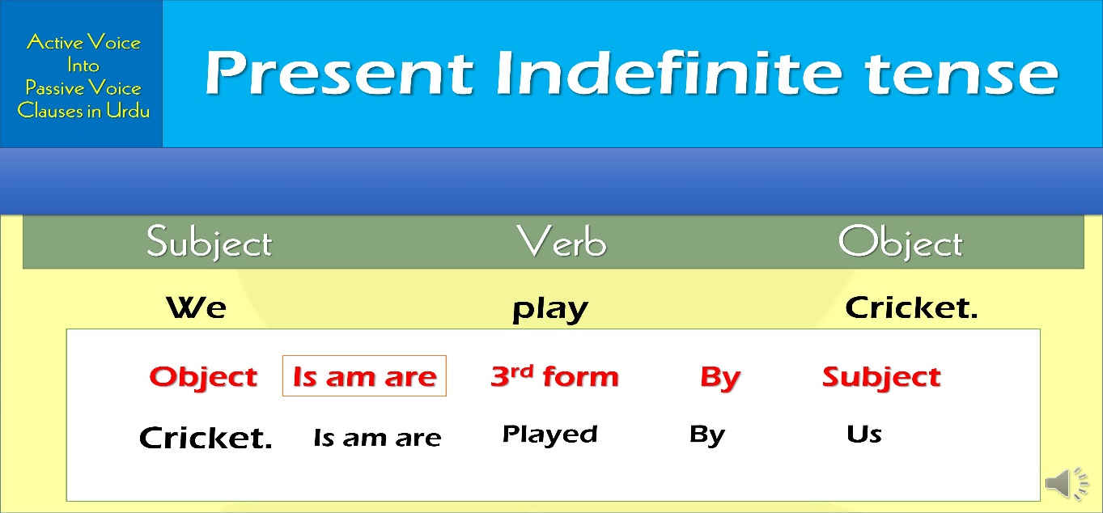

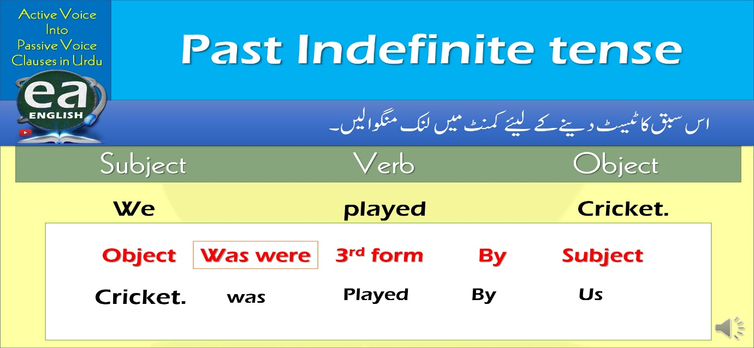

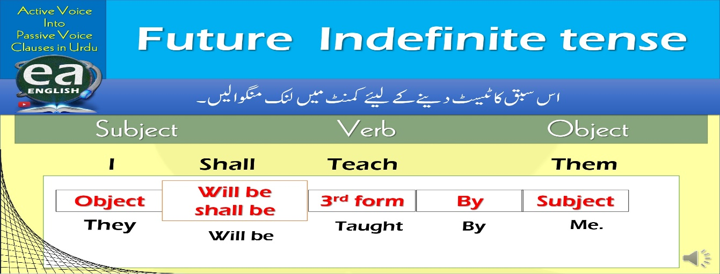

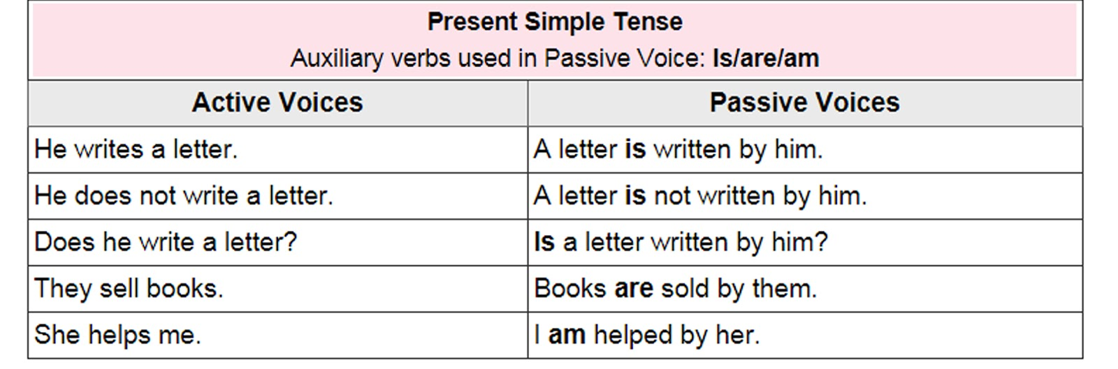

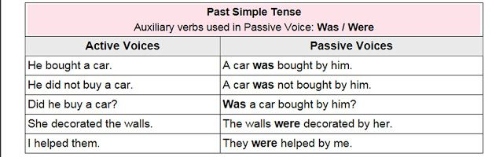

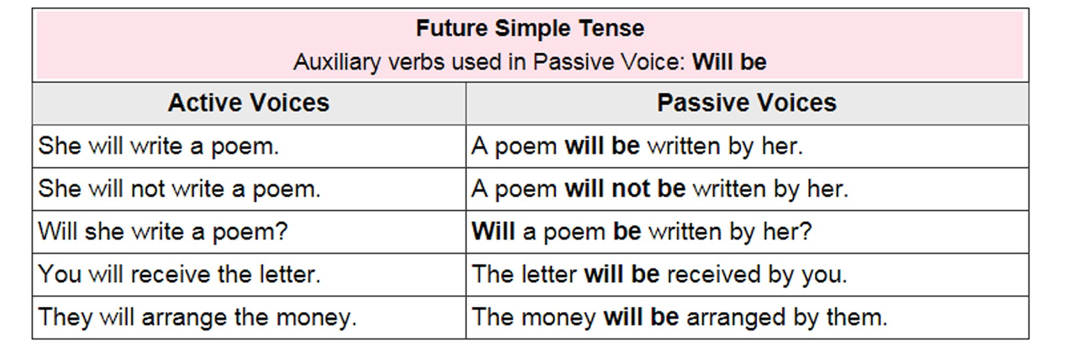

**Now do these:**

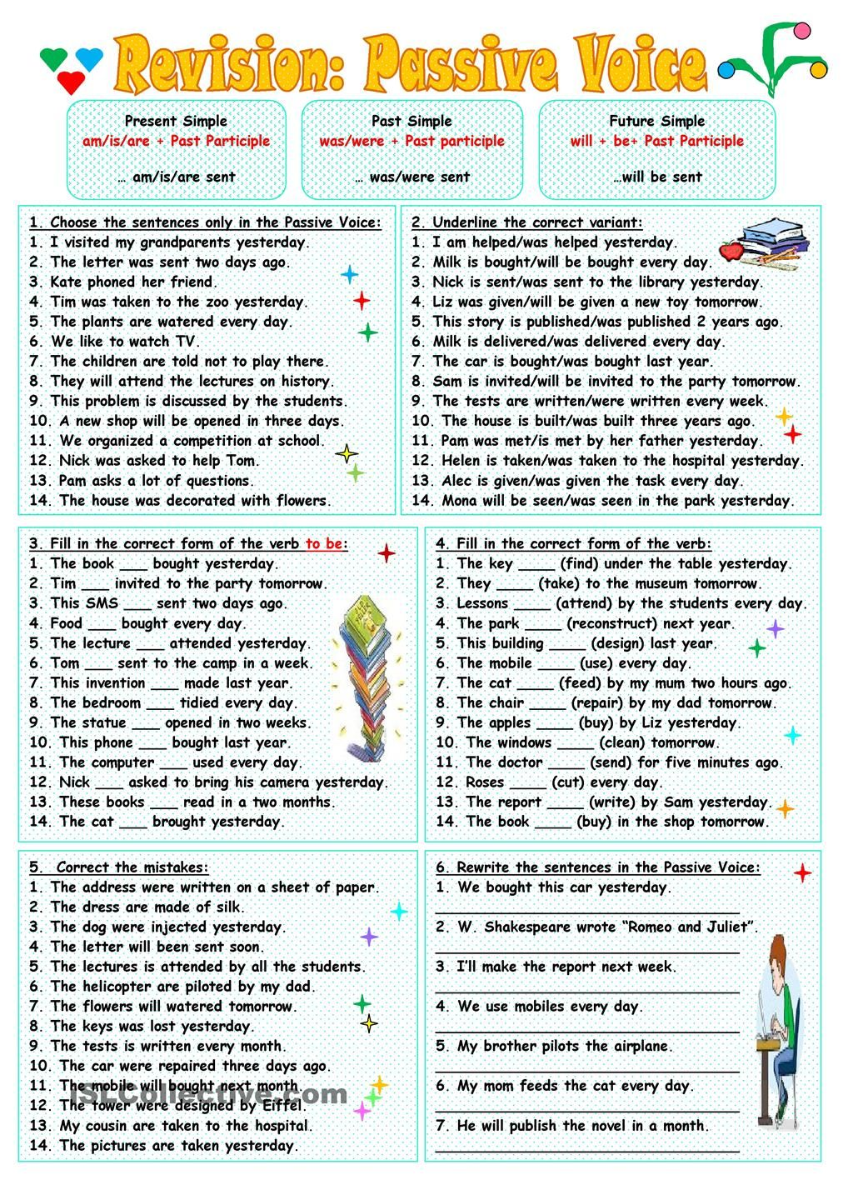

**Past Indefinite Tense:**

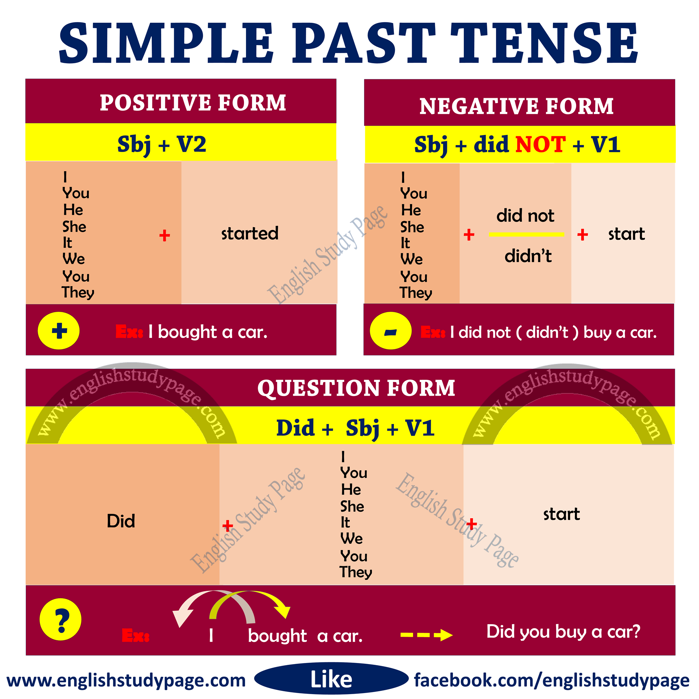

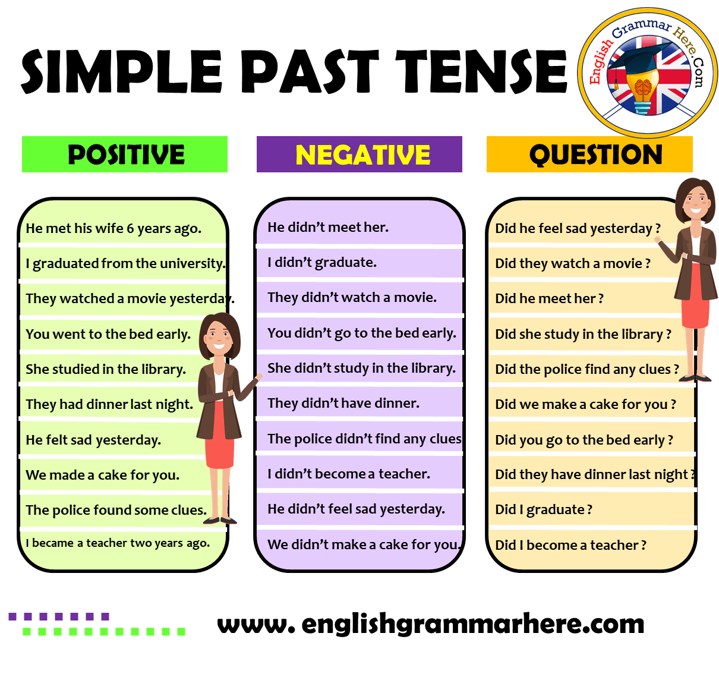

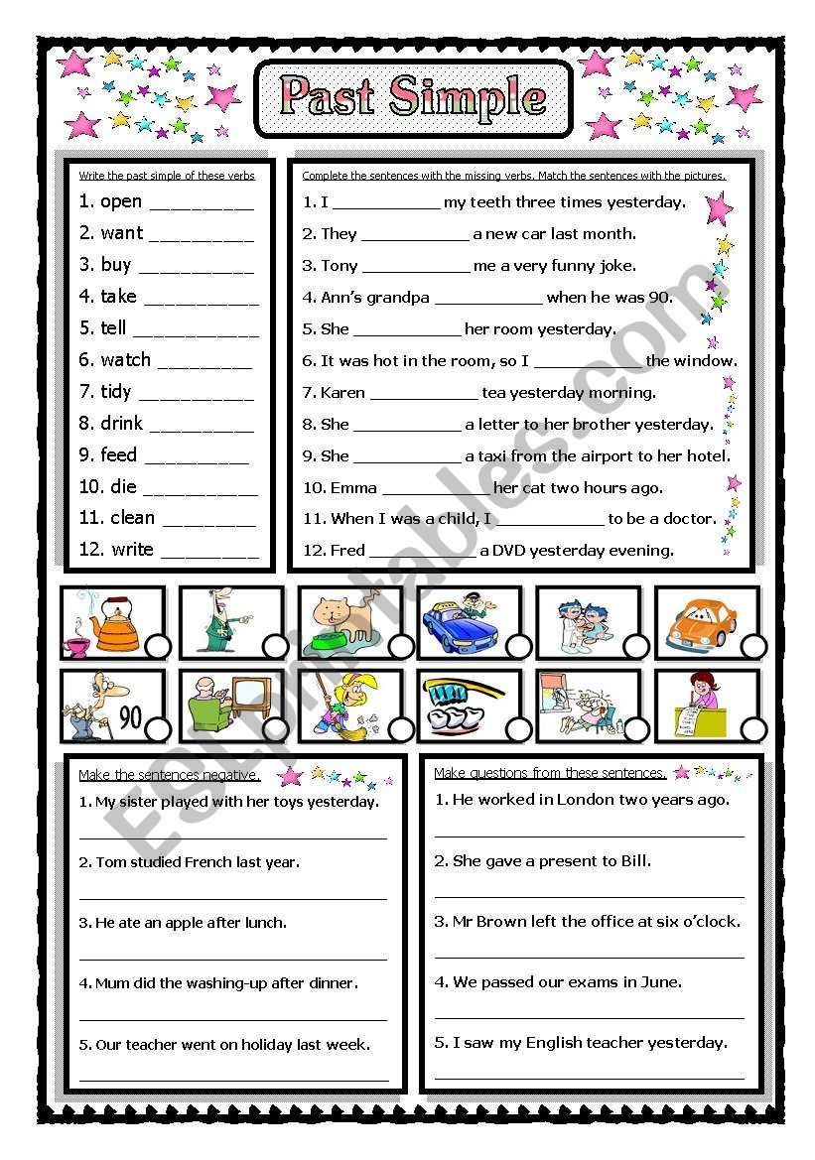

|  |  |  |  |  |
| --- | --- | --- | --- | --- |
| **Rubric:** | **Ex.** | **Go.** | **Sat.** | **NI** |
| **Content Accuracy** | **1** | **2** | **3** | **4** |
| **Creativity** | **1** | **2** | **3** | **4** |
| **Completeness** | **1** | **2** | **3** | **4** |
| **Neatness** | **1** | **2** | **3** | **4** |
| **1-Excellent 2- Good 3- Satisfactory**  **4- Needs improvement** | | | | |