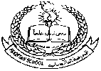**Pakistan School, Kingdom of Bahrain**

**E- Support and Learning Material / Session 2020-2021**

**Subject : English LKG ( Manama / Isa Town)**

**Name: _________________________________**

**LETTER “A” (WorkSheet-1)**

**Q1. Color the friends of letter “A”.**

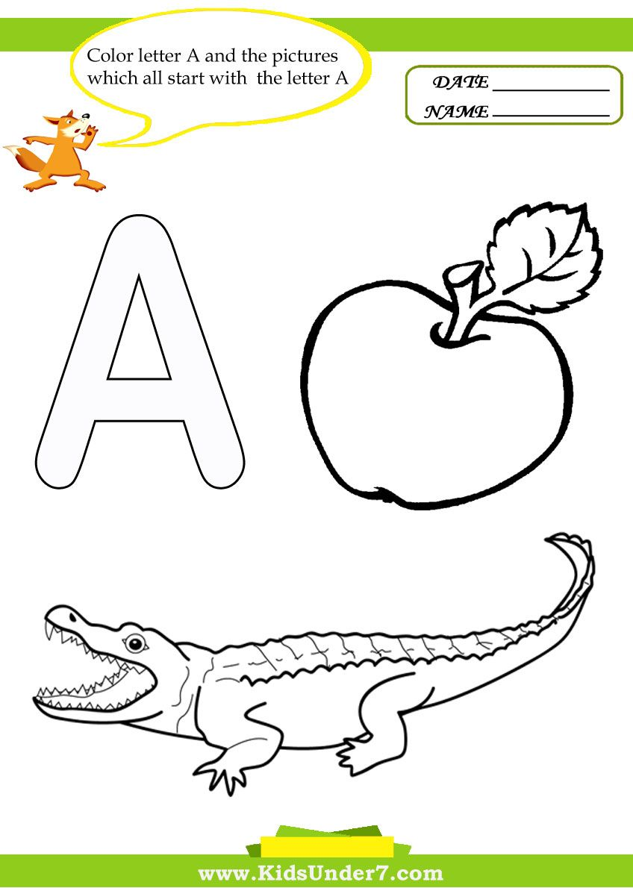



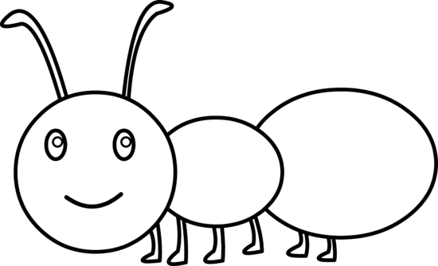

**Q1.Circle the letter “A”**

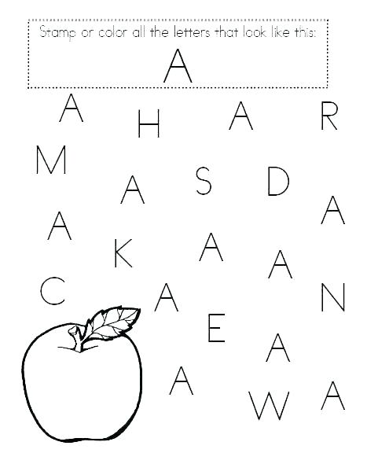

**Q2. Match pictures with the letter ”A”.**



A

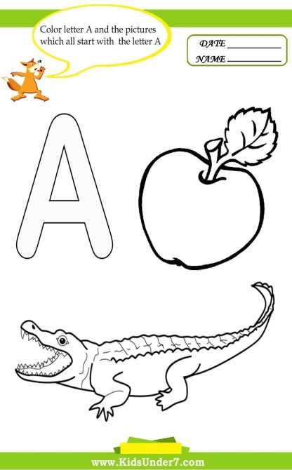

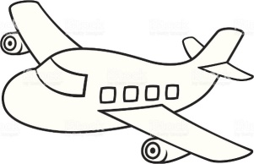

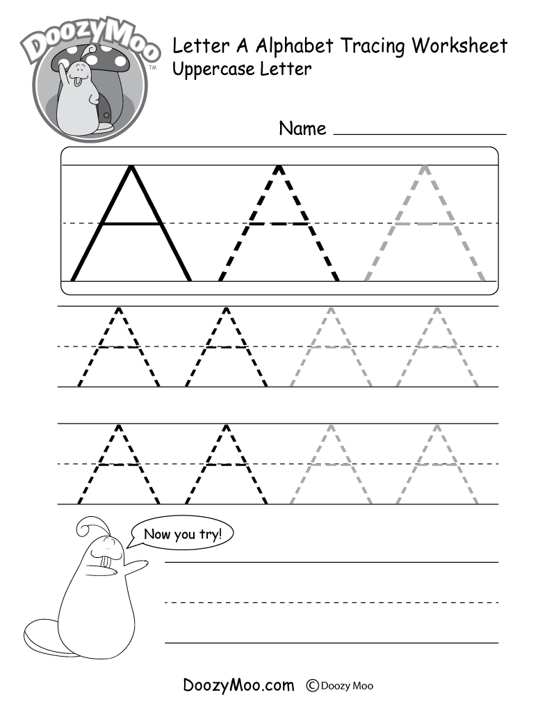**Q3. Trace letter “A”**

**Pakistan School, Kingdom of Bahrain**

**E- Support and Learning Material / Session 2020-2021**

**Subject : English LKG ( Manama / Isa Town)**

**Name: _________________________________**

**LETTER “X” (WorkSheet-2)**

Color the friends of letter X:

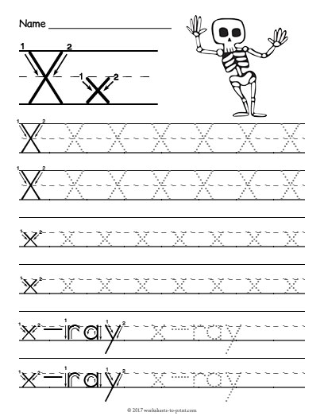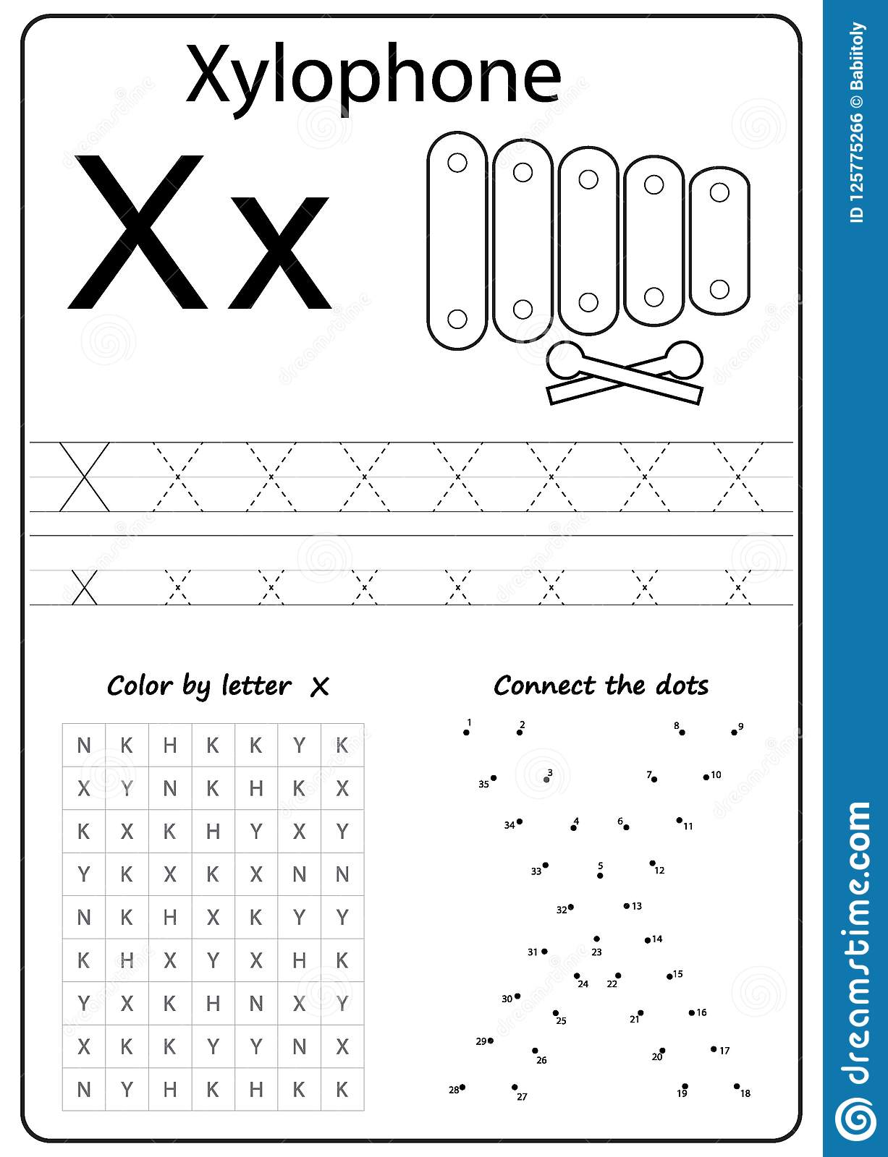

**Trace the letter X:**



Circle letter X:

X U B X R X U X W

T X R X U N W X

**Pakistan School, Kingdom of Bahrain**

**E- Support and Learning Material / Session 2020-2021**

**Subject : English LKG ( Manama / Isa Town)**

**Name: _________________________________**

**LETTER “Y” (WorkSheet-3)**

Color the friends of letter Y:

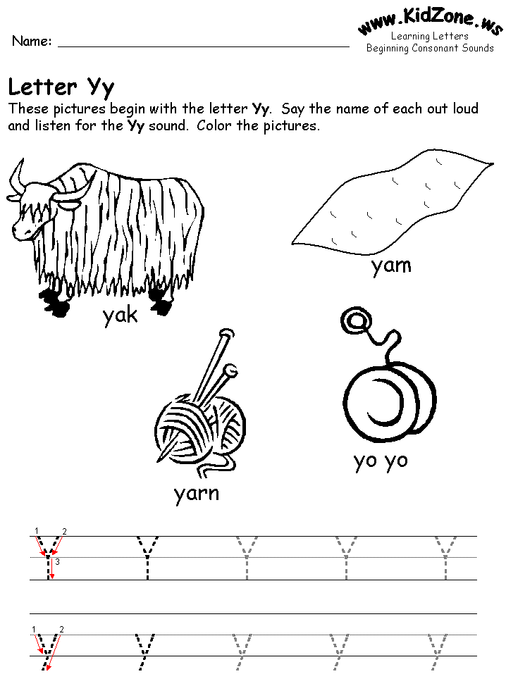

**Trace the letter Y:**



Circle letter Y:

Y U Y X R Y U X Y

T Y R Y U Y W Y

**Pakistan School, Kingdom of Bahrain**

**E- Support and Learning Material / Session 2020-2021**

**Subject : English LKG ( Manama / Isa Town)**

**Name: _________________________________**

**LETTER “Z” (WorkSheet-4)**

Color the friends of letter Z:

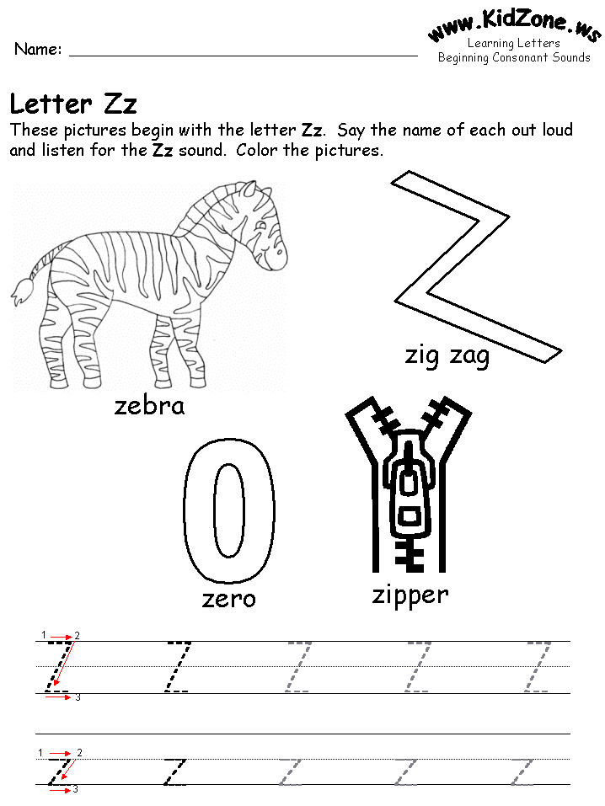

**Trace the letter Z:** 

Circle letter Z:

Z U Z X R Z U X Z

T Z R Y Z Y W Z