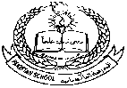**Pakistan School, Kingdom of Bahrain**

**E- Support and Learning Material**

**Subject: English Grade : HKG**

**Reading and Writing Two Letter Words (so, lo, go, no)**

|  |  |
| --- | --- |
|  |  |
| **Student‘s Name: _________________________________________________** | |
|  | |

**Q.1: Write the following words:**

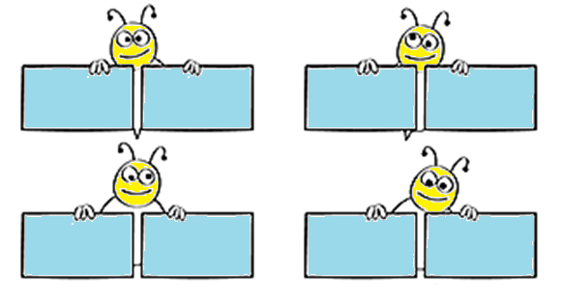

lo

go

no

so

**Q.2: Match the same words by drawing a line:**

**so**

**lo**

**go**

**no**

**lo**

**no**

**so**

**go**

**Q. 3: Complete two letter words:**

|  |  |  |
| --- | --- | --- |
|  | **s__** |  |
|  |  |  |
|  | **l__** |  |
|  |  |  |
|  | **g__** |  |
|  |  |  |
|  | **n__** |  |

**Q.4: Read and practice book page number 6, 7, 8, 9.**

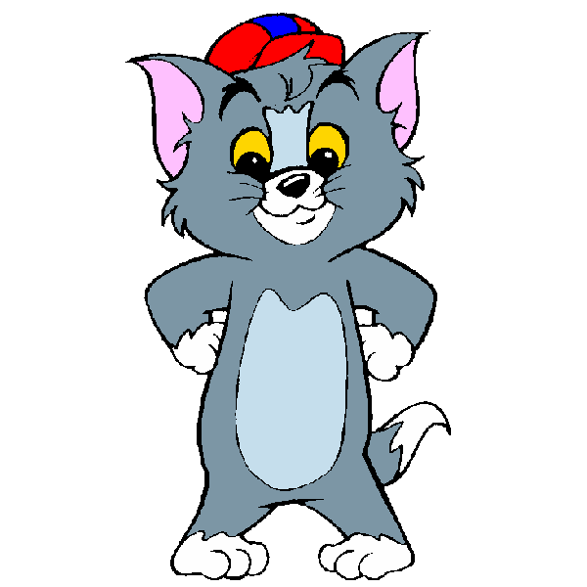

**Pakistan School, Kingdom of Bahrain**

**E- Support and Learning Material**

**Subject: English Grade : HKG**

**Reading and Writing Two Letter Words (he, be, we, me)**

|  |  |
| --- | --- |
|  |  |
| **Student’s Name: _________________________________________________** | |
|  | |

**Q.1: Write the following words:**

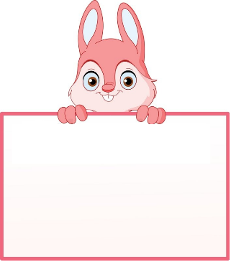

be

me



we

he



**Q.2: Match the same words by drawing a line:**

**he**

**be**

**we**

**me**

**we**

**me**

**he**

**be**

**Q. 3: Complete two letter words:**

|  |  |  |
| --- | --- | --- |
|  | **h__** |  |
|  |  |  |
|  | **w__** |  |
|  |  |  |
|  | **b__** |  |
|  |  |  |
|  | **m__** |  |

**Q.4: Read and practice book page numbers 10, 11 and 12.**

