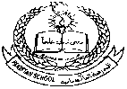**Pakistan School , Ministry of Education , Kingdom of Bahrain**

**E-Support and Learning /Session 2020-2021**

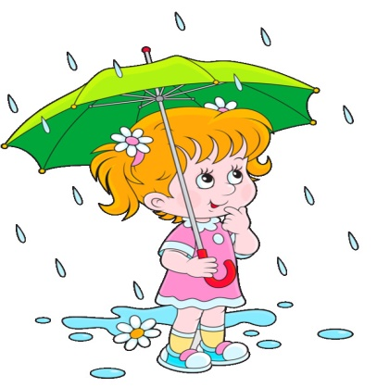 **Subject : English - Grade : I**

**First Term**

**Book: Student Book 1 Pg.No – 12**

**Unit 3 : What is rain?**

1. **Vocabulary words**

c-l-o-u-d-s

clouds

w-a-t-e-r

water

[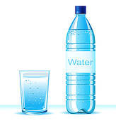](https://www.google.com/url?sa=i&url=https://webcomicms.net/clipart-9247345-bottled-water-clipart&psig=AOvVaw2DaQjVxx5ZM3BsoVIcQmVE&ust=1584945842142000&source=images&cd=vfe&ved=0CAIQjRxqFwoTCIjBhsy9regCFQAAAAAdAAAAABAJ)

[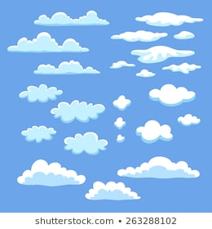](https://www.google.com/url?sa=i&url=https://www.shutterstock.com/search/clipart%2Bclouds&psig=AOvVaw11Jcad-1_J--jkuT8L25zn&ust=1584945980975000&source=images&cd=vfe&ved=0CAIQjRxqFwoTCMCzhYi-regCFQAAAAAdAAAAABAD)

p-e-o-p-l-e

people

d-r-o-p-s

drops

[](https://www.google.com/url?sa=i&url=https://www.kissclipart.com/employee-transparent-clipart-royalty-free-employee-0f3928/&psig=AOvVaw2YDIgDQFqWNjnEXAokbIos&ust=1584946085901000&source=images&cd=vfe&ved=0CAIQjRxqFwoTCKCTnLi-regCFQAAAAAdAAAAABAJ)[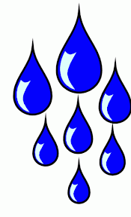](https://www.google.com/url?sa=i&url=http://niceclipart.com/10247/drops.html/drops-clipart-3&psig=AOvVaw32Zf7qRXy7XlXo42HcpMJq&ust=1584945767314000&source=images&cd=vfe&ved=0CAIQjRxqFwoTCOD0lJ69regCFQAAAAAdAAAAABAD)

p-l-a-n-t-s

plants

a-n-i-m-a-l-s

animals

[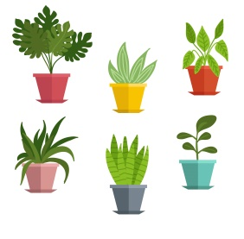](https://www.google.com/url?sa=i&url=https://clipartart.com/categories/clipart-potted-plants.html&psig=AOvVaw1K4UrxC1ZSLoeZzFyI7Lgg&ust=1584946211533000&source=images&cd=vfe&ved=0CAIQjRxqFwoTCKjZt_G-regCFQAAAAAdAAAAABAD)

[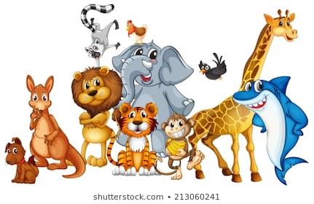](https://www.google.com/url?sa=i&url=https://www.shutterstock.com/search/animals%2Bclipart&psig=AOvVaw1mTVpm6MY47k9nOa6HXE2h&ust=1584946310138000&source=images&cd=vfe&ved=0CAIQjRxqFwoTCKCAi6G_regCFQAAAAAdAAAAABAO)

**II- Give the meanings of :**

|  |  |
| --- | --- |
| **word** | **Meanings** |
| 1. tiny | very small |
| 2. spoil | destroy |
| 3. millions | hundred thousands |



III – **Answer the questions:**

Q1). Where does the rain fall from?

Ans). The rain falls from clouds.

[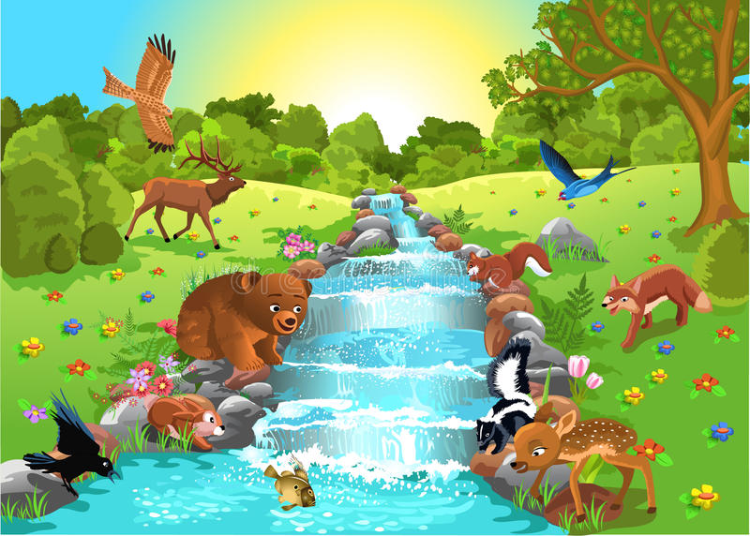](https://www.google.com/url?sa=i&url=https://www.dreamstime.com/royalty-free-stock-images-cute-animals-forest-cartoon-illustration-wild-image31549149&psig=AOvVaw17NB6Wl4HM1UXoURnDBPob&ust=1584950037904000&source=images&cd=vfe&ved=0CAIQjRxqFwoTCKDutpTNregCFQAAAAAdAAAAABAD)

Q2). Why do people and animals need water?

Ans). People and animals need water to drink.

**IV - Make sentences.**

|  |  |
| --- | --- |
| **word** | **Sentences** |
| 1. rain | Rain falls from clouds. |
| 2. clouds | We can see the clouds in the sky. |
| 3. plants | Plants need water to grow. |

**Student Book 1 (Page # 13, Opposites)**

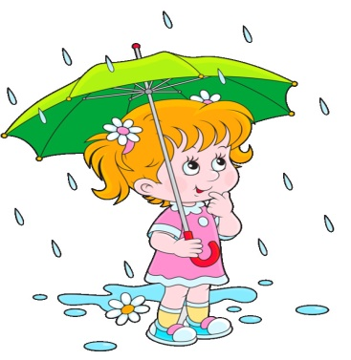**Write the correct opposite for the given words.**

long , hot , out , big , dry

1. cold ___**hot**___

2. short ___**long**__

3. small ___**big**___

4. dry ___**wet**__

5. in ___**out**___

**Student Book 1 (Page # 14, Exercise A)**

**Add a letter to the given naming words.**

|  |  |  |
| --- | --- | --- |
| d o g | m a n | s u n |
| r a i n | h o r s e | w e b |

**Student Book 1 (Page # 14, Exercise B)**

**Write the given naming words in place of the pictures.**

girl , rain , cloud , umbrella

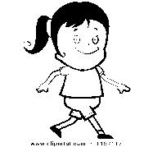

The g i r l went for a walk. A big c l o u d came.

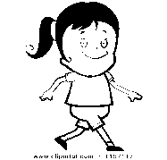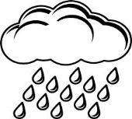

Heavy r a i n fell so the g i r l was pleased she

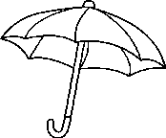

had an u m b r e l l a .

[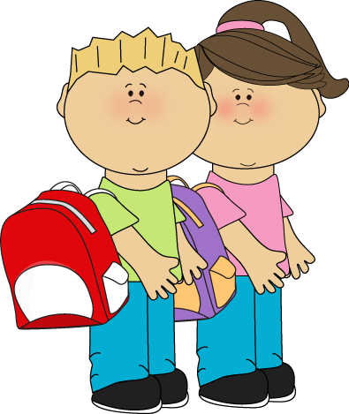](https://www.google.com/url?sa=i&url=https://www.pinterest.com/pin/283445370270450163/&psig=AOvVaw2fuIpGotKSe-eHvNHQbBUe&ust=1584952329097000&source=images&cd=vfe&ved=0CAIQjRxqFwoTCMCR7NnVregCFQAAAAAdAAAAABAN)

**Composition: Myself**

1. I am a boy / girl.

2. My name is ____________ .

3. I am seven years old.

4. I am in grade 1.

5. I go to Pakistan School.

6. I live in Bahrain.

**Composition: My Pet**

[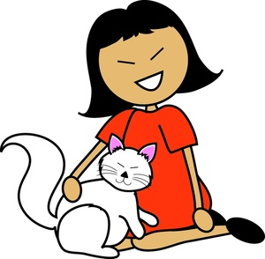](https://www.google.com/url?sa=i&url=https://www.clipart.email/clipart/me-and-my-pet-clipart-68787.html&psig=AOvVaw1e1PZhDwtvVqFswvvsHI4H&ust=1584952462324000&source=images&cd=vfe&ved=0CAIQjRxqFwoTCICklJfWregCFQAAAAAdAAAAABAD)1. I have a pet cat.

2. Its name is Tom.

3. Its colour is white.

4. It likes to eat fish.

5. It likes to drink milk.

6. I play with my pet.

**Subject : English** **Worksheet** **Grade: 1**

**Topic: Opposites**

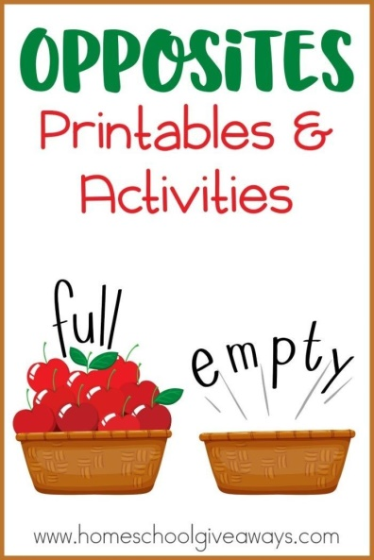[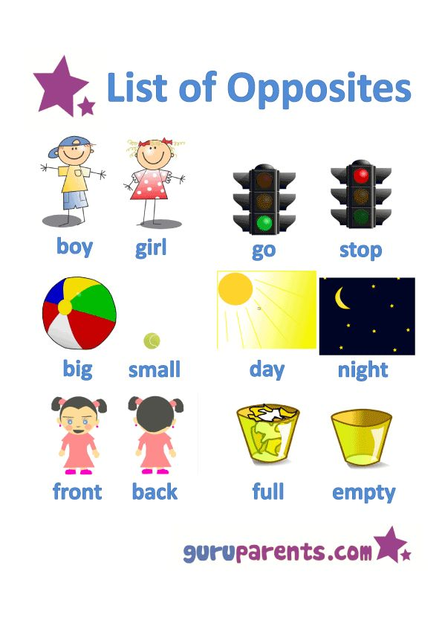](https://www.google.com.eg/url?sa=i&rct=j&q=&esrc=s&source=images&cd=&cad=rja&uact=8&ved=0ahUKEwjRjIWwiNjTAhXLWxoKHTLyAhwQjRwIBw&url=https://www.pinterest.com/explore/opposites-preschool/&psig=AFQjCNGGxAStRy1uJ0WKmuDTG3QCQIBXMg&ust=1494050002141218)

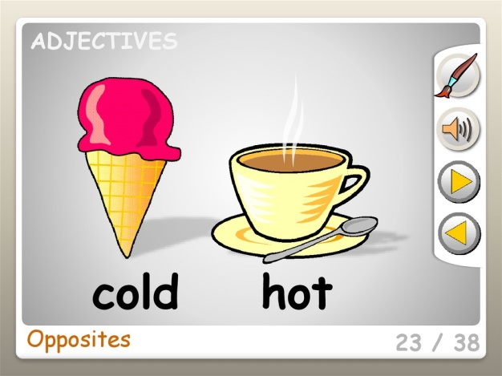

[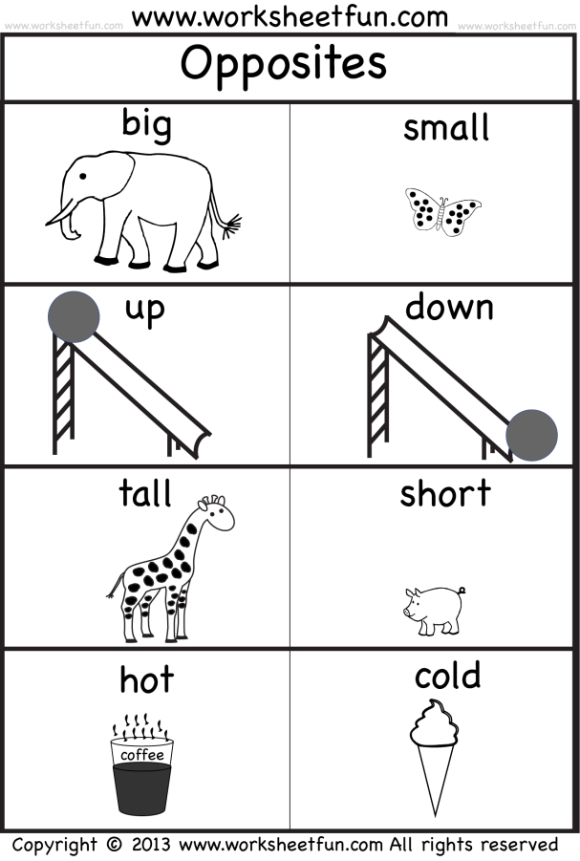](http://www.google.com.eg/url?sa=i&rct=j&q=&esrc=s&source=images&cd=&cad=rja&uact=8&ved=0ahUKEwiLoqn3jtjTAhVL2BoKHfk7BREQjRwIBw&url=http://atkinson-flowers.com/animal-opposites-coloring-pages/&psig=AFQjCNEwFh_3yMtEVWIEh8UTnIWFP-yhNQ&ust=1494051746230967) Q1. Match the pictures with their opposite words.

1. happy down

[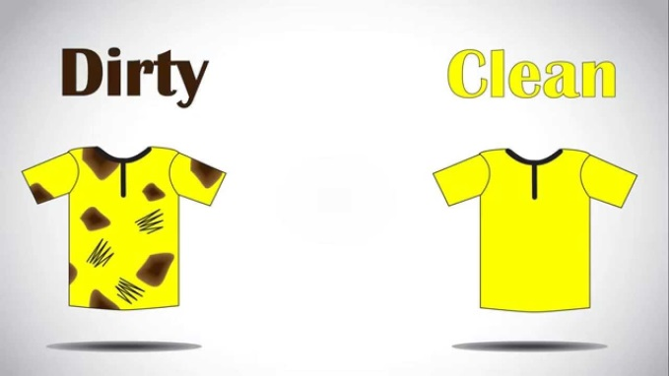](https://www.google.com.eg/url?sa=i&rct=j&q=&esrc=s&source=images&cd=&cad=rja&uact=8&ved=0ahUKEwisju6djdjTAhWBMBoKHTbKAQ8QjRwIBw&url=https://www.youtube.com/watch?v%3DNAqBPjEX5yM&psig=AFQjCNFm2SDhPOQaoT0PobunMtSd-vZ86A&ust=1494051372509231)

2. clean sad

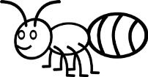[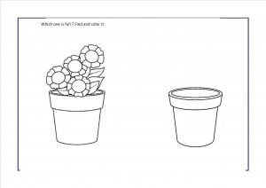](http://www.google.com.eg/url?sa=i&rct=j&q=&esrc=s&source=images&cd=&cad=rja&uact=8&ved=0ahUKEwjNlfLEjNjTAhWDQBoKHYbdCNwQjRwIBw&url=http://www.preschoolactivities.us/full-or-empty-worksheets-for-preschool/&psig=AFQjCNF-AuKMJ_Dr25OJFGoClD_thxCoSQ&ust=1494051139212415)

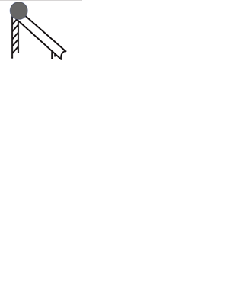 3. small empty

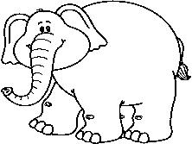

[](http://www.google.com.eg/url?sa=i&rct=j&q=&esrc=s&source=images&cd=&cad=rja&uact=8&ved=0ahUKEwjNlfLEjNjTAhWDQBoKHYbdCNwQjRwIBw&url=http://www.preschoolactivities.us/full-or-empty-worksheets-for-preschool/&psig=AFQjCNF-AuKMJ_Dr25OJFGoClD_thxCoSQ&ust=1494051139212415)[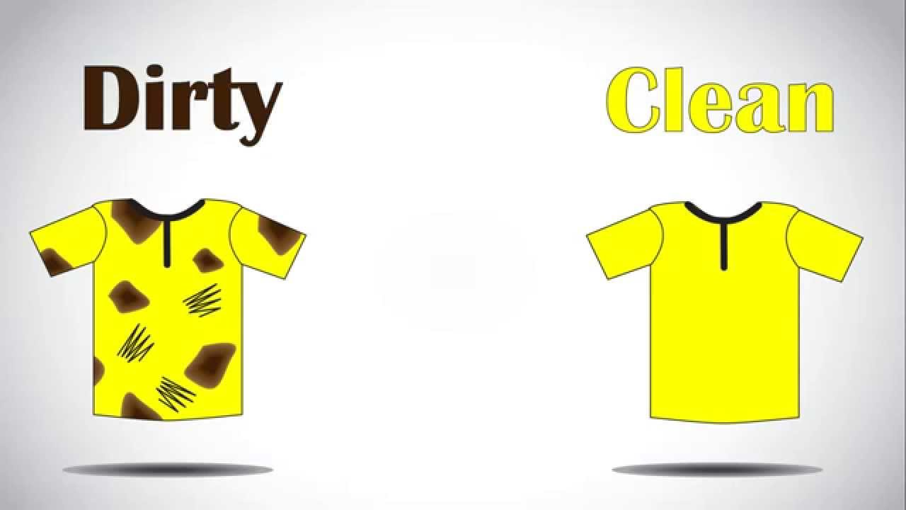](https://www.google.com.eg/url?sa=i&rct=j&q=&esrc=s&source=images&cd=&cad=rja&uact=8&ved=0ahUKEwisju6djdjTAhWBMBoKHTbKAQ8QjRwIBw&url=https://www.youtube.com/watch?v%3DNAqBPjEX5yM&psig=AFQjCNFm2SDhPOQaoT0PobunMtSd-vZ86A&ust=1494051372509231) 4. up big

[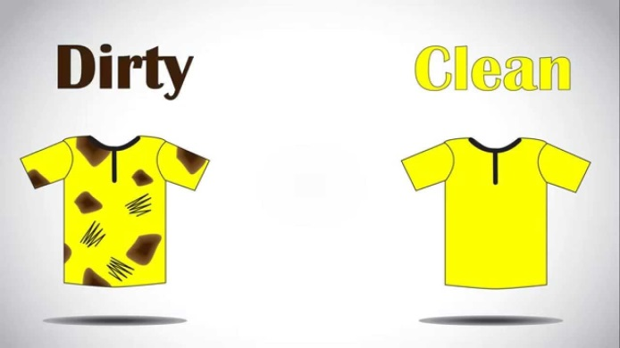](https://www.google.com.eg/url?sa=i&rct=j&q=&esrc=s&source=images&cd=&cad=rja&uact=8&ved=0ahUKEwisju6djdjTAhWBMBoKHTbKAQ8QjRwIBw&url=https://www.youtube.com/watch?v%3DNAqBPjEX5yM&psig=AFQjCNFm2SDhPOQaoT0PobunMtSd-vZ86A&ust=1494051372509231)

5. full dirty

Q2. Write the opposites of the following.

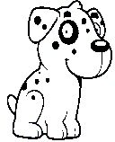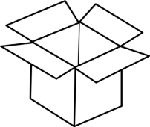

1. in X _____________

[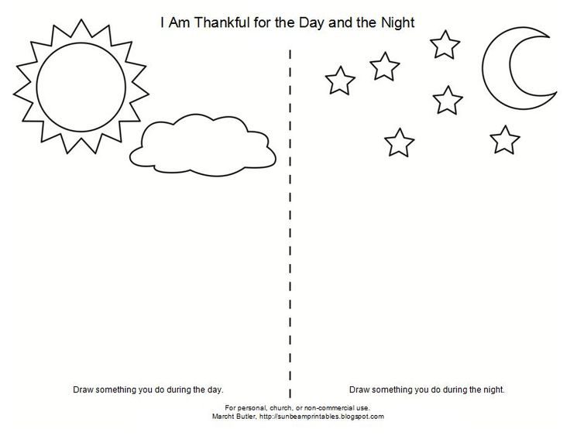](https://www.google.com.eg/url?sa=i&rct=j&q=&esrc=s&source=images&cd=&cad=rja&uact=8&ved=0ahUKEwjRgsP1kNjTAhXEXRoKHUBVAwsQjRwIBw&url=https://www.pinterest.com/karyana74/spacetime-and-night/&psig=AFQjCNEq4DkCUTOD-Tx9rLcWqYKy441H8Q&ust=1494052360918262)

[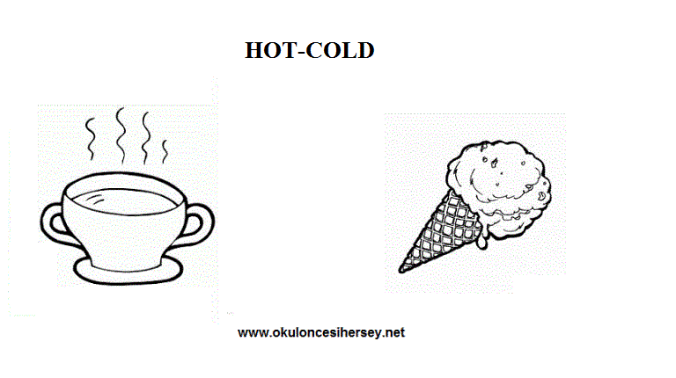](http://www.google.com.eg/url?sa=i&rct=j&q=&esrc=s&source=images&cd=&cad=rja&uact=8&ved=0ahUKEwjC1PPdk9jTAhWGSxoKHaL_DwoQjRwIBw&url=http://www.okuloncesihersey.net/english-worksheets-for-pre-school-opposite-wolrd-1.html&psig=AFQjCNFolfvEFqS9xxs7nDKIxZ_1iQqA0A&ust=1494053112112355)2. day X ___________

[](http://www.google.com.eg/url?sa=i&rct=j&q=&esrc=s&source=images&cd=&cad=rja&uact=8&ved=0ahUKEwjC1PPdk9jTAhWGSxoKHaL_DwoQjRwIBw&url=http://www.okuloncesihersey.net/english-worksheets-for-pre-school-opposite-wolrd-1.html&psig=AFQjCNFolfvEFqS9xxs7nDKIxZ_1iQqA0A&ust=1494053112112355)

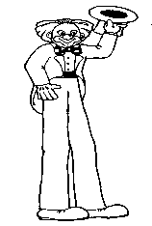3. cold X _____________

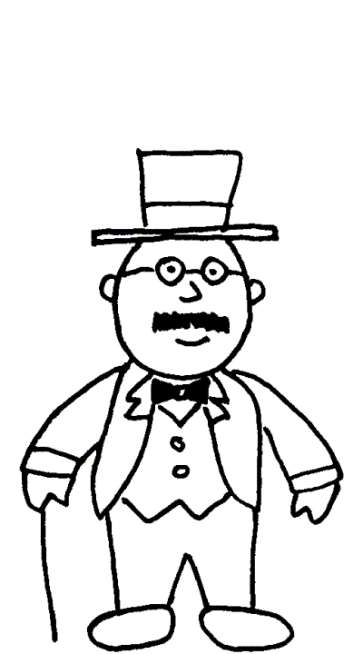

[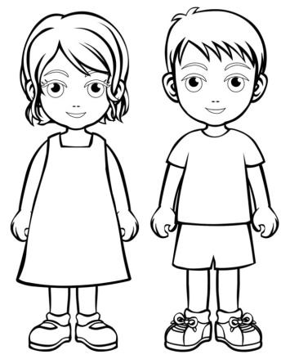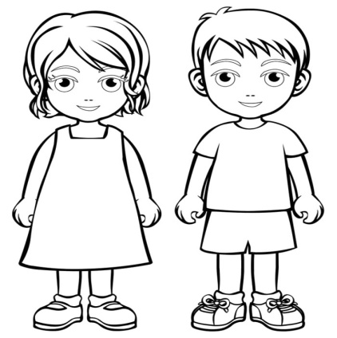](http://www.google.com.eg/url?sa=i&rct=j&q=&esrc=s&source=images&cd=&cad=rja&uact=8&ved=0ahUKEwinyf-Fk9jTAhVCtBoKHdvpDZ0QjRwIBw&url=http://www.soundfieldusa.com/6251/boy-and-girl-coloring-pages-26-01-2017/lovely-boy-and-girl-coloring-pages-17-with-additional-free-colouring-pages-with-boy-and-girl-coloring-pages/&psig=AFQjCNEDVZCLHC_7RINpoxmwIQOuqmDahw&ust=1494052894308912)4. tall X _____________

5. boy X ____________

|  |  |  |  |  |
| --- | --- | --- | --- | --- |
| **Rubric:** | **Ex.** | **Go.** | **Sat.** | **NI** |
| **Content Accuracy** | **1** | **2** | **3** | **4** |
| **Creativity** | **1** | **2** | **3** | **4** |
| **Completeness** | **1** | **2** | **3** | **4** |
| **Neatness** | **1** | **2** | **3** | **4** |
| **1-Excellent 2- Good 3- Satisfactory**  **4- Needs improvement** | | | | |