**PAKISTAN SCHOOL , KINGDOM OF BAHRAIN.**

**E-Support and Learning Material/Session 2020-2021**

**Subject: English Grade: 2**

** Unit : 2 Tigers Text Book page (8)**

**Vocabulary words:**

h-e-r-d

herd

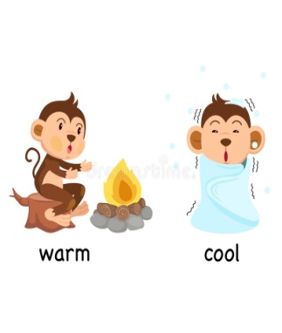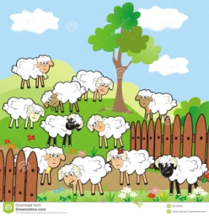

e-n-v-i-r-o-n-m-e-n-t w-a-r-m

 environment warm



b-o-a-r

boar

h-u-n-t

hunt

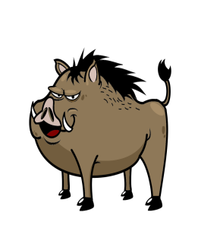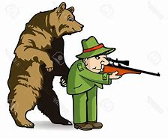

h-i-d-e

hide



p-r-e-y

prey

p-o-u-n-c-e

pounce

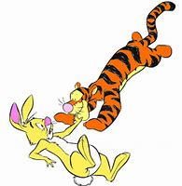 c-a-t-c-h

catch

**Q: Write the meanings of given words.**

|  |  |  |
| --- | --- | --- |
| **S.N** | **Words** | **Meanings** |
| 1. | herd | large group of animal |
| 2. | creep | to move slowly |
| 3. | prey | something that is hunted |
| 4. | pounce | to jump |
| 5. | boar | a wild pig |

**COMPREHENSION SKILLS : TEXT BOOK PAGE (9)**

**Q: Read Text Book page 8 and 9 and write whether the statements are True or False.**

1: A female tiger is bigger than a male tiger. **False**

2: Tigers live and hunt alone. **True**

3: Tigers belong to the cat family. **True**

4: Most tigers have orange fur and black stripes. **True**

5: Tigers hunt at night. **True**

6: Tigers will eat only deer and boar. **False**

7: Tigers only live in hot environment. **False**

**Q: Make meaningful sentences using these words.**

|  |  |  |
| --- | --- | --- |
| **S.N** | **Words** | **Sentences** |
| 1. | belong | I belong to a rich family. |
| 2. | long | She has long hair. |
| 3 | jungle | Lions live in jungle. |
| 4. | hunt | Tigers hunt at night. |
| 5 | deer | I like to see deer. |

**COMPREHENSION SKILLS .**

**Q: Read Text Book page (8,9) and answer the following questions.**

Q:1 To which family tigers belong?

Ans: Tigers belong to the cat family.

Q:2 Where can we find most tigers?

Ans: We can find them in cold and hot environment of Siberia and India.

Q:3 When do tigers hunt?

Ans: Tigers hunt at night.

* **LANGUAGE SKILLS : TEXT BOOK PAGE (10)**
* Look at these animals and underline that belong to the cat family.

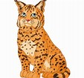

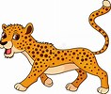 **lion**  elephant **lynx**  **jaguar**

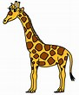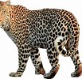

**leopard** giraffe monkey **cheetah**

**PAKISTAN SCHOOL , KINGDOM OF BAHRAIN**

**E-Support and Learning Material/Session 2020-2021**

**Subject: English Grade: 2**

**UNIT : 2 Tigers ACTIVITY : 1**

**Q: Read Text book page (8) and choose the correct answer.**

1: Tigers belong to the __________ family . **( dog , cat )**

2: They also live in warm places such as jungles in _________ **. ( India , Japan )**

3: They do not live in __________ or packs. **( alone , herd )**

4: A male tiger is ___________ than a female tiger . **( bigger , smaller )**

**Q: Read Text Book page (8) and complete the missing words.**

**f ___ m ___ l y**

**h ___ n ___**



**w ____ r ____**

**j ___ n g ___ e**

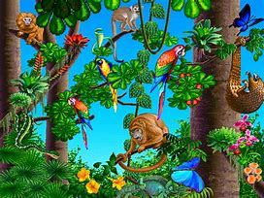

**s ____ o ____ y**

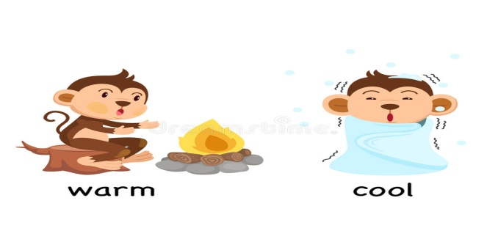

|  |  |  |  |  |
| --- | --- | --- | --- | --- |
| **Rubric:** | **Ex.** | **Go.** | **Sat.** | **NI** |
| **Content Accuracy** | **1** | **2** | **3** | **4** |
| **Creativity** | **1** | **2** | **3** | **4** |
| **Completeness** | **1** | **2** | **3** | **4** |
| **Neatness** | **1** | **2** | **3** | **4** |
| **1-Excellent 2- Good 3- Satisfactory**  **4- Needs improvement** | | | | |

**PAKISTAN SCHOOL , KINGDOM OF BAHRAIN**

**E-Support and Learning Material/Session 2020-2021**

**Subject: English Grade: 2**

**UNIT : 2 Tigers ACTIVITY : 2**

**Q: Match the words with their meanings.**

 **Words Meanings Answers**

1. prey a wild pig



1. boar to jump



3. creep something that is hunted



1. pounce large group of animal



5. herd to move slowly

**Q: Fill in the blanks with the help of given words.**

|  |  |  |  |  |
| --- | --- | --- | --- | --- |
| **night** | **hunt** | **fast** | **black** | **deer** |

|  |  |  |  |  |
| --- | --- | --- | --- | --- |
| **Rubric:** | **Ex.** | **Go.** | **Sat.** | **NI** |
| **Content Accuracy** | **1** | **2** | **3** | **4** |
| **Creativity** | **1** | **2** | **3** | **4** |
| **Completeness** | **1** | **2** | **3** | **4** |
| **Neatness** | **1** | **2** | **3** | **4** |
| **1-Excellent 2- Good 3- Satisfactory**  **4- Needs improvement** | | | | |

1: Tigers will only eat ___________ and boar.

2: Tigers are not really _________ runners .

3: Tigers live and _________ alone.

4: Tigers hunt at __________ .

5: Most tigers have oranges fur and _________ stripes.

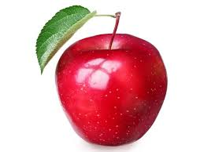**Topic: Composition**

**( My Favourite Fruit)**

1: My favourite fruit is an apple. 2: It is red in colour.

3: It is very juicy. 4: It is very sweet .

5: It is very good for our health. 6: I like to eat an apple every morning.

7: I love apples very much.

**Now you write five sentences about your favourite fruit.**

**1._______________________________________________________________**

**2. ________________________________________________________________**

**3. _________________________________________________________________**

**4. _________________________________________________________________**

**5. __________________________________________________________________**

|  |  |  |  |  |
| --- | --- | --- | --- | --- |
| **Rubric:** | **Ex.** | **Go.** | **Sat.** | **NI** |
| **Content Accuracy** | **1** | **2** | **3** | **4** |
| **Creativity** | **1** | **2** | **3** | **4** |
| **Completeness** | **1** | **2** | **3** | **4** |
| **Neatness** | **1** | **2** | **3** | **4** |
| **1-Excellent 2- Good 3- Satisfactory**  **4- Needs improvement** | | | | |

|  |
| --- |
| **Draw and colour here:** |
|  |
| **Name of Fruit: __________________** |