**SPAKISTAN SCHOOL , KINGDOM OF BAHRAIN.**

**E-Support and Learning Material/Session 2020-2021**

**Subject: English Grade: 3**

**Lesson 2: The Glory Of Athens Pg 8-9**

**Vocabulary Words**

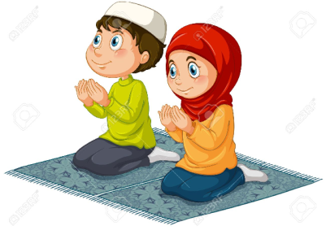 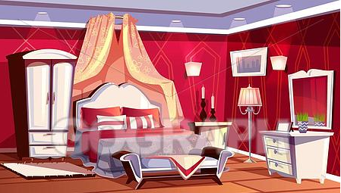

**W – o – r – s – h – I - p l – u – x – u – r - y**

**Worship luxury**

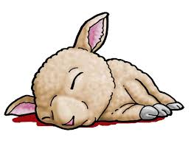 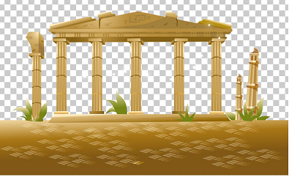

**s – a – c – r – i – f – i – c - e t – e – m – p – l - e**

**sacrifice temple**

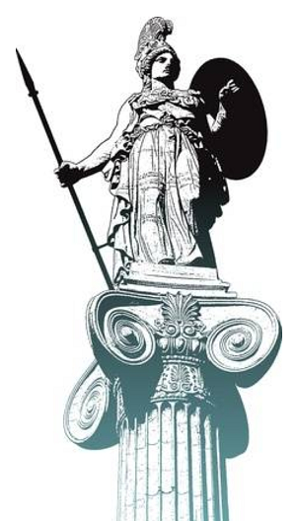 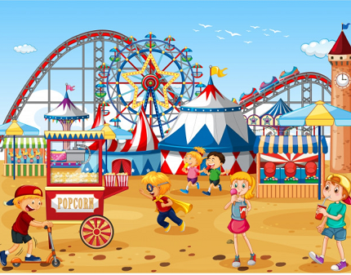

**s – t –a – t – u - e f – e – s – t – I – v – a - l**

**statue festival**

**Practice Dictation Sentences:**

1. The people of Athens worshipped Goddess Athena.
2. The statue of Athena was made of gold and ivory.
3. Eating meat was a luxury in Athens.

**Words- Meanings**

|  |  |  |
| --- | --- | --- |
| 1 | wisdom | the quality of having good knowledge |
| 2 | worship | show love by praying |
| 3 | festival | a time of celebration |
| 4 | sacrifice | killing an animal for the sake of a god |
| 5 | luxury | great comfort |

**Words- Sentences**

|  |  |  |
| --- | --- | --- |
| 1 | wisdom | Athena was known for her wisdom. |
| 2 | worship | Muslims worship Allah. |
| 3 | festival | Eid is my favorite festival. |
| 4 | sacrifice | Muslims sacrifice goats and sheep on Eid al Adha. |
| 5 | luxury | The royal family lives a life of luxury. |

**Comprehension Skills: Ex A - Fill in the blanks**

1. The hill in the center of the city was called the **Acropolis**.
2. The people built **temples** for the goddess Athena.
3. The grandest temple was the **Parthenon**.

**Ex B - Questions and Answers**

Q1: What was inside the Parthenon?

Ans: Inside was simply a huge statue of Athena made of gold and ivory.

Q2: What was the Parthenon built for?

Ans: It was built to please Athena.

Q3: Why was it unusual for the people to eat meat in Athens?

Ans: It was unusual for the people to eat meat in Athens because there was no place to keep farm animals.

**Language Skills: there and their(Pg 9)**

1. **There** were many beautiful temples in Athens.
2. The people built temples to please **their** goddess Athena.
3. **There** were many festivals.
4. "We like to go **there** with our parents," said the children.
5. One of **their** friends competed in the Olympic Games.
6. You can still see some remains of the Parthenon **there**.

**Dictionary Work (Pg 10)**

ExA: Sort these words into alphabetical order

1. Greece, Acropolis, Parthenon.

Acropolis, Greece, Parthenon

1. Sacrifice, animals, temple.

Animals, sacrifice, temple

1. Festival, ivory, gold, statue, columns

Columns, festival, gold, ivory, statue

**Ex B: Look at the second alphabet in each word and arrange the words in alphabetical order**.

1. Actor, able, aeroplane, adder, afraid

Able, actor, adder, aeroplane, afraid

1. Athens, Acropolis, Alos, Andros

Acropolis, Alos, Andros, Athens.

1. Drama, dancers, discus, Delphi

Dancers, Delphi, discus, drama

1. Myth, metal, marble, mosaic

Marble, metal, mosaic, myth

**Capital letters, full stops, question marks, commas ( Pg 11)**

Write these sentences correctly

1. the games were held in honor of Zeus

The games were held in honor of Zeus.

1. the first games were for men only

The first games were for men only.

1. wrestling jumping archery and javelin were the main events

Wrestling, jumping, archery and javelin were the main events.

1. an olive branch was given to each of the winners

An olive branch was given to each of the winners.

1. today men and women can take part

Today men and women can take part.

1. would you like to go to the Olympic Games

Would you like to go to the Olympic Games?

**Subject: English WORKSHEET Grade: 3**

**Lsn 2: The Glory of Athens (Pg 8)/ Activity**

I am the statue of Athena. Can you give me beautiful colors and fill my fact file?

**Fact File**

I am Goddess of : __________________

People built this to please me : _________________

I am made of : __________________

I am inside the : __________________

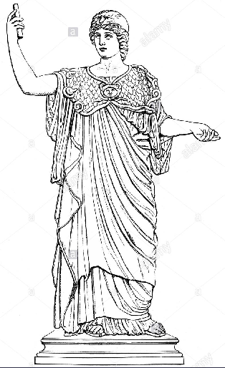

Q1: Fill in the blanks

1. Athens is a city in ______________ .
2. Acropolis means _______________ .
3. Inside the Parthenon was a statue of _____________.

Q2: Give one Word answer:

1. Name of the goddess the people of Athens worshipped. ___________________
2. What was eating meat like for the people of Athens? ___________________
3. Name of grandest temple. ___________________
4. Did the people pray inside the temple? ___________________
5. Where did the people meet and enjoy themselves? ___________________
6. Did the people carry out sacrifices sometimes or often? ___________________

**Practice comprehension Passage**

Summer is always what I look forward to. It’s my favorite time of the year. We get a two month long off from school which means lots of fun and entertainment. We always look forward to go to the beach and swim and play to our heart’s content. Another exciting thing about summers is mangoes and watermelons. These are the sweetest and juiciest during the summers. I just cannot have enough of them. It’s also a time when we catch up on our friends and go out and enjoy ourselves. But my mother also tells me to pay attention to my school work so I don’t fall back when school starts again. I think she is right. But let’s not think about that right now !

**Read the above passage carefully and answer the following questions in a proper sentence.**

Q1: What do I always look forward to?

______________________________________________________________________________

Q2: What fruits do I like to eat during the summers?

______________________________________________________________________________

Q3: What does my mother tell me to do?

______________________________________________________________________________

Q4: Do I like to go to the beach?

______________________________________________________________________________

**State whether the statements are True or False:**

1. Spring is my favorite time of the year. ____________
2. We get a three month long vacation._____________
3. I love to play on the beach. ____________
4. My favorites are mangoes and watermelons. _______________
5. I don’t like going out with my friends. _____________

|  |  |  |  |  |
| --- | --- | --- | --- | --- |
| **Rubric:** | **Ex.** | **Go.** | **Sat.** | **NI** |
| **Content Accuracy** | **1** | **2** | **3** | **4** |
| **Creativity** | **1** | **2** | **3** | **4** |
| **Completeness** | **1** | **2** | **3** | **4** |
| **Neatness** | **1** | **2** | **3** | **4** |
| **1-Excellent 2- Good 3- Satisfactory**  **4- Needs improvement** | | | | |