

**Pakistan School, Kingdom of Bahrain**

**E- Support and Learning Material / Session 2020-2021**

**Subject: English Grammar (worksheet) Grade: 4th**

**Topic: Simple Present Tense FIRST TERM**

The simple present can describe actions that happen regularly. This means things we do again and again, things we do every day, every week, every month. This can be routines and habits, and also [things that are currently, always, or generally true](https://learnenglish.britishcouncil.org/en/english-grammar/verbs/present-tense/present-simple).

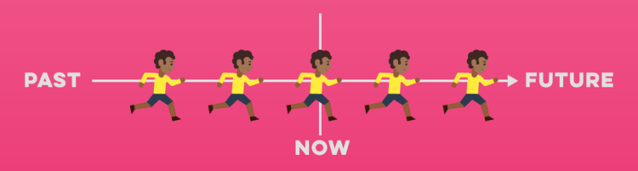

**Q1. Write the affirmative setences. Use the verbs in the brackets.**

1. **Mary and I _______________ (go) to the cinema every Friday.**
2. **Ahmed and his friends ____________(gather) once a month.**
3. **My brother Muhammad __________ (do) karate three days a week.**
4. **Mr. Dean _________ (go) to the bakery every week.**
5. **Mr. and Mrs. Rehan ___________ (come) from Canada.**

**Q1. Write the affirmative setences. Use the verbs in the brackets.**

**Q2. Write the negative setences. Use the verbs in the brackets.**

1. **My brother______________(not like) to dance but he loves having a good talk.**
2. **Sara___________ ( not live) in Manama. She lives in Hidd.**
3. **Ali __________ (not like) apple, he loves mango.**
4. **My school workers _________ (not do) the homework on time.**
5. **Marium ___________ (not cook) well. She loves eating.**

**Q3. Write interrogative setences. Use Do or Does and the verbs in the brackets**

1. **__________ you like to _______( go) to the movies?**
2. **__________ your mother__________(read) the newspaper everyday?**
3. **_______________your cousins__________ (come) to vsit you every weekend?**
4. **What _________ you ___________( like) for dinner?**
5. **___________ you like to _________( go) to school?**

|  |  |  |  |  |
| --- | --- | --- | --- | --- |
| **Rubric:** | **Ex.** | **Go.** | **Sat.** | **NI** |
| **Content Accuracy** | **1** | **2** | **3** | **4** |
| **Creativity** | **1** | **2** | **3** | **4** |
| **Completeness** | **1** | **2** | **3** | **4** |
| **Neatness** | **1** | **2** | **3** | **4** |
| **1-Excellent 2- Good 3- Satisfactory**  **4- Needs improvement** | | | | |

**Subject: English (Grammar Club)**

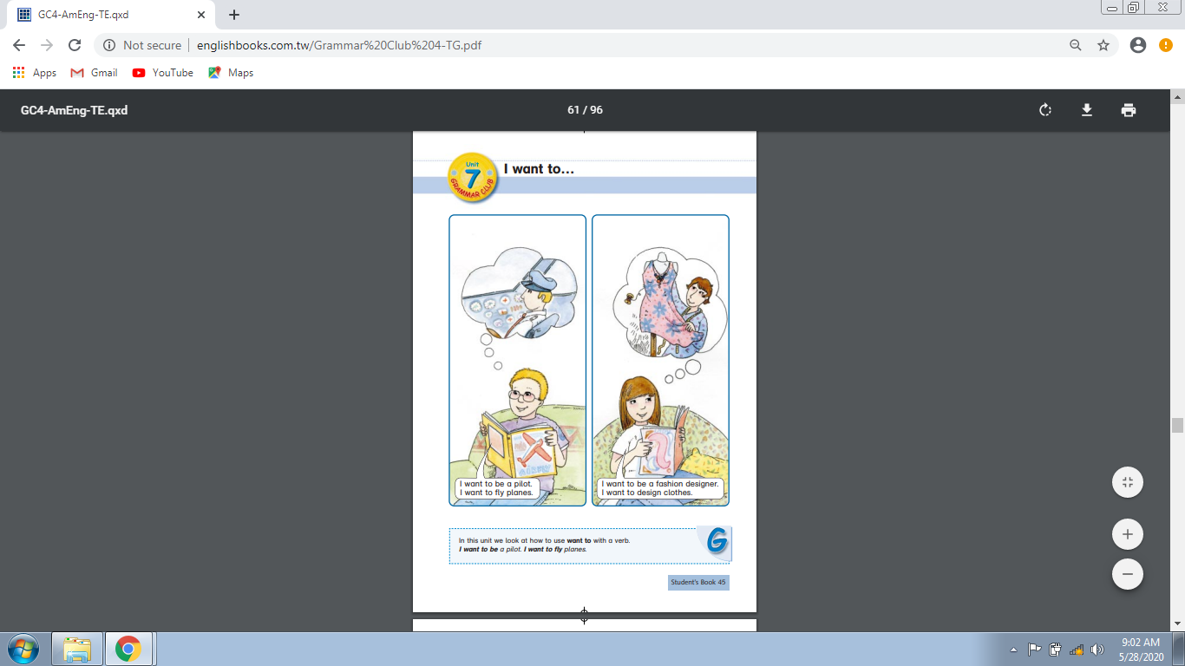**Topic: Unit7: I want to**

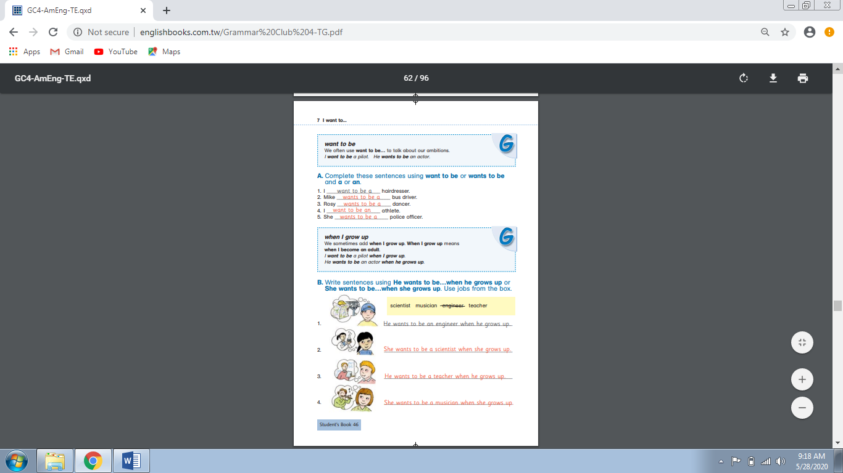

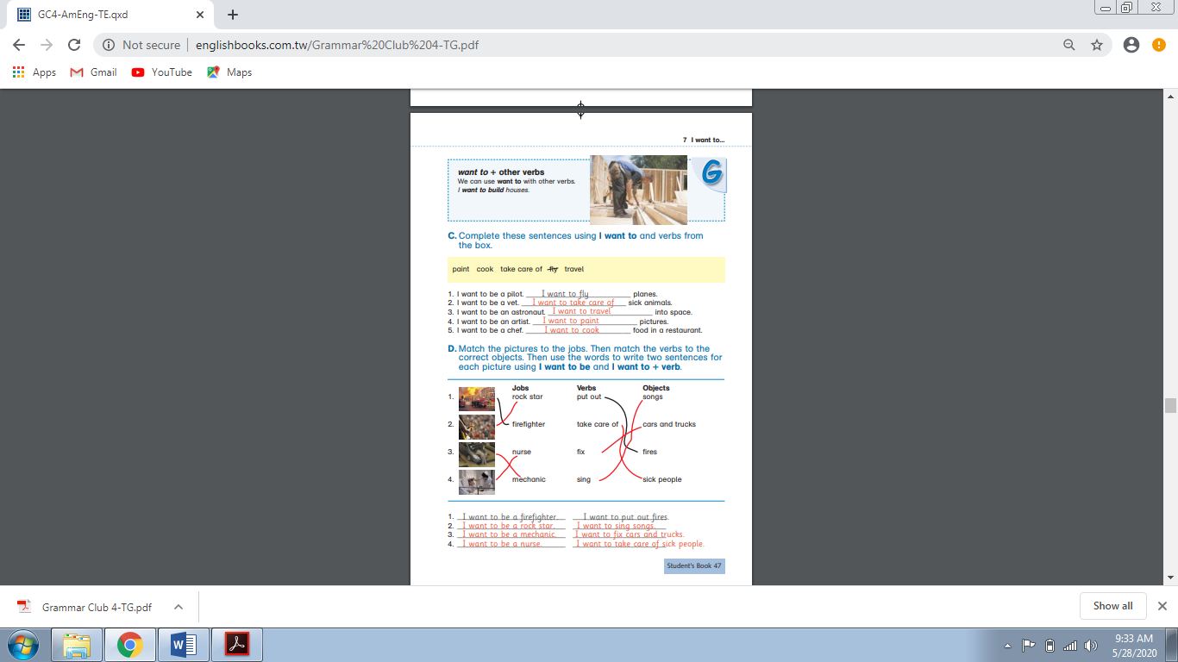

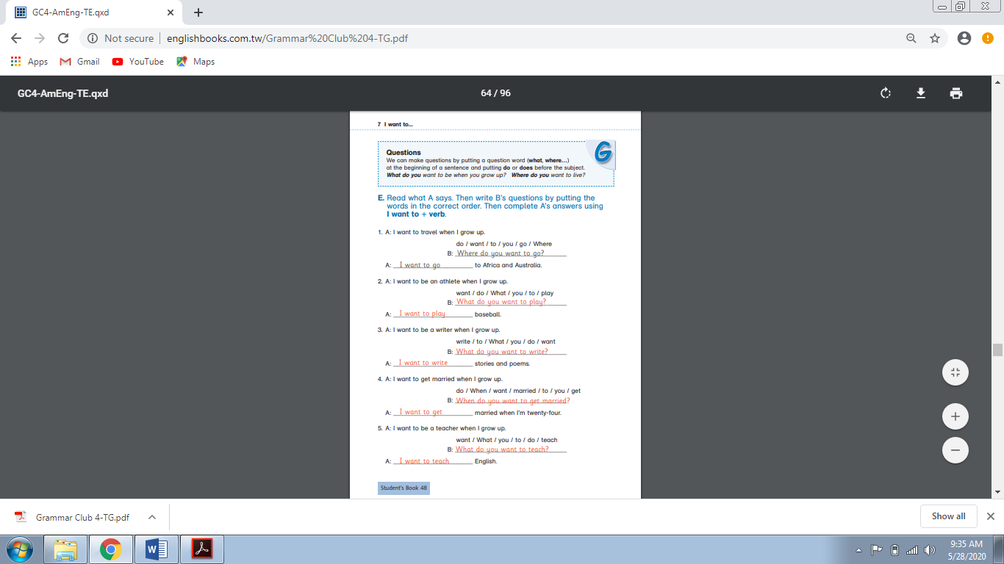

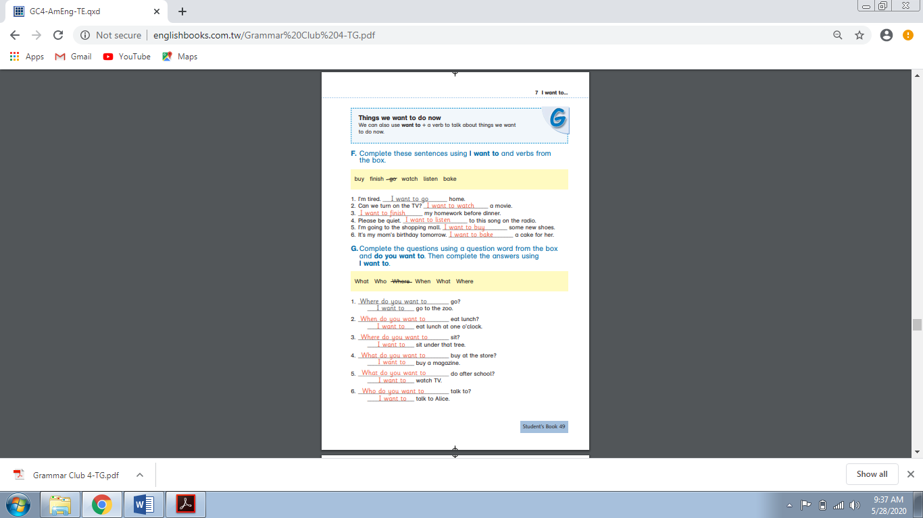

**Practice: Comprehension Passage**

|  |  |  |  |  |
| --- | --- | --- | --- | --- |
| **Rubric:** | **Ex.** | **Go.** | **Sat.** | **NI** |
| **Content Accuracy** | **1** | **2** | **3** | **4** |
| **Creativity** | **1** | **2** | **3** | **4** |
| **Completeness** | **1** | **2** | **3** | **4** |
| **Neatness** | **1** | **2** | **3** | **4** |
| **1-Excellent 2- Good 3- Satisfactory**  **4- Needs improvement** | | | | |

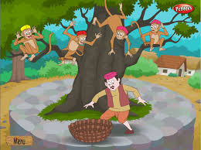

**The Capseller and the Monkeys**

**Read the story below**.

**It was a hot day. A cap seller was going to a fair to sell his caps. His way lay through a thick forest and he was so tired, so he decided to take some rest under a big shady tree. Soon he was fast asleep. There lived many monkeys on the tree. They saw him wearing a cap on his head. They came down, opened his bundle and took the caps and wore them on their heads. Then they climbed up on the high branches of the tree. After some time, the cap seller woke up. He found his caps not there. The caps were missing. He felt very gloomy and looked around for them. All of a sudden, he looked up and saw the monkeys wearing the caps. An idea struck his mind. He at once took off his own cap and threw it on the ground. He knew that monkeys are good imitators. The monkeys also threw their caps down. He collected all his caps and went his way to the fair.**

**Answer each question.**

**1. Why was the cap seller going to the fair?**

**ANS: _____________________________________________________________________________________**

**2. What did the cap seller decide to do?**

**ANS: _____________________________________________________________________________________**

**3. There lived many monkeys on the tree.**

**a. True b. False**

**4. What did the monkeys do?**

**ANS: _____________________________________________________________________________________**

**5. What was the cap seller’s idea?**

**ANS: _____________________________________________________________________________________**