**Pakistan School , Kingdom of Bahrain**

**E- Support and Learning Material / Session 2020-2021**

**Subject: English Grade : 6th**

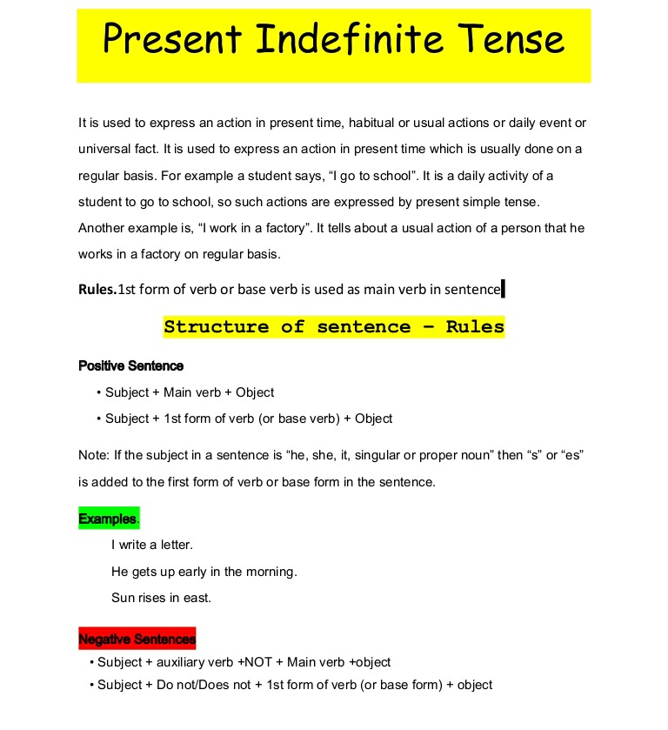**Book: Grammar FIRST TERM**

Present Simple 3rd person, positive, negative and questions

1. **Write the 3rd person singular of the verbs:**

1. I join - he joins 2. I like - he ______ 3. I run ______

4. I fly - he ______ 5. I watch - he ______ 6. I enjoy - he ______

7. I talk - he ______ 8. I go - he ______ 9. I teach - he ______

10. I buy - she ______ 11. I finish - she ______ 12. I cry - she ______

1. **Use the verbs in brackets to complete the sentences, as in the example:**

1. I live (live) in Edinburgh.

 2. He ______ (do) his homework every evening.

3. She’s a teacher. She______ (work) at primary school.

4. “Are you a singer?” “No, I’m a pilot. ______ (fly) aeroplanes.

5. Joan ______ (wash) her hair every day.

6. The museum ______ (close) at seven in the evening.

7. Daniel______ (brush) his teeth every morning.

8. She ______ (study) Science at university.

. Every Saturday, Paul ______ (give) his dog a bath.

10. In the mornings, Betty ______ (take) her sister to school.

11. We ______ (go) to the swimming pool at the weekend.

12. John and Mary ______ (have) a cup of tea in the afternoon

1. **Use the prompts to write sentences, as in the example:**
2. 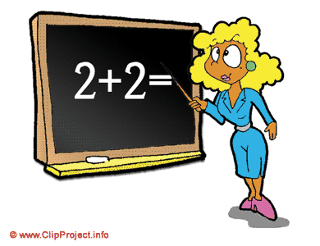he / every day / work / on the computer →

He works on the computer every day.

1. Susana / at the weekend / do her laundry → _________________________________
2. My friends and I / at the weekend / go fishing → _________________________________
3. he / every morning / read the newspaper → _________________________________
4. Sharon / exercise / in the morning → _________________________________
5. dinner / they / at 7:30 / eat → _________________________________
6. **Write questions and negations as in the example.**
   1. Tom lives in England. → Does Tom live in England? Tom doesn’t live in England.
   2. Mr Simpson teaches Chemistry. →_________________________________
   3. You like playing computer games. → _________________________________
   4. John and Sue work in a café. → _________________________________.
   5. We do the shopping on Saturdays. → _________________________________
   6. The baby cries all the time. → _________________________________

**V. Fill in do / don’t, does / doesn’t.**

1. Sam speaks French, but he ______ Speak Russian.

2. Ann ______ like jazz music but she likes pop music.

3. “______ she play the saxophone?” “No, she ______”.

4. Where ______ you work?

5. He ______ go to school on Sunday.

6. What______ you have for dinner?

**VI. Match the questions to the answers.**

1. What time does she get up? A. She goes to bed at 10:00.

2. How does she go to school? B. She walks to school.

3. Does she have breakfast every day? C. She gets up at 7:00.

4. What does she do in the afternoon? D. No, she doesn’t.

5. When does she go to bed? E. She does her homework.

**☺ Good luck ☺**

|  |  |  |  |  |
| --- | --- | --- | --- | --- |
| **Rubric:** | **Ex.** | **Go.** | **Sat.** | **NI** |
| **Content Accuracy** | **1** | **2** | **3** | **4** |
| **Creativity** | **1** | **2** | **3** | **4** |
| **Completeness** | **1** | **2** | **3** | **4** |
| **Neatness** | **1** | **2** | **3** | **4** |
| **1-Excellent 2- Good 3- Satisfactory**  **4- Needs improvement** | | | | |

**Subject: English Grade : 6th**

**Book: Grammar Club 6 FIRST TERM**

**Unit 3 :All of, none of, some of and most of Pg. No: 15-18**

