**Pakistan School , Kingdom of Bahrain**

**E- Support and Learning Material / Session 2020-2021**

**Subject: English Grade : 7**

**Book: Student Book 2 FIRST TERM**

**Unit 2 Pg. No: 22to 24.**

**SIM DALT HAS TWO LONG, LOOSE ARMS.** 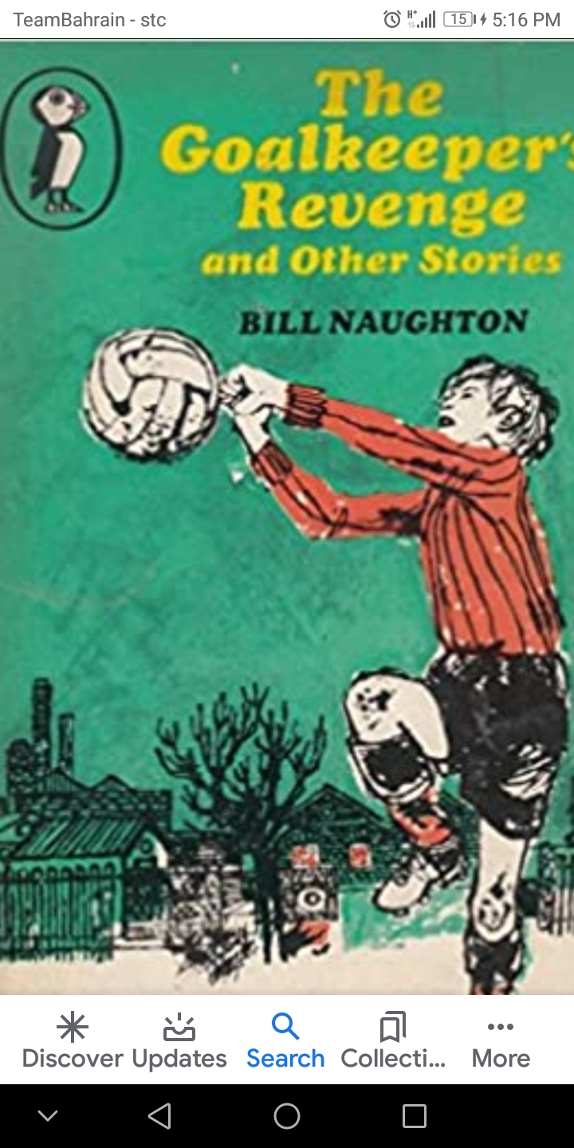

**Q.1 Vocabulary Words.**

|  |  |  |
| --- | --- | --- |
| Spindly | Elementary | Enter |
| Ferocious | Cajole | Bloodless |
| Thorough | Interposed |  |

**Q.2 Words Meanings.**

|  |  |  |
| --- | --- | --- |
| **No.** | **Words** | **Meanings** |
| **1** | Spindly | Thin and weak |
| **2** | Elementary | pertaining to an elementary school |
| **3** | Ferocious | extreme or intense |
| **4** | Cajole | to persuade by flattery or promises |
| **5** | Thorough | executed without negligence |

**Q.3. Words sentences. Page 18**

|  |  |  |
| --- | --- | --- |
| **No.** | **Words** | **Sentences** |
| 1 | Spindly | This boy had spindly legs. |
| 2 | Elementary | Sim was in elementary school. |
| 3 | Ferocious | Sam always had ferocious wish to hang around. |
| 4 | Cajole | Sim would cajole with new friends. |
| 5 | Thorough | He also gained a **thorough** acquaintance with the French language. |

**Q.4 Comprehension.**

**Choose the best answer for each question.**

**1. Sim main interest was being a goalkeeper.**

**2. Sim wanted to play football even in the summer.**

**3.He used heaps of jackets for the goalposts.**

**4.He was twelve when he was picked for the school team.**

**5.If he played until the end of the season, he would get a medal.**

**Q. 5 Answer the questions.**

**Q1.List the adjectives used in the first paragraph to describe Sim?**

**A.** Sim Dalt had

1.long, loose arms,

2. spindly legs,

3. gleaming brown eyes.

**Q2.How do you know he was good at goalkeeping from an early age?**

**A** He was good at goalkeeping from his early age because he used to play with his mother as a goalkeeper by defending a rubber ball and that practice had helped him to be a good goalkeeper.

**Q3. Explain in your own words :**

**1.touched in the head.**

A. little bit crazy

**2.in the nursery days.**

A. childhood days

**3.scholastic ability.**

A. concerning schools and education.

**Q4.How did the inspector decision affected to goalkeeper?**

A. Inspector’s decision gave a new turn to goalkeeper’s life.

**Q5. Explain in your own words Bob’s attitude to goalkeepers .**

A. Bob Thropper was a jealous man and he had great hatred for goalkeepers.

Since his career as a goalkeeper was a great failure , that hatred

eventually turned into a revenge.

**SPELLING:**

**A prefix is a group of letters put at the beginning of a word to change its meaning *.***

**E.g.: re + arrange=rearrange *=* to arrange again.**

**Dis + continue=discont*inue =not to continue.***

**Choose the prefix “dis,Un, re” to solve the clues.**

|  |  |  |
| --- | --- | --- |
| **Root Words** | **Prefix** | **Meaning** |
| Interested | Disinterested | having no interest |
| Satisfied | Unsatisfied | not being satisfied |
| Visit | Revisit | to visit again |
| Sure | Unsure | not sure |
| Even | Uneven | not even |
| Attended | Unattended | not attended |

**Grammar and Punctuation page 25**

**SENTENCE Types**

**A sentence is a group of words which makes sense.**

**EG: Goalkeeping was the main interest in Sim's life.**

**Not a sentence.**

**Goalkeeping was the main.**

**Statements are sentences which tell us something.**

**They end with a full stop.**

**E.g. Sim was very good at goalkeeping.**

**A. Copy and punctuate these statements**.

**1.sim attended Scuttle Street elementary school.**

A. Sim attended Scuttle Street elementary school.

**2.he would play football even in the hot summer**.

A. He would play football even in the hot summer.

**3.it was rare anyone got the ball past Sim.**

A. It was rare anyone got the ball past Sim.

**Questions are sentence which ask us something. They end with a question mark**

**E. g. But what shall we do for a goalkeeper?**

**B. Copy and punctuate these questions correctly.**

**1.what was the main interest in Sim's life.**

A. What was the main interest in Sim's life?

**2.did his mum play football with him.**

A. Did his mum play football with him?

**3.were Scuttle Street the top of the league.**

A. Were Scuttle Street the top of the league?

**SENTENCES which are exclamation shows when a character is shouting, surprised, frightened etc.**

**They end with an exclamation mark(!).**

**E.g. I 'll bust your shins in!**

**C. Copy and punctuate these exclamations correctly.**

**1.sim's school work was dreadful.**

A. Sim's school work was dreadful!

**2. goal.**

A. Goal!

**3. if i don't play, l won't get a medal.**

A. If I don't play , I won't get a medal!

**Homework :-**

**Writing Assignment :-**

**Write the first two paragraphs of a story where,**

**The first paragraph**

* **introduces a character**
* **gives the reader a description of the character**

**The second paragraph tell us**

* **what the character’s only interest in life is**
* **how he /she became so interested in it**

**It can be as unusual as you like. Does your character want to be.**

* **an astronaut?**
* **A magician?**
* **A deep sea diver?**

**You don’t have to choose one of these. You can think of your own idea.**

**Subject: English Worksheet Grade: 7**

**Unit 2 : SIM DALT HAS TWO LONG, LOOSE ARMS.**

Complete each sentence with the correct punctuation mark. Then



There are four kinds of sentences in the English language.

1

. Interrogative- asks a question (?)

2

. Exclamatory- expresses strong feeling (!)

label if it is an exclamatory or interrogative sentence.

*Where are we going for the field trip _____* *Interrogative- Where are we going for the field trip?*

1. Yay _____ I won the prize _____



1. Do you remember who won the game _____



1. What is your favorite type of food ___



1. Terrific _____ You did a wonderful job ______



1. I can’t believe we won the championship _____



1. Who is your best friend ___

______________________________________

**Directions: Read each sentence and add the correct punctuation mark. Then, label it; declarative, interrogative or exclamatory.**

***Example A: You did an excellent job***

***Answer: You did an excellent job. Declarative***

1. **How was your day in school _______ __________________________**
2. **I’m so excited I passed the test ______ ___________________________**
3. **Who is the most popular singer ______ ___________________________**
4. **You need to get with the program ______ ___________________________**
5. **He is the leader of the group _______ ___________________________**
6. **What is your favorite magazine _______ ___________________________**
7. **Congratulations on your achievement _____ ___________________________**
8. **That was a physical game ______ _________________________________**

|  |  |  |  |  |
| --- | --- | --- | --- | --- |
| **Rubric:** | **Ex.** | **Go.** | **Sat.** | **NI** |
| **Content Accuracy** | **1** | **2** | **3** | **4** |
| **Creativity** | **1** | **2** | **3** | **4** |
| **Completeness** | **1** | **2** | **3** | **4** |
| **Neatness** | **1** | **2** | **3** | **4** |
| **1-Excellent 2- Good 3- Satisfactory**  **4- Needs improvement** | | | | |

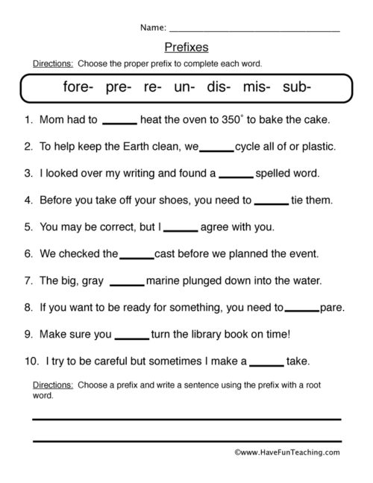

|  |  |  |  |  |
| --- | --- | --- | --- | --- |
| **Rubric:** | **Ex.** | **Go.** | **Sat.** | **NI** |
| **Content Accuracy** | **1** | **2** | **3** | **4** |
| **Creativity** | **1** | **2** | **3** | **4** |
| **Completeness** | **1** | **2** | **3** | **4** |
| **Neatness** | **1** | **2** | **3** | **4** |
| **1-Excellent 2- Good 3- Satisfactory**  **4- Needs improvement** | | | | |