**Pakistan School , Kingdom of Bahrain**

**E- Support and Learning Material / Session 2020-2021**

**Subject: English Grade : 8th** 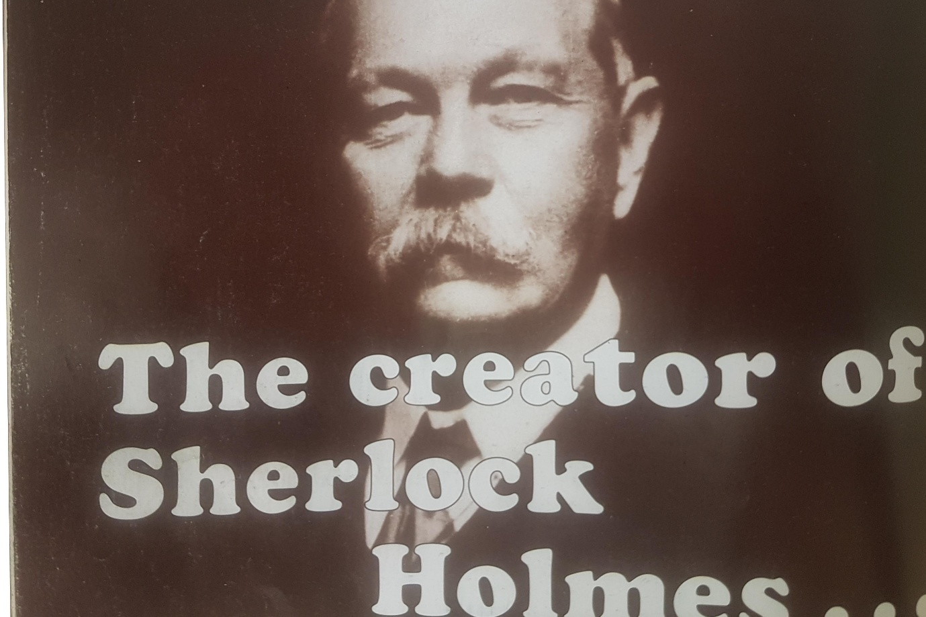

**Vocabulary Words**

|  |  |  |
| --- | --- | --- |
| Detective | Habit | Jesuit |
| Strict | Lively | Impressed |
| Famous | Bond | Household |

**Words -Meanings**

|  |  |  |
| --- | --- | --- |
| **No.** | **Words** | **Meanings** |
| **1** | **Chronic** | Going on for a long time |
| **2** | **Erratically** | Not consistent or regular |
| **3** | **Obscure** | Not well known |
| **4** | **Excessive** | Extreme |
| **5** | **Observation** | A statement about something one has noticed |
| **6** | **Deduction** | Reduction , Discount |

**Words Sentences**

|  |  |  |
| --- | --- | --- |
| **No.** | **Words** | **Sentences** |
| **1** | **Chronic** | In **chronic** cases diet, exercise and natural methods were chiefly relied upon. |
| **2** | **Erratically** | She was panting heavily and her heart beat **erratically**. |
| **3** | **Obscure** | Everything seemed dark, **obscure** and terrible. |
| **4** | **Excessive** | You should not demand such an excessive charge. |
| **5** | **Observation** | I'm making an observation about the style. |
| **6** | **Deduction** | This **deduction** is not in fact true. |

**Comprehension.**

**Fill in the missing words.**

1. Arthur's father was ***Charles*** Altamont Doyle.
2. Arthur enjoyed playing ***cricket*** at school.
3. Arthur inherited the gift of ***story telling*** from his mother.
4. Arthur studied medicine at ***Edinburgh*** University.
5. Sherlock Holmes first appeared in the story called ***A Study In Scarlet.***

**Questions Answers. Page. 118**

1. **Little spare money.** Canon Doyle was very poor in his childhood and didn't have much money to spend.
2. **Gift of storytelling.** This phrase shows the talent of storytelling. In this lesson, Arthur and his mother were very rich in this talent.
3. **A household name.**  This phrase is used for that person who is well known for some skills. In the lesson, this phrase is used for Arthur whose first story made him popular.

**Q2. What impression do you get of Arthurs’ life at school?**

**Ans.** Arthur’s life at school was very hard due to strict discipline. The moment of happiness came to him only at that time when he played cricket and wrote to his mother.

**Q3. How do you know that Arthur and his mother had close relationship?**

**Ans.** Arthur’s habit to write a letter to his mother regularly shows the close relationship of Arthur and his mother.

**Q4. Do you think Arthur was more interested in being a doctor or a writer?**

**Ans.** Arthur was much interested in being a writer rather than a doctor because when he was in the university, he made a close observation of people and was much interested in writing stories.

**Grammar and punctuation**

**Ex.A page 119.**

|  |  |  |
| --- | --- | --- |
| **Nouns** | **Collective** | **Abstract** |
| **herd** |  |  |
| **faith** |  |  |
| **peace** |  |  |
| **flock** |  |  |
| **truth** |  |  |
| **talent** |  |  |
| **friendship** |  |  |
| **tribe** |  |  |

**Ex. B Page. 119**

|  |  |
| --- | --- |
| **Adjective** | **Abstract Noun** |
| Strong | Strength |
| Thirsty | Thirst |
| Beautiful | Beauty |
| Free | Freedom |
| Anxious | Anxiety |

**Work Book page 10**

**Use the collective nouns in the box to complete each expression.**

|  |
| --- |
| **bunch flight pack batch herd school** |

1. A pack of wolves
2. A herd of buffaloes
3. A batch of loves
4. A flight of stairs
5. A bunch of flowers
6. A school of fish.

**Ex.C page 10**

**Complete these sentences. The missing word is an abstract noun based on the underlined word.**

1. The hero was given a medal for his **heroism**
2. The robbers who committed the **robbery** were caught.
3. The **wisdom** of the wise man solved the problem.
4. The coward displayed his **cowardice** and ran away.
5. A tyrant is feared for his **tyrannies.**

**Ex. D page 10**

**Use these abstract nouns in the sentences of your own.**

1. She shows her **generosity** towards the poor.
2. We were greeted with warmth and friendliness.

**Worksheet – English - Grade 8**

**The Creator of Sherlock Holmes …(Pg.116)**

**Q.1 Match the same meaning words and write your answer in Column C.**

|  |  |  |
| --- | --- | --- |
| **Column A** | **Column B** | **Column C** |
| Chronic | rich |  |
| Erratically | happened |  |
| Occurred | irregular |  |
| Wealthy | Going on for a long time |  |

**Q2. Choose the correct answer.**

1. Conan Doyle was born on __________ 22, 1859 in Edinburgh.

a) April b) May c) June

2. He spent __________ years at school in Edinburgh.

a) six b) seven c) eight

3. Discipline at the school was _______________ .

a) strict b) not strict c) normal

4. Arthur's father was ___________ Altamont Doyle.

a) Mr. b) Robert c) Charles

5. At university, he met ______________ .

a) Dr. Joseph Bell b) Dr. William c) Dr. Austin

**The Creator of Sherlock Holmes … ( Second half page 117 )**

**Q.1 Encircle T for True and F for False for statements.**

1. Conan Doyle's father married Mary Foley T F
2. Arthur Conan Doyle became an arts student after school. T F
3. In May 1886, Doyle began work on a story. T F
4. He studied at the university of London. T F

**Q2. Choose any two words and compose meaningful sentences:**

**( story teller - lively - autobiography – realise )**

1. **____________________________________________________**
2. **____________________________________________________**

**Q3. Complete the table to show which type of noun each word is:**

|  |  |  |
| --- | --- | --- |
| **Noun** | **Collective** | **Abstract** |
| Army |  |  |
| Independence |  |  |
| Racism |  |  |
| Audience |  |  |

**Q4. Change the given adjectives into abstract nouns:**

|  |  |
| --- | --- |
| **Adjectives** | **Abstract Nouns** |
| True |  |
| Hard |  |
| Friend |  |
| Dark |  |

|  |  |  |  |  |
| --- | --- | --- | --- | --- |
| **Rubric:** | **Ex.** | **Go.** | **Sat.** | **NI** |
| **Content Accuracy** | **1** | **2** | **3** | **4** |
| **Creativity** | **1** | **2** | **3** | **4** |
| **Completeness** | **1** | **2** | **3** | **4** |
| **Neatness** | **1** | **2** | **3** | **4** |
| **1-Excellent 2- Good 3- Satisfactory**  **4- Needs improvement** | | | | |