**Pakistan School , Kingdom of Bahrain**

**E- Support and Learning Material / Session 2020-2021**

**Subject: English Grade : 9**

**Unit 4 : Hazrat Asma (RA)**

**Pg. 38 Ex. C : Answer the following questions:**

**Q: What happened when Abu Jehl asked about Hazrat Abu Bakr Siddique (RA)?**

**Ans: When Abu Jehl asked about Hazrat Abu Bakr Siddique (RA), Hazrat Asma (RA) simply posed a counter question that how she would know about him. At this, Abu Jehl became furious and slapped Hazrat Asma’s face so hard that her ear-ring fell off but she remained steadfast and didn’t reveal the secret.**

**Q: Why was Hazrat Abu Quhafaa worried?**

**Ans: Hazrat Abu Quhafaa (RA) was worried because he thought that Hazrat Abu Bakr Siddique (RA) had taken away all the wealth leaving Hazrat Asma (RA) and children empty-handed and helpless.**

**Q: How did Hazrat Asma (RA) console her grandfather?**

**Ans: She put some pebbles at the place of money and jewels and covered them with a piece of cloth. She made her grandfather touch them and said that Hazrat Abu Bakr Siddique (RA) had left all his wealth at home. In this way, she wisely consoled her grandfather.**

**Q: Who was Hazrat Abdullah bin Zubair (RA)?**

**Ans: Hazrat Abdullah bin Zubair (RA) was the son of Hazrat Asma (RA) and Hazrat Zubair bin al-Awwam (RA).**

**Q: Which incident in the story showed Hazrat Asma’s love and respect for the Holy Prophet (PBUH)?**

**Ans: She took risk of her life, bore hardships and managed to supply food to the Holy Prophet (PBUH) and her father. This shows her great love and respect for the Holy Prophet (PBUH).**

**Q: Which incident in the story tells about the generosity of Hazrat Asma (RA)?**

**Ans: When she inherited a garden after the death of her sister Hazrat Ayesha (RA), she sold it and gave away all the money among the poor and the needy and felt more pleasure than those who received the gifts. This incident tells us about her generosity.**

**Q: What message do you get from the life of Hazrat Asma (RA)?**

**Ans: We get this message from her life that we should face all hardships and dangers bravely and courageously while following the right path.**

**Q: “Her life would always be a beacon of light for all of us.” How?**

**Ans: Hazrat Asma (RA) was a true Muslim and a follower of the Holy Prophet (SAW). She is a role model for the entire Muslim Ummah. She was a perfect example of modesty, truthfulness, honesty, piety, bravery and generosity. We should follow her in true spirits to become a true Muslim*.***

***Q: Who were emigrants and where did they migrate to?***

***Ans: The Holy Prophet (PBUH) and Hazrat Abu Bakr Siddique (R.A) were emigrants. They migrated from Makkah to Madinah in the year 622 A.D.***

***Q: What do you understand by the phrase “in a fit of fury”?***

***Ans: It means ‘being mad with anger’.***

***Q: Why was Abu Jehl furious?***

***Ans: Abu Jehl was furious because he got certain that the Holy Prophet (pbuh) had gone beyond his reach.***

***Q: What other words you can use for “accepted”?***

***Ans: We can use the following words for it: ‘admitted’, ‘embraced’, ‘received’, etc.***

**Pg.39 Ex. D : Tell whether the reference given in these sentences is cataphoric or anaphoric:**

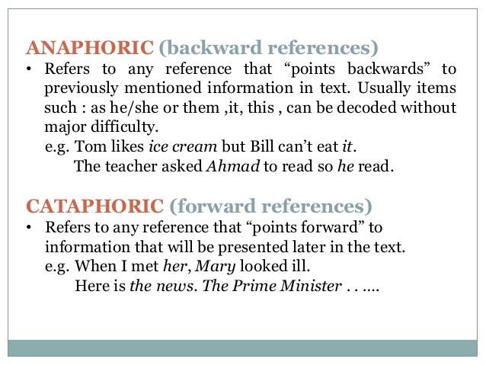

**Watch the video using this link :** [**https://youtu.be/iBSuHDzxpEQ**](https://youtu.be/iBSuHDzxpEQ)

**1.Abu Jehl, the chief of the disbelievers, in a fit of fury headed towards Hazrat Abu Bakr Siddique’s(RA) home. He began knocking at the door violently. He is Anaphoric Reference.**

**2. Her grandfather, Abu Quhafaa (RA) was a disbeliever at that time.**

**Her grandfather is Cataphoric Reference.**

**3. When Aslam was playing cricket , he hurt his hand.**

**He is Anaphoric Reference.**

**4. Before she finished the work, Neelam checked the mistakes once again.**

**She is Cataphoric Reference.**

**5. Anees threw the stone. He broke the window. He is Anaphoric Reference.**

**6. When she entered the room, Zeba was surprised to see so many guests.**

**She is Cataphoric Reference.**

**7. The city of gardens , Lahore is also famous for its historical places.**

**The city of gardens is Cataphoric Reference.**

**Pg. 40 – Vocabulary**

**Ex. A Choose the correct meaning of the underlined words:**

**i- It was so delicate situation. ( sensitive )**

**ii- Abu Jehl began knocking at the door violently. ( forcefully )**

**iii- She simply posed a counter question that infuriated Abu Jehl. ( enraged )**

**iv- She remained steadfast and did not reveal the secret. ( firm and resolute)**

**Pg.40 Ex. B: Use these words/phrases in sentences of your own:**

|  |  |
| --- | --- |
| **mad with anger** | **He was mad with anger and tore all his documents.** |
| **fit of fury** | **In a fit of fury , she broke all the dishes.** |
| **reveal the secret** | **All friends expect each other not to reveal the secret.** |
| **resolute** | **We should have a resolute faith in Allah Almighty.** |
| **alleviate** | **They tried to alleviate the miseries of this poor family.** |
| **migration** | **The birds are beginning their migration to the south.** |
| **companion** | **Ali is one of my closest companion.** |
| **refuge** | **We took refuge in an old hut.** |
| **gave away** | **He gave away all his money to the needy.** |
| **determined** | **He is determined to top this year exams.** |

**Pg. 41-43 : Grammar**

**Pg.41 Ex. A : Underline Abstract Nouns in paragraph 4.**

**migration , fit , response , wisdom , courage , clue , secret**

**Pg. 41 Ex. B : Form abstract nouns from the following adjectives and verbs. Use these nouns in sentences of your own.**

|  |  |  |
| --- | --- | --- |
| **Adjectives/Verbs** | **Abstract Nouns** | **Sentences** |
| **courageous** | **courage** | **He faced every calamity of life with courage.** |
| **empty** | **emptiness** | **The emptiness of house scared the old lady.** |
| **difficult** | **difficulty** | **He is speaking with great difficulty.** |
| **generous** | **generosity** | **Islam lays great stress on generosity.** |
| **resolute** | **resolution** | **I made a resolution to study harder.** |
| **suffer** | **suffering** | **He couldn’t face the sufferings of life and died soon.** |

**Pg.41 Ex. C : Put articles,where required.**

**1. Trees are grown on either sides of the canal.**

**2. Her courage and patience is exemplary.**

**3. Kindness and tolerance are noble deeds.**

**4. The higher you go , the cooler it is.**

**5. He is the tallest in the class.**

**6. The dog is a faithful animal.**

**7. The Indus is the largest river in Pakistan.**

**8. The Mount Everest is the highest peak in the world.**

**9. Alizey is the most intelligent girl in the school.**

**10. Where are the books which I bought a week ago?**

**Prepositions of Time ( in , at , on )**

**Pg. 42 Ex D : Identify the prepositions in paragraph 3 & 4 of the lesson.**

**Paragraph 3 : on , of , in , for , at**

**Paragraph 4 : at , to , with , of for**

**Pg. 42-43 Ex. E : Fill in the blanks with suitable prepositions given below each sentence:**

**i- The Holy Prophet (PBUH) migrated from Makkah to Madinah in 622 AD.**

**ii- Abu Jehl , in a fit of fury headed towards Hazrat Abu Bakr Siddique’s (RA) home.**

**iii- He began knocking at the door violently.**

**iv- At this , she instantly ran to a corner of the home.**

**v- She has resolute faith in Allah the Almighty.**

**vi- She gave away all the money to the poor and the needy.**

**vii- Her life would always be a beacon of light for all of us.**

**Pg. 43 Ex. F : Fill in the blanks with the prepositions of time.**

**a. Ali is arriving on January 26 at 2 o’ clock in the afternoon.**

**b. Saqib is leaving on Friday at noon.**

**c. Ashar has started working for his law firm in 1995.**

**d. I met Shaheen at 9:00 AM.**

**e. The doctor will see Alizay in the evening.**

**f. Sobia has her birthday on September 11.**

**g. We will have vacation in summer.**

**Pg. 43 Ex. G : Punctuate the following using capital letter, comma, and full stop.**

**The Holy Prophet (PBUH) and his close companion Hazrat Abu Bakr Siddique (RA) , migrated from Makkah to Madinah in the year 622 AD.**

**On their way to Madinah they sought temporary refuge in the cave of Thawr.**